Bio

John Neal Crossman Sr.

Born Glastonbury, Connecticut

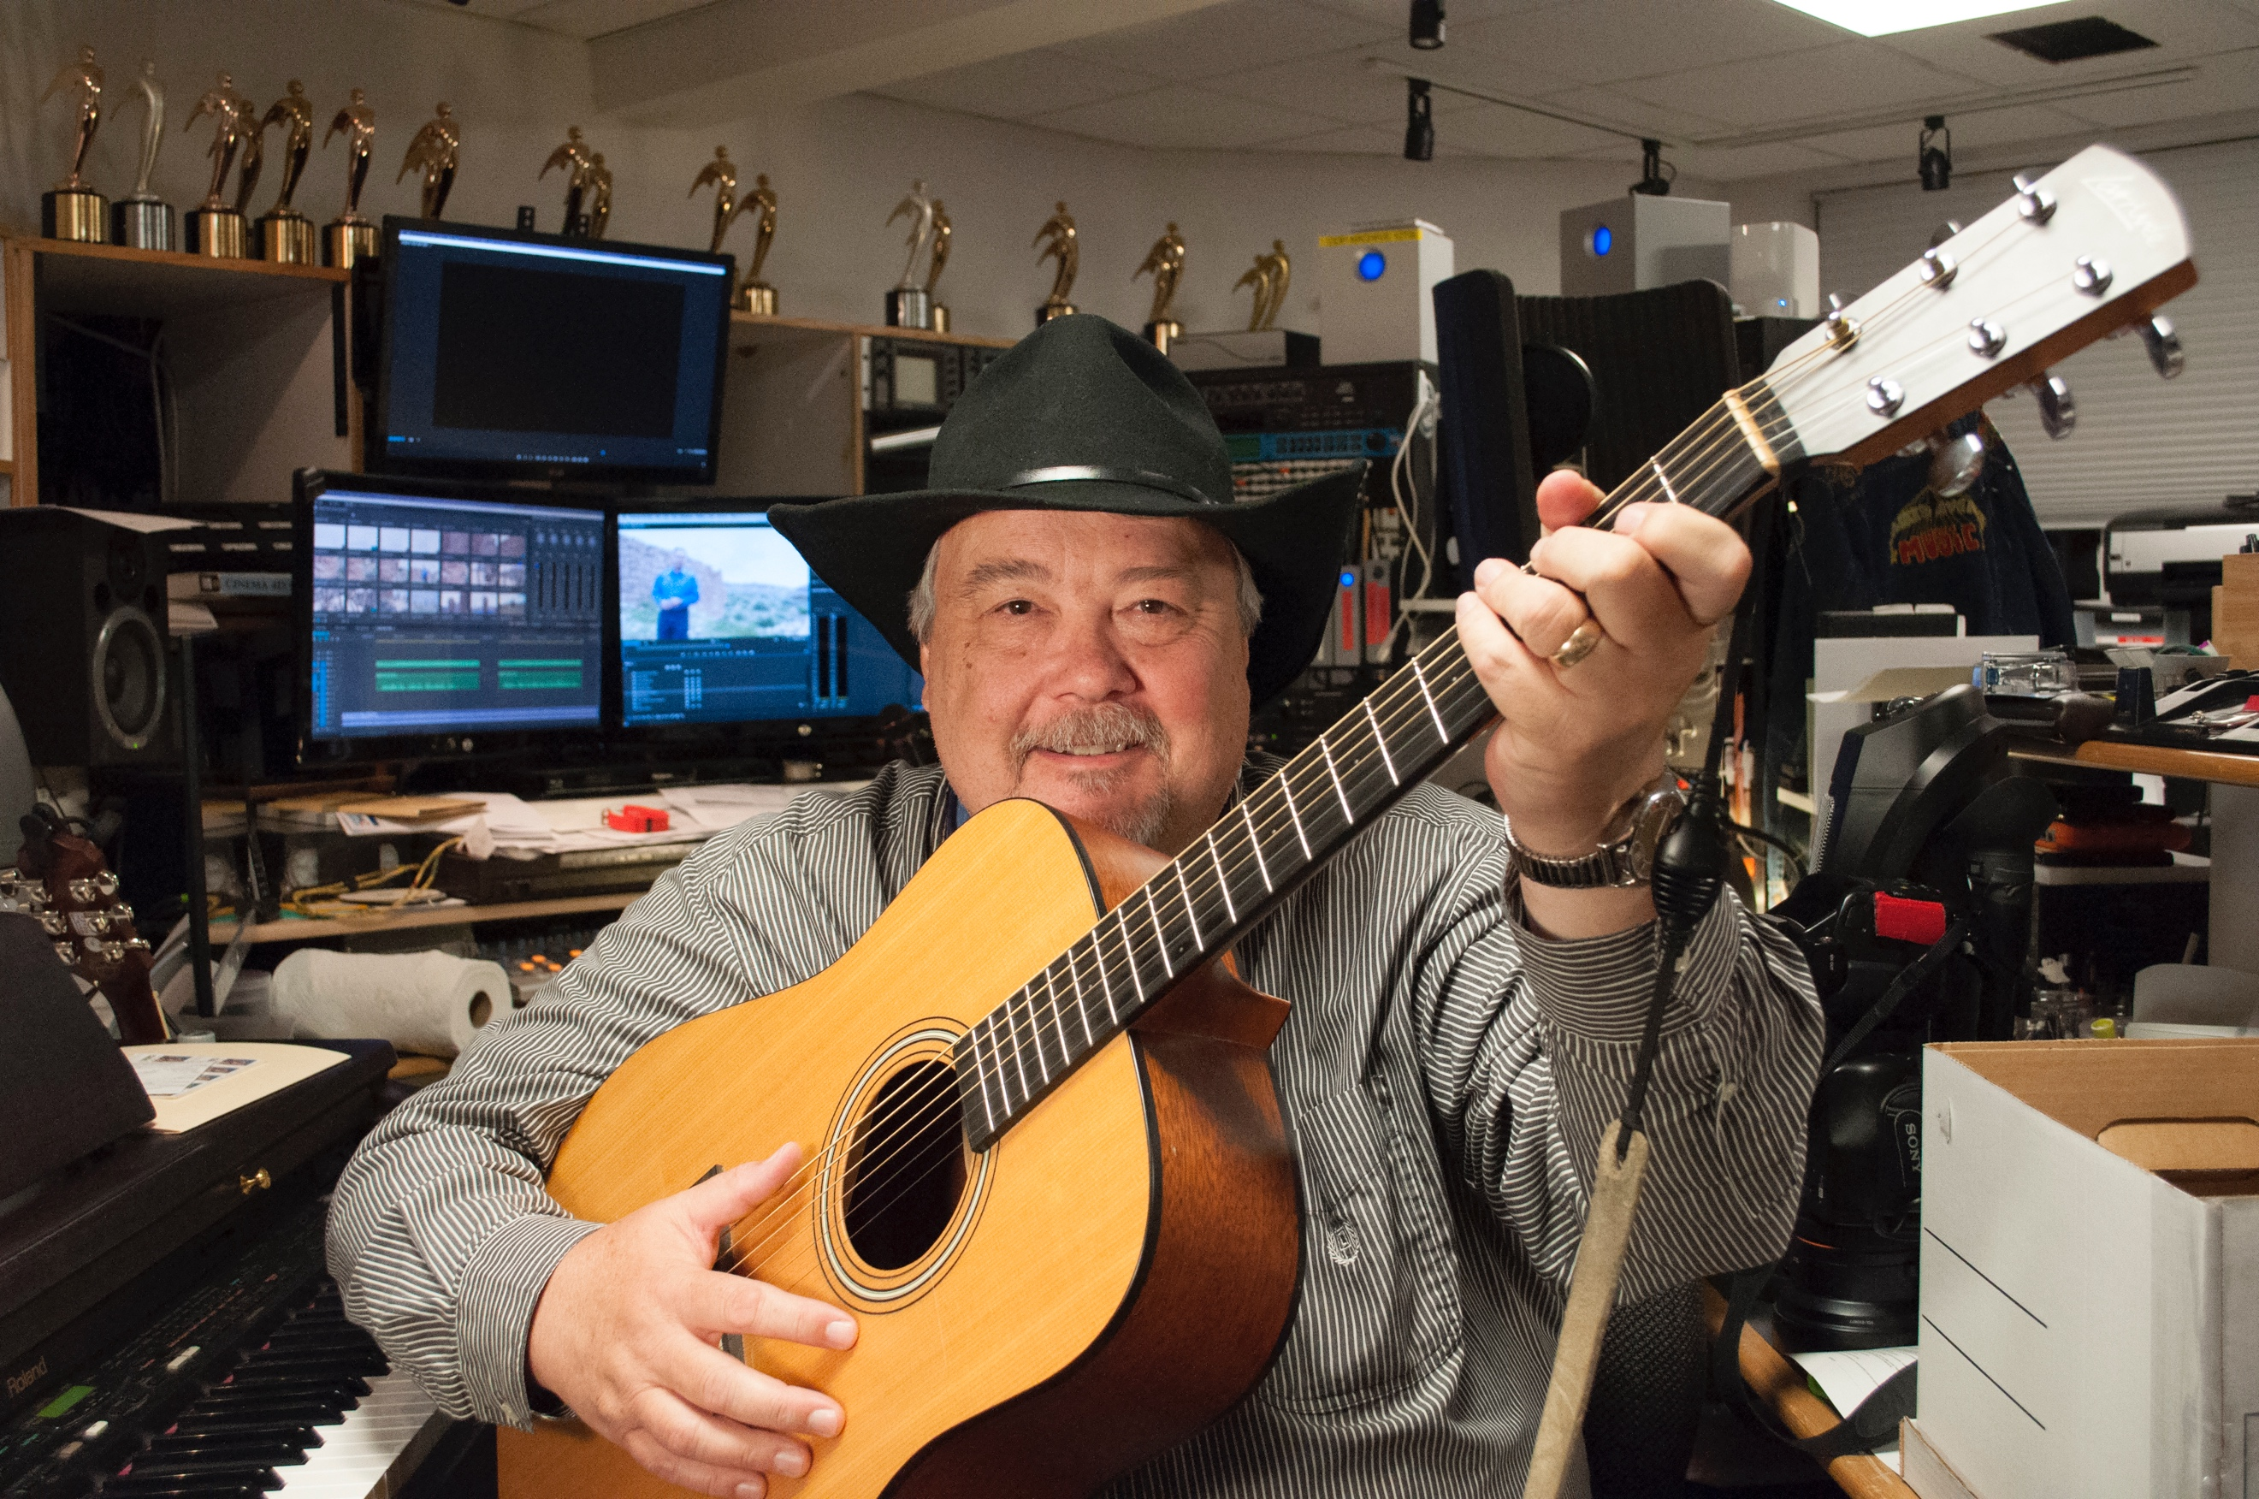

**Youth:**

I always loved music and singing. I grew up listening to my parents 78’s of *Oklahoma!*, and *Carousel* musicals. Choir started in 6th grade. Leads in the following productions:

Gilbert & Sullivan’s Ruddigore [Robin Oakapple], Pirates of Penance [Chief of Police]. L’il Abner [Gen Bullmoose], Carousel [Mr. Snow], You’re a Good Man Charlie Brown [Linus], A Midsummer Night’s Dream [Puck].

Toured Connecticut and New England throughout high school singing and playing guitar in Sing Out Glastonbury.

**College Years.**

Toured internationally in 1974 thru 1976 with the cast of Up With People! Played bass, acoustic guitar, was the band leader, transportation coordinator, and sang lead vocals. Across America, Puerto Rico, Venezuela, and Mexico.

Moved to Utah in 1978 for school and music [a band with former UWP drummer] and started washing cars at KSL TV News. In 1979, I got “caught” editing a music video [way before MTV] and became their first dedicated video editor. From 1980 to 1986 grew the editing staff to 10 people, in 1983 became Chief Editor and joined the management team. I designed the editing area in KSL’s new Triad building, Won Regional Emmy for a show I created called the Year in Review, Won Society of Professional Journalists awards for Editing, Special Projects and received special recognition for my work on “A Year in Review”.

Graduated 1981 with a BS in Marketing/Public Relations from the University of Utah. Played locally and regionally with band “Weekend”, wrote and recorded original music between 1978 and 1991, and have renewed that effort as of late.

**Working.**

In 1986 I left KSL to start one of the first first boutique editing companies in Utah, “The Beta Bay” in Park City with partners, who had been freelance clients while I was at KSL. Between 1986 and 1991 I won 3 more regional Emmy’s, one in particular for a documentary on the first Western Opera Company to tour China after the cultural revolution was stopped. There I did post production work for Salomon, Marker, The Video Journal of Education, Estes Corporation, Deer Valley, Converse, Wilson Sporting Goods, Yonex, Yamaha, Specialized, Varnet and others.

In 1991 I left and started Crossman Post Production in Salt Lake City. Clients included Smith’s Food and Drug, UPS, The Utah Jazz, KXIV and KJZZ TV, NBC, OLN, ESPN, KUED, Penna Powers Cutting and Hayes [Taco Time, Hold On to Dear Life, Mt Fuel], Enrich International, Xango, Sinclair, Cornerstone Productions, Broadcast International, Wilson, Freestyle Fitness, ICON Health and Fitness, Jack Nicolaus Golf Academy, School Improvement Network, Harry K Wong Publications, Learning Forward.

As the market changed I had to change as well adding full production to my work and doing projects for Alsco, Ascend Humanitarian, Pacific Educational Group [Courageous Conversation Summit] Courier Tennis Academies, Choice Humanitarian, Hometeam.com[Reality TV Show-Fuel Media], Young Living, Chasqui Humanitarian, South Valley Boys and Girls Club, Sandy Club, The Power of Words, Beautiful Woman, OPG, Geomancer, Utah Sports Hall of Fame, Genshai.com, and others. Addys, Vision, Communicator Awards, Over 30 Telly Awards, 3 Docs I worked on for KUED won Emmy’s as well.

I have done production across the US, as well as Europe and South America.

In 2012, long time client School Improvement Network asked me if I would come on full time. For the first 16 years, I edited and did graphics and animations for every classroom, marketing, promotional, and training video they did. They were very early adopters of online video delivery and created a very successful platform called PD360. They sought and got investor money to expand and asked me to join them as they ramped up production from 2 to 30 people. I oversaw 8 editors, 5 writers, 4 producers as well as audio post and associate producers. I edited, shot, interviewed, and quality checked every piece of video the team produced for the next 5 years being on the management team as Director of Post Production and then Vice President of Media Development and special projects. I did production from one end to the other of America as well as an intensive documentary work on a new educational approach in the state of Michigan, focused in Detroit.

School Improvement Network grew from several million in sales to almost 50 miliion in sales over the next few years. The content was considered the premiere educational video content of the time. In the last two years sales began to fall for several reasons I will share in other places. As sales fell, the investor group that had fueled the buildup wanted their return on investment and coupled with a sharp decline in sales, School Improvement went from approximately 280 employees to about 60 by the time I was laid off in 2016. It was sold to Frontline Education [a VC group] in 2017.

Currently I am back at Crossman Digital seeking to create effective communications for all my clients. Over my career I have expanded into web design, writing, music production and other supportive arts. I am an avid reader of biographies and business books. I have several novels underway as well as having the goal of recording the best of my catalogue of original songs.

I am proficient in Premiere, After Effects, Photoshop, Illustrator, Encoder, Office, and other software as well as having SONY HD and 4k cameras.

I look for opportunities to serve clients and grow in my life. I like to believe that one of my intangible skills sets is perspective. The ability to see things from multiple perspectives, not just my point of view, but as a viewer, as a learner, as a communicator. The ability to see beyond what might be on the surface brings depth and purpose to my work.

The work I was a part of at School Improvement was believed to have impacted up to 70,000,000 students over 20 years. Based on teachers and licenses. That is exciting to me. It isn’t unique to me certainly but impacting people for good is the highest reward I can think of.

**Experience at School Improvement Network.**

I edited every piece of content The Video Journal of Education, later to be renamed School Improvement Network did in their first 16 years. Every year we produced at least 12 hours of documentary style video product that was aimed at sharing research and best practices for educators and administrators. Some years we nearly doubled that.

Control Theory, Classroom Management, Outcome based Education, STEM, The Common Core, Block Scheduling, Helping Teach Children of Poverty, Teacher Induction Training, Math Standards, Equity, Writing Through the Curriculum, Principals as Instructional Leaders, nearly 140 subjects. For 16 years we covered 9 topics a year and many major ones did versions for elementary and secondary. While not producing these videos per se, it is fair to day that over the course of editing these projects I became very familiar with the theory and practice. Many of the issues had custom graphics and 3D models of how the theory worked and each piece also had classroom examples of how it was applied in a classroom and I also did all of the graphic work. The content was aimed at teachers, with some created for leadership as well. It was not generally content for specific subjects although the STEM series was and the Common Core was based around teaching those standards.

I shot, logged and editing literally 1,000’s of teacher interviews over the course of 20 years and developed a real admiration for those who try to make a difference in children’s lives.

**What I have learned.**

People respond to authentic content.

Instruction is personal.

Teaching is a relationship.

Learning is personal effort.

Content has to have an engagement.

Part of that engagement is the student seeing themselves in the instruction. [Diversity]

While not wanting to drive even more ADHD, every moment of the viewers time valuable and you need to respect it.

People like stories.

Teachers like real, authentic content.

People are used to the story telling cycle, and beginning, middle and end.

When all the elements of communication are not intentional, then the result is less effective.

I always start with the music.

Effective Teachers know how to manage a classroom.

While videos can present many different messages, each video should be limited to a clear instructional goal.

The Video journal of Education/School Improvement Network

A Story.

**Historic Starting Point.**

At the time there were no other educational videos being done like this. A typical educational video was a “talking head” on camera or a camera locked down on a wide shot at the back of the classroom. My client, John Linton had graduated in Journalism and had made “films” for educational, corporate and entertainment audiences his whole career before finding himself teaching 9th grade biology at Jordan High School. He was frustrated by the culture of school then because every teacher was isolated in their own classroom and there was no effort to spread effective teaching principles among teachers. Through a series of events, he found himself producing a few videos for the district and as he approached them in a documentary style it occurred to him that it would be the perfect way to share best practices through a video program. One thing led to another and in 1991 he and his wife founded the Video Journal of Education. I had been editing his education projects up at the Beta Bay and we found we had very complimentary talents and approaches to doing this work. The first several programs I edited up at the Beta Bay before splitting with my partners [no connection] and forming Crossman Post Production. I continued to their work right up until they hired me in 2012.

At the time I joined them, they had moved or where moving all of their content online. They stopped producing their yearly quota of programs, had gone out and raised some venture capital out of Boston and started a new series of programs to explain the major standards of the newly released, or about to be released Common Core. I wasn’t involved in the planning or much of the execution of this strategy much to my dismay because frankly there where some huge holes in the planning and execution of this product that I saw when I saw when I started.

*Much has been said about the common core, many things negative and politically motivated and most from people who have never read the common core standards. The first thing I did when I started to work on this project is download and printout and read the standards. I wasn’t required to, but that’s what I do. I love the work I do because I am able to learn something everyday.*

*They were created by the CCSSO, or the Council of Chief State School Officers. It is a subcommittee of the National Governors Association. Not republican, not democratic, all state governors. It has nothing to do with the federal government, something always thrown up against it.*

*The standards do not tell teachers what to teach. It does not tell them how to teach. It simply states standards, most with specific examples of what the students need to know and be able to do. That’s it. Any other things you might have heard is not part of the standards.*

*The standards where created so that a high school diploma from Idaho would represent the same scope of skills as one from Connecticut, or Alabama. The need for this was generated largely from business that pays millions of dollars to train their employees in remedial skills.*

*A common sense kind of thing created over 5 years involving University, Public and private school educators, business and other leaders. Every state has historically had standards, yet this was pushed as over reaching and suffered from the “not invented here” backlash, when ironically every state and educators from across the country had input into them.*

**The Common Core Project.**

The first issue was they had selected a person with no video production, no education experience, or producing experience to head up this major multi-million-dollar project. While the person was smart and capable, the lack of understanding the basics of what needed to be accomplished ended up with hundreds of thousands of dollars of poor content we could not use. Not understanding the technical aspects of how production was done, and then not using tried and tested processes for tracking the footage, or even checking the footage [!] lead to significant issues down the line. Why would they do this you might ask? One of the owners of the company [the founders had sold the company to their 3 sons], who spearheaded the project thought someone who had no experience would find “better” ways to do production than someone who actually had a track record of doing a project of this scope. The other brothers were not in production and so there were no questions apparently on this strategy. I had questions, but I wasn’t on the team yet.

The end of the story in this case was 185 segments over 3 years when there are 3,500 standards divided into probably about 10 categories, and we didn’t even hit all of the categories. In my opinion, not only was it set up to be unsuccessful in meeting the needed goals, the owners should have known better. But this particular owner was a very hands off manager to the point that as new people joined the team they got basically no training or introduction to the company. When he gave this project to this person, they were a personal friend and he either was influenced by her intellect or bullied by her ambition. He got regular reports that this wasn’t working well [once he hired an experienced field producer to help the producer] but he was very slow to investigate and take corrective measures.

The type of segments we eventually did for the common core were basically showing a classroom teacher presenting a lesson showing how through just the normal course of teaching, they would easily include CC standards. Issues became apparent soon when we discovered that teachers the producer had “contracted” with in Kentucky – although recommended by their principals or districts – were very uneven in their quality and so we went back for three years capturing teaching that did not represent the best practices SINET had always been known for.

As director of post production, I fought to maintain the common sense approaches we had used for years, such as supering names as people spoke, adding graphics to help reinforce the key learning points and other techniques and was basically told it was the producers call… again someone with no experience… so while I was hired for my experience, I was not backed up by my boss. As time went on most of these things were “discovered” as effective by the team, but it was stupid waste of time and money by my boss not backing me up at the time. It was just the beginning of the strange experience of actually working for someone who “loved” my work, but actually gave me little power to direct the team.

Poor Judgement in the Executive Suite

The company had grown from mom and pop to over 50 million in sales and seemed destined to keep growing. No other teacher development platform had the variety, experience and finished product to compete with SINET. The teachers Channel was founded by the co-founder of Microsoft but after the initial funding.

The founders were teachers and one had a strong production background doing feature length movies and many industrial projects before starting the VJE.

They sold the company to their 3 sons, and the oldest had the largest share and had in fact been there throughout their history being pivotal in their start up. Shortly after selling, the decision was made to stop producing content and focus on selling the library they had developed over 15 years. I was still freelance and was hired regulally as they converted all of their library to DVD.

A short coming I don’t think they saw was that education loves change and programs. The VJE started with a series of videos explaining “Outcome-based education” as a way to raise student success in any district. A couple of the first partners in VJE were directly tied to the Outcome-based Movement and actually lost interest when the founders told them they had to document more than just OBE methods and models. So while a pause in production, to focus on sales wasn’t a bad idea at the surface, it didn’t reflect the true nature of our clients… there was always something new to be learned and trained in. Many of the tennats of Outcome-based Education where common sense to me and begins with letting the students know what they are going to learn and be able to do either in class, or the next unit, or the school year. This was considered radical some what at the time, with an out cry of “Teaching to the test!” but of course, would you test students on what they weren’t supposed to learn? We all experienced teachers who liked to ambush the students with tests or quizzes they may not be prepared for. This group advocated doing away with that theory of educating kids and said why should what we want them to learn be a secret? That was outrageous in some corners of education, yet totally nonsensical to me. Over the next 17 years I would see elements of OBE reintroduced as “new” and clothed in new language. Education loves that.

Sales in the education market is very difficult because it is so balkanized. Over 75% of the school districts in the United States have 3 or fewer schools. And every district feels their needs are unlike anyone else. So sales took years to grow, but grow they did. By the time School Improvement network had moved all of their work on line, they had grown to around 50 million in sales and that was around the time the founders or parents sold to their 3 sons.

The pause in production probably last ed less than a year because it be came apparent education wasn’t sitting around and with “No Child Left behind” and the education reforms that followed, there was high demand for teacher training and money for it.

The oldest son, who wasn’t a “content” person and wasn’t a teacher was enamoured by technology and while it wasn’t really his strong suit, he fell in love with the idea of turning SINET into more of a technology company rather than a content company. He went out looking for some venture capital to be able to remold the company and “ed-tech” was a hot place in the market and he and his brothers where able to aquire funding for the company.

This injection of capital I’m sure had many purposes but one of them was vcreating new content and so for the first time, they went out a started to build a content team of writers, producers and editors. I was still helping them and they asked me if I’d consider coming on fulltime which at first I refused… really because I didn’t understand why they wanted to spend money on staff when they got a better bang for their buck with freelancing out the work. When it became clear that the die was cast, I did join them full time in 2012 and helped them build a very good team of 8 video editors, writers, producers and assistants. While I was given a title, I actually had little backing from the owner/brother who was now over production. He had a degree in film from USC and should have known the value of experience yet some how was immune to it. Whether it was a small detail or purchasing a million dollars of new equipment, he wanted to lead and make the decisions, all decisions at all times. At the same time he had published an education book on Race and was traveling every week around the country to support the book, speak and train.

Eventually, the investors