

Content Development

Team Member Manual

Updated Dec 3, 2013

# Content Development Team Member Manual Contents

1. Overview

* 1. Welcome to the Team!
  2. Department Organization Chart/Management Structure
  3. Team Leaders Bio
  4. What We Do in Content Development
  5. Kina’ole - Our Commitment to Excellence
  6. Department Positions and Job Descriptions/Responsibilities
  7. Day-to-Day Operations
  8. Technical Information
     1. Accessing the Department RAID
     2. Accessing the Editing or Fast RAID
     3. Clarizen Project Management Software
     4. SharePoint Data Management Software
     5. Currently Used Software
     6. SINET and Department Terms and Lingo
  9. Where to Go With Ideas
  10. Where to Go With Problems

2. The Standard School Improvement Network Production Cycle

2.1 Content Decision-Making Process

2.2 Pre-production

2.3 Production

2.4 Post-production

2.5 Delivery

3. Style Guides for School Improvement Network Video Programs

3.1 General Video Style Guide [Philosophy]

3.2 General Writing Style Guide [Philosophy]

3.3 PD 360 Videos Series

3.4 Common Core Segments

3.5 Common Core in the Classroom

3.6 Whole Classrooms

3.7 Whole Classrooms With Commentary

3.8 Success Stories

3.9 Marketing Videos and Special Projects

3.9 Shooting for School Improvement Network

4. Production Cycle Processes: Producer

4.1 Pre-production

4.1.1 Finance

4.1.2 Travel

4.1.3 Identify Production Team

4.1.4 Permissions/Release Forms

4.1.5 Filming Schedule

4.1.6 Communicating With Educators

4.1.7 Filming Guide/Outline

4.1.8 Equipment Check

4.1.9 Producer to Double Check Equipment and Divvy Up Baggage

4.1.10 Slates/Cards

4.1.11 Pre-Travel Checklist

4.2 Production

4.2.1 Equipment Prep and Travel

4.2.2 Dress Code

4.2.3 Signing In

4.2.4 Overseeing Production

4.2.5 Slates and Release Forms

4.2.6 SXS Cards

4.2.7 Prepping Students

4.2.8 B-Roll

4.2.9 Meals and Snacks

4.2.10 Producer Notes

4.2.11 Production Wrap-Up

4.3 Post-production

4.3.1 SXS Cards and Slates

4.3.2 Thank Yous

4.3.3 Permission/Release Forms

4.3.4 Comp Licenses

4.3.5 Forms for Use

4.3.6 Producer Procedure Quick Guide

5. Production Cycle Processes: Writers

5.1.1 General Video Script Workflow Process

5.1.2 How to Write a SINET Video Script [Technical]

5.1.3 CC 360 Classroom Video Scripts

5.1.4 How to Write a Guidebook

5.1.5 How to Access and Upload a Document on SharePoint

5.1.6 Educational Writing Tips

6. Production Cycle Processes: Editors

6.1 The Communication Process of Post-production

6.2 Post-production Roles

6.3 Edit and Review Procedures

6.4 Editing Workflow Process

6.4.1 Pre-edit Set Up

6.4.2 Editing and Graphics

6.4.3 Promos

6.4.4 QA and Beyond

6.4.5 Final Export

6.4.6 Delivery Assets

6.4.7 Archiving and Backups

6.4.8 RAID Procedures and Naming

7. Production Cycle Processes: Support

7.1 Media Management

7.1.1 Card Transfer

7.1.2 Card Conversion

7.1.3 Video Compression for Transcription

7.1.4 Logging Ticket Preparation

8. Production Cycle Processes: Delivery/Encoding

8.1 Encoding

8.2 Uploading Process

8.3 Flush/Purge Files

8.4 Back Up

8.5 Proofing Process

8.6 Creating Descriptions for PD 360, Common Core Info Boxes

9. Your Personal Training Schedule and Check off

9.1 Company History

9.1.1 John and Blanch Linton and Linton Productions

9.1.2 Chet and Joan Linton and The Video Journal of Education

9.1.3 Cory, Curtis, and Hollee Linton [McKay] and School Improvement Network

9.1.4 Where You Can Find Further Bits of History in This Guide

9.2 Company Leadership

9.2.1 CEO/President

9.2.2 Executive VP Product Development

9.2.3 Executive VP Operations

9.2.4 Executive VP Sales and Customer Success

9.3 Department Structure and Leadership

9.3.1 Who Do I Report to for Resources, Personnel, and Administrative Issues?

9.3.2 Who Do I Report to for Technical, Style, Creative, and Production Processes?

9.3.3 Annual Review

9.4 Your responsibilities training

9.4.1 My Job Description

9.4.2 People on My Team

9.4.3 Roles on My Team

9.4.4 Understanding and Using the Educator Effectiveness System [PD 360]

9.5 Department Training/Cross Training

9.5.1 Training In the Content Selection Process

9.5.2 Training on the Production Cycle

9.5.3 Training in the Pre-production Process

9.5.4 Training in the Production Process

9.5.5 Training in the Post-production Process

9.5.6 Training in the Delivery and Proofing Process

9.5.7 Concur Training [Producers and Traveling Positions]

9.5.8 Video Segment Review

9.6 Completion Check List

1. Overview

1.1 Overview: Welcome to the Team!

“Never doubt that a small group of thoughtful, committed citizens can change the world; indeed, it's the only thing that ever has.”

– Margaret Meed

You are now part of a small group of thoughtful, committed video professionals that will change the world through our abilities to create high quality, engaging, professional, and research-based video programs for teachers, administrators, district and state educators.

We are a mix of experienced video professionals and we ask that you bring your best to the tasks everyday. While what we do is video, the impact of an idea presented in our videos that a teacher can understand and apply effectively in their classroom will affect generally 30 students per class. The average teacher teaches 100 students, so now you are impacting 100 students every time the teacher learns an effective practice. Currently we have over 900,000 educators on our system . . . let’s say only 500,000 are classroom teachers. Fifty-million children impacted from the improved practice. There is power in our work.

We are excited to have you join us, your success will be our success.

Curtis Linton

Executive Vice President Product

John Neal Crossman

Vice President Media Development

Michelle Fisher

Operations Director Product

Lisa Leith

Vice President Education Research, Policy and Accountability

1.2 Organizational Chart

We are in the Product Division. It is under Curtis Linton, Executive VP of Product.

At this time the organizational chart for the Product division isn’t completely defined.

There is the VP of Educational Research, Policy, and Accountability, who’s office contains of content specialists and researchers.

The Media Development Department, where you will work which is the team of producers, writers, editors, and support that creates the media for our products.

The Software Dev team that creates the product software and is guided by Product Management.

Since the end of 2012, this division has been under going through a redesign in several ways and as of this writing isn’t completely settled.

1.3 Team Leaders Bios

**Curtis Linton, Executive VP Product**

Curtis Linton – Waiting official bio

X

X

X

X

X

X

X

X

X

X

X

**John Neal Crossman, VP Media Development**

John Crossman has had a 35-year career in television production. Cutting his teeth at KSL-TV and then as partner in the first Betacam-based post house in Utah called the Beta Bay, Inc. in Park City. In 1991 he started Crossman Post Production and has worked on every type of production imaginable, from NCAA and NBA basketball, to Huntsman Cancer Institute fund raising. From shows for ESPN, NBC, CBS, the Outdoor Life Network and nationally syndicated reality shows, to 100's of corporate product, promotional, training and image pieces. Breaking news stories and PBS documentaries. Few editors have had the broad range of work and experience that he’s had. This unique combination has been recognized outside the area as well with the work John has done being awarded four Rocky Mountain Emmy Awards, over 30 National Telly Awards, five Addy Awards, three Communicator Awards, three National Vision Awards, as well as two awards form Sigma Delta Chi, the Society of Professional Journalists.

John Linton hired John to edit the first educational videos he did for the Jordan School District [*Now Canyons School District*] back in 1987 and he edited every video for The Video Journal of Education and now SINET for the first 17 years of the business. Raised in Connecticut, he and his family reside in the southeast Salt Lake Valley.

**Michelle Fisher, Operations Director Product Development**

Originally from South Africa, Michelle has a diverse background in video production, having graduated from The Durban Institute of Technology in Video Production. She has edited and produced a variety of broadcast, corporate and training programs as well as live production events.

In 2006, Michelle moved to the UK, where she spent two years working as a Project Manager for AimHigher and the LifeLong Learning Network at Hadlow College in Kent. These projects were aimed at encouraging and enabling students to move onto Further and Higher Education.

When the project was complete, Michelle accepted a position with ClearPlay International as the Operations Manager for Europe and Asia. Here she was tasked with the responsibility of setting up and managing the Product Development and Customer Support departments.

In 2011, Michelle moved to Utah, USA and started working for her current employer, School Improvement Network.

Michelle lives in Layton, Utah with her husband, their son and their two dogs. She is very active and loves being outdoors, she runs every day and has a horse named Nippy who she competes with at show-jumping events.

**Lisa Leith, Vice President, Education Research, Policy and Accountability**

Lisa is the Vice President of Education Research, Policy and Accountability for School Improvement Network. She is also on staff in the Doctoral Department of the University of Phoenix Online, mentoring doctoral students from design of a research proposal, through the writing and defense of the dissertation. Lisa led the District and School Improvement and Quality Assurance process as Director of Accountability and Accreditation for Thompson School District in Loveland, CO. Before joining Thompson School District, she launched a coalition for National Principal Training and Support and was a national coach for the Alternative High School Initiative (AHSI), supporting 10 innovative educational organizations in all aspects of educational and organizational development and data analysis. Prior to her work with AHSI, Lisa served for six years with The National Association of Street Schools, first as Principal of the Denver Street School and then as Vice President of School Development for a nation-wide network of more than 40 alternative schools. Lisa taught a course entitled “Teaching for the success of all adolescents” for the special education department at the University of Colorado, and supported the University education faculty towards increasing use of technology as an instructional and research tool as a Site Tech through the PT3 grant. She has been a secondary math teacher and a principal in elementary, middle and high schools. Lisa earned her MBA from The University of the Incarnate Word in San Antonio, TX and her PhD in Educational Leadership and Innovation from the Univer­sity of Colorado at Denver. Lisa’s research focus and passion is improving academic outcomes for all students through targeted professional development. She lives near Salt Lake City, UT, and enjoys hiking, cycling and skiing in the beautiful Wasatch Mountains.

1.4 What We Do in Content Development

Simply put, the center and anchor of the products of School Improvement Network is video. We have produced educational video programs for close to 30 years. What started out as video programs sold and distributed by VHS videotape is now a fully online platform with many software, interactive and reporting systems patented and built into our online platform, PD 360, and all together comprise the Effective Educator System.

With all of the many features we deliver today, the center is still around showing best practices of educators to educators and that is done with video programs, or segments.

Our video programs are categorized under several different “product lines” or “apps” in the current vernacular.

**PD 360** is largest of our video-based products and has videos created from the present time back to a few of the earliest videos done under the previous company name of the Video Journal of Education. There are well over 1,000 videos in that collection.

Inside of PD 360 there are several continuing series, such as “Equity and Innovation,” “100%,” and “Practical PD.” To align to our cause of 100%, the the team that produces content for PD 360 is considered the 100% Team.

**Common Core** is filled with videos that relate to the Common Core State Standard Initiative, which is a set of educational standards starting in Kindergarten through12th grade for core subjects like math, English, science, and social studies/history. The majority of these videos will be classroom examples of a teacher teaching specific standards at each grade, in other words, the standards progress from year to year. The “reading informational text” standard in 4th grade, will be built upon in the “reading informational text” standard in fifth grade, so there is a link all the way through 13 years of schooling in these core subjects. If you do the math considering there are about 36 core standards, times 13 years of education . . . that’s a lot of segments.

**LumiBook** is a media-rich, interactive e-book experience, using all of the media tools available, and a lot of video. Its unique feature set includes exclusive collaborative and community tools for the readers and author. Since it lives electronically, it can be updated by the author continuously giving the reader a “living” resource that is engaging and connected to others learning.

These are the major video products, but it’s always evolving as well, and we do a fair number of custom content for partners and others in education.

As a video production house, we have producers, writers, editors/graphic artists, audio post, webinar production, even event production at times. While currently we do not have in-house dedicated videographers, many of the editors, and others have done a fair amount of field production. We have all of our own production and post-production equipment, and hire freelance videographers and field audio people on a regular basis.

The goal is to have a production team that is the not only the leader in education, but also able to stand toe to toe with any video production company in the world. We are not making movies, and above all else we need to be real, so at times we will have to use less than perfect material, but our overriding goal is to have outstanding content backed with professional video skills. Raw video is comparable to all the letters of the alphabet . . . it only works to communicate when it’s put together correctly.

1.5 Kina’ole – Our Commitment to Excellence

You will find many attachments to Hawaiian Culture at School Improvement Network, among them Kuleana, meaning a community, and Kina’ole meaning:

Doing the right thing . . . in the right way . . . at the right time . . . in the right place . . . for the right person . . . with the right feeling . . . the first time.

It is the expectation we have for all of our team members. To commit to doing our best work at all times. A fact of our production is we don’t control the environment we shoot in at all times. It is more important to capture authentic practice than perfect production. That being said, we strive at all times to make the final presentation the best it can be. It comes down to ownership of the quality of the project. This is a responsibility we all share. Even if the project is given to you as a quick and dirty, there is no such thing here. An assignment can be simple, but it is never Q&D. Seek any opportunity to make a project better with in the parameters we work with, i.e., we can’t go reshoot for a week. If any thing at any time feels less than the best you feel can be done, please talk to John Crossman and he will address the problems.

1.6 Department Positions and Job Descriptions/Responsibilities

***All job descriptions are subject to change. Not all positions will be active and any one time.***

***These should be considered valid but not necessarily complete.***

Vice President Media Development

Is responsible for technical, creative, style, and total quality of our video and/or media content.

Manages Media Development Team.

Manages technical and equipment needs.

Mentors and grows the team in their abilities.

Develops and maintains department style and quality guidelines and procedures.

Does the final reviews of all video product.

Participates in all department hiring/firing.

Scrum Master

The scrum master facilitates all meeting during the Agile or scrum process. Including meeting to develop the product backlog, Sprint planning, daily scrum meetings, sprint review, retrospectives, and backlog refinement.

Producer

*Overview:*

Producers create content for School Improvement Network inclusive of any specific product and/or campaign, such as PD 360, Common Core, 100% programs, the Educator Effectiveness System, marketing & promotion, partner projects, and all other projects as assigned.

A producer owns the project, receives assignments and coordinates the budget with operations, receives requirements from the Product Owner, and collaborates with the content specialists to ensure quality of content.

As outlined below, they own the production of the project[s] from start to end, and they will be required to handle multiple projects at once as needed by the company.

A producer is expected to gain an understanding of the content, while being responsible for proper scripting, narration, and editing of the final product, as well as successful delivery and release of the project. **While it is collaborative work, the producer is the lynchpin in making the production chain work**.

*Specific Duties:*

* A Producer is responsible for the management of all pre-production, production, post-production, and delivery needs concerning their assigned project.

I have read, understand and agree to perform the above duties [initial] __________

* - Projects are assigned by the Product Development Director of Operations after the business case has been developed by the Product Owner and has been vetted and work-shopped by the Content Specialist.
* - The Producer works with the Director of Operations, the Product Owner, and the Scrum Master to formulate deadlines and project schedules and is ultimately responsible for each member of their team meeting those schedules.

I have read, understand and agree to perform the above duties [initial] __________

* In pre-production, a Producer will complete the Project Start Form with the help of a Content Specialist and PO, create and deliver an MOU adjusting as needed to new circumstances, develop the shooting schedule, book travel, organize the collection of release forms, distribute the SINET introduction video to anyone appearing on camera, and coordinate with internal and external crew members. Additionally, the Producer will communicate with state, district and community representatives, as well as school educators and administration as needed in the scope of production.

I have read, understand and agree to perform the above duties [initial] __________

* During production, the Producer is responsible for the planning, management and successful obtaining of all content from the field production, *with input from and collaboration with a Content Specialist*. The Producer’s primary responsibility during field production is to assure that the crew, talent, equipment, hosts, and other guests are effectively managed and supported in the capturing of the content. This includes before, during, and after daily production occurs, and throughout the duration of travel. The Producer tracks expenses, pays for crew expenses with their corporate AmEx card, and manages effectively the established budget for each shoot.

I have read, understand and agree to perform the above duties [initial] __________

* In post-production, the Producer is responsible to coordinate the process throughout the scope of the project, meet deadlines, ensure payment to freelancers, coordinate team members’ time and talent, collaborate and review scripts and edits as required with Content Specialists, Writers, and Editors, and contribute to the overall betterment of each project. The Producer will participate in a daily scrum to report progress on their projects to the Scrum Master, and will report impediments to the Scrum Master, who will work with the producer on removing those impediments. It is the primary responsibility of the Producer to keep all external crew and internal team members on task, the production on schedule, within budget and approved for delivery on time.

I have read, understand and agree to perform the above duties [initial] __________

* Producers will also collaborate with the necessary people to effectively coordinate content webinars during the delivery month. The Producer will identify potential webinar candidates from location production, work with the webinar coordinator to invite potential candidates to participate in webinars, ensure communication takes place with the webinar participant, webinar coordinator, Writer, and marketing team as necessary for each project.

I have read, understand and agree to perform the above duties [initial] __________

As a producer, I understand and agree to the expectations of the work I am assigned to complete, as defined herein.

Signature: _____________________________________________ Date:____________________

Associate Producer

*Overview:*

SINET, like any established employer, has unique procedures and processes specific to SINET. Therefore, producers may initially be hired as an Associate Producer. This position works in tandem with a Staff Producer but will likely have their own projects as well.

*Specific duties:*

- The Director of Content Development may assign you any projects as necessary.

- You will be expected to continually increase your understanding of K12 Education. Basic levels of understanding include but are not limited to the education system, professional development trends, and educator roles.

- You will be assigned a mentor for understanding both SINET’s production process and educational endeavors.

- In pre-production, an Associate Producer will complete the Project Start Form with the help of a Content Specialist, create and deliver an MOU adjusting as needed to new circumstances, develop the shooting schedule, book travel, organize the collection of release forms, distribute SINET introduction video anyone appearing on camera and coordinate with internal and external crew members. Additionally, the Associate Producer will communicate with state, district and community representatives, as well as school educators and administration.

- During production, the Associate Producer is responsible for the planning, management and successful obtaining of all content on the field production, with input from a Content Specialist. The Associate Producer tracks expenses, pays for crew expenses with their corporate AmEx card, and maintains the established budget for each shoot.

- In post-production, the Associate Producer is responsible to manage expectations, meet deadlines, ensure payment to freelancers, coordinate team members’ time and talent, review scripts and edits as required and contribute to the overall betterment of each project. The Associate Producer will coordinate the post process with the Post-production Coordinator and will assign them the aspects they will oversee. It is the primary responsibility of the Producer to keep all external crew and internal team members on task, the production on schedule and within budget.

- Associate Producers will also manage the initial coordination of webinars during their delivery month. The Associate Producer will identify potential webinar candidates on-location, invite potential candidates to participate in webinars, ensure communication takes place with the webinar participant, webinar coordinator, Writer and marketing team for each project.

Post-production Coordinator

*Overview:*

The Post-production Coordinator is delegated tasks to support the Staff Producer and/or Associate Producer to complete projects on schedule.

*Specific duties:*

- Participate in daily scrum meetings with Director of Content and project team members. Stay current with all progress of project timelines.

- Attend weekly meetings with Producers to detail project developments.

- Create department paperwork such as document templates and “Tickets” for projects as required.

- Create and maintain daily project progress using Clarizen software. Update Producer on each project’s process and coordinate with team members as needed.

- Respond to requests while the Producer is out of the office.

- Assist the Producer in anyway needed to complete tasks on time and budget. These tasks may include:

- Enter production receipts into Concur and submit budget reports

- Assist in travel bookings

- Assist creation of production schedules

- Organize shoot notes into production binder and make notes in Concur

- Assist in creation of production budget

- Sort, package, and send SINET thank-you notes and gifts

Lead Writer

*Overview:*

Understand the philosophical and technical aspects of script styles used for SINET content and support writing team in creating effective scripts.

Have an advanced working knowledge of SINET content, including CC 360 content and integration, PD 360 content and usage trends, and screenwriting best practices.

Support the writing team through the writing process, including planning, time management, clean formatting, and delivery of scripts.

Support producers and department management in developing tasks for writers that foster professional development, cross-department collaboration, and refinement of production processes, managing those tasks as authorized by the Director of Content (DOC).

Exemplify SINET culture, in particular the concepts of *kuleana* (responsibility rather than obligation) and *kina’ole* (excellence)*.*

*Specific duties:*

The lead writer needs to know and understand the SINET writing style guide (section 3.2 in department member guide) for each of the types of production we do, as well as the technical aspects such the workflow process and the location of video and related files on the RAID. The lead writer supports and encourages writing based on the philosophical and technical tenets in these documents.

Understand and communicate producers’ expectations for content, and video editors’ needs for screenwriting conventions, so that writers create clearly focused, ready-to-edit scripts.

As needed, work with the Vice President of Media Development (VPMD) to adjust and refine procedures and style guides.

With the DOC, assign and track script, guidebook, reflection/follow-up question, and transcript review assignments.

Work with Content Specialist, or VP of Education Research, Policy, and Accountability, to ensure alignment of the language and messages of our scripts with our overall mission.

Organize informal and formal training sessions with VPMD for process improvement and expertise sharing among other writers and Content staff.

Head the cross-department team for creating and managing the SINET corporate style guide.

Work with DOC, VPERPA, and VPMD to create job postings, respond to candidates, gather application materials, screen candidates, and conduct initial interviews. Based on those interviews, recommend follow-up with department management and team interviews.

Staff Writer

*Overview:*

Complete writing projects as assigned in a complete and professional manner in alignment with SINET Writing Style guide and the Content Development Team Member Manual.

Have a working knowledge of SINET content, including Common Core content and integration, PD 360 content and usage trends, and screenwriting best practices.

Continuously expand professional knowledge of SINET educational content and support integration and cohesion for CC 360 and PD 360 products, webinars, product descriptions, product maps, and marketing copy.

Continually expand professional knowledge of education trends, theories, practice, and research.

*Specific Duties:*

Writer needs to know and understand the SINET writing style guide (section 3.2 in department member guide) for each of the types of production we do, as well as the technical aspects such the workflow process and the location of video and related files on the RAID.

Understand and communicate producers’ expectations for content and video editors’ needs for screenwriting conventions so that, as writers, we write clearly focused, ready-to-edit scripts.

Using raw footage and transcripts (logs), write, peer-review, and edit video scripts, guidebooks, reflection and follow-up questions, final transcripts, market messaging, and product descriptions.

In alignment with SINET production process guidelines, collaborate with editors and producers to cultivate a vision of each product that coincides with producer expectations for final product.

Work with Content Specialists and VP of Research to ensure that the language and message of scripts are aligned with best-known practice and research to further the 100% cause.

Preview videos and offer constructive feedback (in alignment with SINET production process).

As needed, travel to production sites to serve as educational consultant and coach during conferences, interviews, classroom examples, PD, and other filming events.

Participate in informal and formal training sessions for process improvement and expertise sharing among writers, editors, producers, and other content staff.

Associate Writer

*Overview:*

Complete writing projects as assigned in a complete and professional manner in alignment with SINET Writing Style guide and the Content Development Team Member Manual.

Gain a working knowledge of SINET content, including Common Core content and integration, PD 360 content and usage trends, and screenwriting best practices.

Develop professional knowledge of SINET educational content and support integration and cohesion for CC 360 and PD 360 products, webinars, product descriptions, product maps, and marketing copy.

Develop professional knowledge of education trends, theories, practice, and research.

*Specific Duties:*

Understand and communicate producers’ expectations for content and video editors’ needs for screenwriting conventions so that, as writers, we write clearly focused, ready-to-edit scripts.

Using raw footage and transcripts (logs), write, peer-review, and edit video scripts, guidebooks, reflection and follow-up questions, final transcripts, market messaging, and product descriptions.

In alignment with SINET production process guidelines, collaborate with editors and producers to cultivate a vision of each product that coincides with producer expectations for final product.

Work with Content Specialists and VP of Research to ensure that the language and message of scripts are aligned with best-known practice and research to further the 100% cause.

Preview videos and offer constructive feedback (in alignment with SINET production process).

Travel to production sites to serve as educational consultant and coach during conferences, interviews, classroom examples, PD, and other filming events.

Participate in informal and formal training sessions for process improvement and expertise sharing among writers, editors, producers and other Content staff.

Research Associate

The Research Associate (RA) will be responsible for all aspects of research and evaluation, including data collection and analysis, with a particular focus on student achievement and teacher effectiveness data.

Activities will include collecting, organizing, and analyzing data; preparing reports; developing research and evaluation briefs and producing white papers. The RA will be responsible for creating graphic representations of relevant data and for presenting and interpreting data for cross-departmental teams. RA will consult on projects and collaborate with production team to support alignment of video content and products with best-known practice.

Qualifications:

BA required/ Masters Degree preferred in social sciences, education, research and evaluation, or statistical measurement

Experience with educational research and evaluation projects that require multiple qualitative and quantitative research designs and methodologies

Experience working in the education sector and a demonstrated familiarity with the policy issues and challenges of public PK-12 education as well as public, private, and proprietary postsecondary education

Expertise in quantitative and qualitative analysis

Knowledge of data organization and analysis software for storing, analyzing, and reporting qualitative and quantitative data

Demonstrated ability to work independently, meet deadlines, and coordinate with colleagues at varying organizational levels

Excellent interpersonal, writing and oral communication skills

Strong project management skills and consultative skills

Willingness and ability to work flexible hours necessary to complete tasks

Content Specialist

Overview:

Specific Duties:

Logging Coordinator (Support Specialist)

*Overview:*

Logging Coordinator gets all of the media assets into our post-production workflow once they have been shot in the field.

Detail and follow through are critical in this role, and the ability to do it correctly ripples throughout the post-production process.

*Specific Duties:*

Copy (to Library) and backup (to Archives) all incoming footage from producers.

Convert and compress all raw footage and save to the RAID.

Send out A-cam footage to be transcribed.

Delegate out B-cam footage in house for transcription.

Communicate with producers and writers when footage is 100% logged to begin script process.

Maintain and update SharePoint to reflect all incoming footage.

Perform QA checks with Jeannie to maintain consistency throughout videos.

Process Support Specialist

*Overview:*

This position covers a broad range of responsibilities mostly around tasks that need to be done to support various functions on the content development team such as proofing in the post process and adding search keywords and descriptions to the final online product.

*Specific Duties:*

Post-production Support

Compile folders with all name slates after production trips.

Scan all release forms and load them on the RAID.

Proof the scripts before they go to the editors.

Support to the editors as needed. This can involve cutaway ideas, proper grammar on graphics, finding file footage, or other needs as arise.

QA/Proofing Support

Proof all edited segments for anomalies; then send changes, compiled with Devon’s, to VPMD.

Once all changes have been made, and audio has been sweetened, a final check against the changes document created by VPMD.

Delivery Support

Write a description for each new folder on PD 360/Common Core.

Create descriptions for each segment using bullet points and time codes using an Excel document.

Enter search items into the description boxes for each segment using the admin tools.

Tag each segment with approved search terms.

Tags for PD 360 come from a content list created by John Linton.

Tags for Common Core come from the CC Standards.

Create accurate transcripts for final delivery by reviewing and adjusting the scripts to match the final video segments. These transcripts are then formatted, branded, and then saved as PDFs and loaded onto the PD 360/Common Core platform as transcripts.

PD 360/Legacy Support

View each segment originally created from the Video Journal of Education library and determine where to cut anything that says program, introduction, or guidebook.

Create a new transcript for the Legacy editor.

Proof the reedits with Legacy editor.

Send materials to person assigned to rewrite guidebooks.

Create a new program ticket for Tracie.

Watch each new segment and adjust the description boxes, verify info, and tagging to fit the reedited programs.

Proof and adjust each transcript to make certain that it matches the reedited segment.

Department Support

Be available to proof a document.

Maintain Total Content List for PD 360 and Common Core. These lists contain each segment, stock number, titles, descriptions, release dates, stock numbers, and segment times.

Delivery Manager

*Overview:*

The delivery manager has a team to do final QA once the videos are loaded onto the platform, and they oversee and/or do the final encoding and uploading to the platform.

*Specific Duties:*

Research, deploy and maintain the proper encoding codecs and settings based on joint agreement with the IT/Platform team.

Encode final video content.

Upload, or see that it’s uploaded properly to the video servers.

Organize workflow for final QA/Proofing on the platform.

Create and maintain archive and back up of all finished content, and the documentation thereof.

Troubleshoot any playback issues sent to content.

Working with the IT Platform team as needed and as related to video needs.

Coordinate and organize codec, encoding, and other technical research related to video content on the platform.

Create all video license types with added content.

Add/delete added content to license types.

Add and manage all customer custom content with in PD 360 and CC 360.

Add/Edit content on CC 360 and PD 360 platforms.

Maintain royalties with accounting on newly added content.

Guidebook Coordinator

Overview:

Specific Duties:

Quality Assurance Manager

*Overview:*

Leads team of QA and proofers, who proof all content on the platform.

*Specific Duties:*

Proof assigned content in an excellent and timely manner.

Make sure other proofers are following through on their assignments.

Proof all possible client contact with the platform such as descriptions, downloads, links, audio, video, PDFs, etc., and make sure they are functioning as per spec.

Adds time in seconds to CC 360 and PD 360 platforms.

Maintains SharePoint tracking and data input.

Proofs all video links out side of platforms.

Proofs guidebooks and transcripts.

Proof material from other departments as requested.

Gives input to company-wide style issues.

Proofer

*Overview:*

Proofing is the final Quality Check of our programs on the platform. Proofers make sure all of the content plays, loads, downloads, and links as expected.

*Specific Duties:*

Proof content as assigned (e.g. video, audio, platform links, print, etc.).

Adds custom/standard questions to PD 360 and CC 360 platforms.

Maintains SharePoint tracking and data input.

Proofs all video links out side of platforms.

Transcribes and proofs transcripts.

Logger/Transcription

Overview:

Accurately capture and transcribe everything said and seen on our raw footage during production.

Specific Duties:

Follow proper protocols, routines, and procedures for transcribing our footage including location, who is speaking, titles, and other responsibilities as outlined by the logging coordinator.

Production Assistant

*Overview:*

The production assistant (PA) is the jack-of-all-trades and as such will be called upon to do a variety of work from shooting, to sound, to editing, to sweeping the floor, and running errands. The PA must be ready to do whatever they are called upon to do, and to do it with a great attitude.

*Specific Duties:*

Manage the equipment; which includes but not limited to, making sure all equipment is ready for production.

All cameras are working properly.

All cameras are set to the correct setting for SINET production. [see VPMD for current settings].

All batteries are charged and that all chargers are working.

All cameras have been cleaned from last production, using compressed air and cleaning

wipes as needed.

Lens caps, where applicable, are in place.

Cases are clean and organized.

All sound equipment is working properly, bag batteries charged, re-chargeable batteries charged and accounted for, boompole working, wireless all working correctly.

Create and maintain a list of equipment repairs, drop-off and pick-up equipment to be repaired, verify repairs.

Maintain and organized equipment locations in addition to the locked up closet.

Create and maintain check out lists of equipment.

All equipment should be labeled.

Maintain Studio; which includes but is not limited to:

Make sure studio is clean and ready to be used each day. This may mean emptying the trash and vacuuming.

Unused equipment such as lights and monitor can be in studio, but should be organized and stored out of the way.

Maintaining the green screen to be ready for use.

Shoot and edit in-house training videos as needed.

Edit projects as assigned.

Seek to be productive and useful.

Associate Staff Editor

*Overview:*

Associate Staff Editors edit content for the Educator Effectiveness System inclusive of any specific product such as Common Core or 100% programs.

*Specific Duties:*

Edits projects assigned to them in a professional and timely manner following established guidelines for the content they are editing.

Editor uses their creativity and skills to enhance and strengthen the message in the script, and collaborates with the writer and producer to produce the best possible product.

Editor may collaborate with other editors to streamline and enhance their projects, if say you want 3D graphics, but aren’t proficient on 3D software. Likewise, editors should be willing to help each other whenever possible.

Editor is proficient in using editing software such as Final Cut or Adobe Premiere, and is constantly looking to improve practice and knowledge in tools of the trade.

Follows the procedures in this manual as far as QA, exporting, backing up and any other routines.

Staff Video Editor

*Overview:*

Staff Editors edit content for the Educator Effectiveness System inclusive of any specific product such as Common Core or 100% programs.

*Specific Duties:*

Edits projects assigned to them in a professional and timely manner following established guidelines for the content they are editing.

Editor uses their creativity and skills to enhance and strengthen the message in the script, and collaborates with the writer and producer to produce the best possible product.

Editor may collaborate with other editors to streamline and enhance their projects, if say you want 3D graphics, but aren’t proficient on 3D software. Likewise, editors should be willing to help each other whenever possible.

Editor is proficient in using editing and graphics software such as Final Cut, Premiere, Photoshop, After Effects, and others as needed. Also constantly looks to improve practice and knowledge in tools of the trade.

Follows the procedures in this manual as far as QA, exporting, naming, project backing up and any other routines.

Staff Lead Editor

*Overview:*

Staff Lead Editors edit content for the Educator Effectiveness System inclusive of any specific product such as Common Core or 100% programs.

Mentors editing team in techniques and technology as needed. Develops and maintains systems and procedures to make the editing flow as efficient as possible. Assists the PO and scrum master in planning sprints and work shopping up coming projects.

*Specific Duties:*

Edits projects assigned to them in a professional and timely manner following established guidelines for the content they are editing.

Editor uses their creativity and skills to enhance and strengthen the message in the script, and collaborates with the writer and producer to produce the best possible product.

Editor collaborates with other editors to streamline and enhance their projects, and be willing to help each other whenever possible.

Editor is advanced in using editing and graphics software such as Final Cut, Premiere, Photoshop, After Effects, and others as needed. Also constantly looks to improve practice and knowledge in tools of the trade.

Follows the procedures in this manual as far as QA, exporting, naming, project back up, and any other routines.

Team Lead Staff Editor

*Overview:*

Team Lead Staff Editors edit content for the Educator Effectiveness System inclusive of any specific product such as Common Core or 100% programs.

Mentor other editors on procedure, routines, technology and style as needed

Carries responsibility for overall project quality, deadlines, style and other aspects of editing over a product offering as assigned by Director of Content and/or VPMD

*Specific Duties:*

Edits projects assigned to them in a professional and timely manner following established guidelines for the content they are editing.

Editor uses their creativity and skills to enhance and strengthen the message in the script, and collaborates with the writer and producer to produce the best possible product.

Editor may collaborate with other editors to streamline and enhance their projects, if say you want 3D graphics, but aren’t proficient on 3D software. Likewise, editors should be willing to help each other whenever possible.

Editor is advanced or expert in using editing and graphics software such as Final Cut, Premiere, Photoshop, After Effects, and others as needed. Also constantly looks to improve practice and knowledge in tools of the trade.

Follows the procedures in this manual as far as QA, exporting, naming, project backing up and any other routines.

Audio Post Engineer

*Overview:*

Create final audio mix for products insuring highest achievable quality in a stereo mix.

Other audio related duties as assigned including but not limited to; field audio, studio audio, event audio, music selection, etc.

*Specific Duties:*

Use Avid Pro Tools Software to create final mix for video and audio products.

Final mix will consist of:

Proper noise reduction

Proper EQ

Use of proper channels of raw audio

Proper levels between voice-over, music, and natural sound

Final proper compression to 0db

Use Logic software or similar when and as needed.

Record voice-over sessions

Create proper file types for final encoding and platform delivery

Achieve and back up all needed files and projects

Senior Audio Post Engineer

*Overview:*

Create final audio mix for products insuring highest achievable quality in a stereo mix.

Other audio related duties as assigned including but not limited to; field audio, studio audio, event audio, music selection, etc.

Custom Music Creation

*Specific Duties:*

Use Avid Pro Tools Software to create final mix for video and audio products.

Final mix will consist of:

Proper noise reduction

Proper EQ

Use of proper channels of raw audio

Proper levels between voice-over, music, and natural sound

Final proper compression to 0db

Use Logic software or similar when and as needed.

Record voice-over sessions

Create proper file types for final encoding and platform delivery

Create and deliver custom music compositions for various company projects as needed

Achieve and back up all needed files and projects

1.6 Day-to-Day Operations

**The Agile Process, also known as the scrum process**

The Agile process was developed in the software industry to be fast and efficient when it came to developing or revising software. We have adapted it as our process in media development because it pushes responsibility down to the people who do the work, while allowing a high degree of project planning and tracking.

There are 3-4 roles in the Agile process; The Product Owner, the ScrumMaster, and the Development Team [which is a multi-person team of 5-7 people]. There can also be a Product Owner Agent, who can assist the Product owner, but final responsibility always remains with the product owner. In basic terms the roles are this:

**Product Owner**

The PO is responsible for the business side of the product development. They gather input from the stakeholders and prioritize a Product Backlog, which is designed so that the most important projects get done first. They follow the process through from beginning to end, keeping and changing the priorities as needed during and in-between sprints.

**Sprints** are what we call development cycles. With our first implementation of this process we have settled on a two week sprint, however that can change and be as long as a month. During a sprint, only projects that have been accepted into the sprint can be worked on, however during a sprint the PO can change priorities of the project within a sprint. For instance, say the writing team has signed on for 8 scripts during the next sprint. A day or two in it’s determined that number has to change. The PO would decide what gets bumped. There is a lot that goes into the process, and this is only meant to be a overall introduction, so we aren’t going any deeper here.

The **ScrumMaster** runs and facilitates all of the many meetings that are a part of Agile. This includes PO meetings with stakeholders, Dev teams, the daily scrum with Dev teams, sprint planning, sprint retrospectives, sprint review, and more.

The **Development Teams** are Producers, Writers, Editors, and Support – which includes ingest and delivery of media.

Each team is self directed, meaning while there maybe team leads, each member of the team is responsible for getting their work done. If they finish their tasks early, they are charged with asking who they can help, and if that’s not possible, who they can watch and learn from.

The PO doesn’t manage the ScrumMaster or development team personnel, and neither does the ScrumMaster manage the PO or dev team members. The dev teams as self managed, and team leads may help with organizational needs, but they don’t supervise the other dev team members.

The PO is managed – or reports to the Exec/ VP of Product. The ScrumMaster for media development, and the members of the development team report to the VP of Media Development.

John, Lisa, and Michelle report directly to Curtis.

**Day-to-Day**

John Crossman is responsible for style, production processes, and overall quality control of our video product. John is looking after the process and style . . . ***how*** are we writing, ***how*** are we editing, ***how*** is the final product turning out. Training and mentoring in the different aspects of the video production cycle. He also reviews performance of the various teams.

Michelle Fisher works at the division level and supports each department with personnel, budget and general planning and management. The go to market team reports to her. She also keeps the paperwork flowing for the department for hires/fires, pay periods, budgets, and inter-company needs.

Lisa works with the team to make sure we are getting good content and clearly explaining and delineating the content . . . the educators voice we call it . . . making sure content is sound, research based, effective and properly represented. She also has a researcher and content specialists who research and vet prosible production for media on the platform.

She with Curtis, users, clients, and the rest of the management team, are stake holders helping the PO prioritize the product backlog.

She trains all team members and indeed, as many company members as possible about educational practices and concerns.

**Interaction Examples**

In all cases direct communication is preferred, but if problems and issues persist, there are responsible parties to get things taken care of.

Michelle assigns and/or knows what every member of the department is working on at any time. She has the authority to make adjustments as needed, i.e to pull an editor on to a side project that needs to get done quickly . . . pull together a small group to get a special request done for a partner etc. If she has an issue with how a project is being done, she would talk to John if unable to resolve it directly with the person doing the work.

John reviews all final videos. He notices a trend with soft interviews. He has the authority to find out who is doing this camera work and ask the producer to make sure it is corrected. If it reoccurs, John would have the authority to take that person off the freelancer list. John notices that scripts are having a lot of long run-on sentences that are hard to read/interpret for the VO person. He has the authority to address this issue with the writers. John observes on a location shoot that the line producer isn’t paying attention to what the crew is doing, or isn’t clear about what the crew needs to capture. It would be his responsibility to communicate concerns and train if needed to get the proper results. John gets feedback from the crews about a producer, John has the authority to run that down and find out if there is a problem, and take corrective action.

Lisa sees a video in which the standards aren’t correctly represented; she can speak to a writer directly, or speak to John. In all style, content, visual concerns John should be in the loop. In all personnel, scheduling, administration [frustration with reimbursements, non-content dev department issues, etc.] Michelle should be in the loop.

With all content concerns, Lisa should be in the loop.

1.8 Technical Information

1.8.1 Accessing the Department RAID

1-Go to Finder, and connect to server

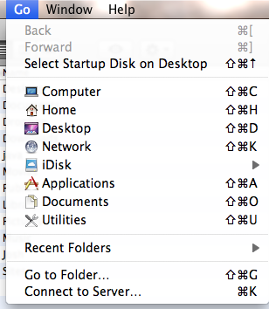

2-Type in address: 10.0.10.52 and connect

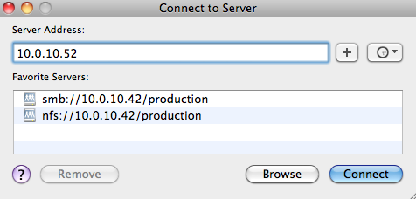

3-Enter user name: appleusers and password: pd360.

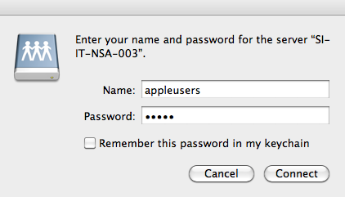

Note, the RAID may also be visible in the Finder window under “shared,” or “devices” as SI-IT-NSA-003. In that case, you simply click and will be prompted for a name and password. By clicking “remember this password in my keychain,” you should not have to enter the name and password again, when accessing the RAID.

1.8.2 Accessing The Editing RAID [or Fast RAID] “ARC Storage”

Each editor’s computer and a few others have a 10GB Ethernet card installed for access to another RAID that allows them to edit directly from that storage, rather than downloading footage to a local drive. Generally this RAID is on it’s own network and not accessible from any other computers. If you find that you do have access, you will only have standard speed access to that RAID without the special card and drivers. Only editing footage and current video assets should be on this RAID. Do not place any other things [scripts, non edit video, pictures, etc.] on this RAID.

1.8.3 Clarizen Project Management Software

Clarizen is project management software we use to track projects through the process. If your position needs to use the software you will have the opportunity to train. They have extensive online training as well as our expert users here.

1.8.4 SharePoint Data Management Software

SharePoint is our data management software. All the information regarding master files, hard drives, final cut projects, and footage in stored on SharePoint lists. You can access SharePoint the various ways below. The thing to remember is that datasheet view is only available within Internet Explorer.

Remote Desktop Access

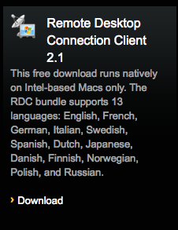<http://www.microsoft.com/mac/remote-desktop-client>

The address is: 10.0.10.254

Open Web browser using Internet Explorer

<http://intraweb.schoolimprovement.com/>

Login and password: Same as email

Web Browser access:

<http://intraweb.schoolimprovement.com/>

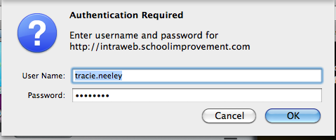

Login and password: Same as email

No Datasheet access

VPN access from offsite:

[https://vpn1.schoolimprovement.com](https://vpn1.schoolimprovement.com/)

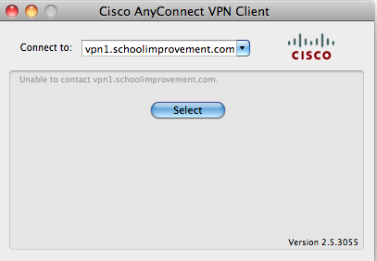

Downloand the vpn and install on computer. Once done go to remote desktop and open web browser using Internet Explorer.

<http://intraweb.schoolimprovement.com/>

The address is: 10.0.10.254

Login and password: Same as email

1.8.5 Currently Used Software

Currently we use Final Cut Pro 7 for editing. We will be moving to Adobe Premiere, as we need to. The advantage of FCP 7 is everyone knows it very well and has long established workflows based on it. The disadvantage is that with the last upgrade and new version, Apple completely rewrote the program rendering much of that experience useless. Although some 3rd party software is now available, FCP X remains such a different product that our editor’s trial use of it holds no appeal.

We already own the Adobe Creative Suite, so we already have Premiere in our machines. It has several advantages at the moment over FCP 7, the drawback being few editors know it well enough to be as productive with it, so we will migrate as it fits into our overall productivity needs. There frankly are a few workflow issues still to work out with adobe as well, but it’s integration with the rest of the suite is it’s strongest plus.

We use Photoshop, After Effects, Illustrator, LightWave 3D, Carara 3D and other software as needed.

We encode using Sorenson Squeeze, and have done extensive testing with bit rate, frame size and compression settings to use what we use. Our current playback technology also has limitations we must address when encoding.

1.8.6 SINET and Department Terms and Lingo

A

**ASCD**

A national educational organization that is big in teacher training, as well as promoting, lobbying, and influencing educational policy in the US. They are a competitor in some areas, but we have been supportive of their organization since the start.

**Anamorphic format:**

Is a term normally used for: the [cinematography](http://en.wikipedia.org/wiki/Cinematography" \o "Cinematography) technique of shooting a [widescreen](http://en.wikipedia.org/wiki/Widescreen" \o "Widescreen) picture on standard [35 mm film](http://en.wikipedia.org/wiki/35_mm_film" \o "35 mm film) or other visual recording media with a non-widescreen native [aspect ratio](http://en.wikipedia.org/wiki/Aspect_ratio_%28image%29" \o "Aspect ratio (image)); or the projection format in which a distorted image is 'stretched' by an anamorphic projection lens to recreate the original aspect ratio on the viewing screen. (It should not be confused with [anamorphic widescreen](http://en.wikipedia.org/wiki/Anamorphic_widescreen" \o "Anamorphic widescreen), a different video encoding concept that uses similar principles but different means.) The word "[anamorphic](http://en.wikipedia.org/wiki/Anamorphosis" \o "Anamorphosis)" and its derivatives stem from the Greek words meaning *formed again*.

**Anamorphic widescreen**, when applied to DVD manufacture, is a video process that horizontally squeezes a [widescreen](http://en.wikipedia.org/wiki/Widescreen" \o "Widescreen) image so that it can be stored in a standard [4:3](http://en.wikipedia.org/wiki/4:3" \o "4:3) [aspect ratio](http://en.wikipedia.org/wiki/Aspect_ratio_%28image%29" \o "Aspect ratio (image)) DVD image frame. Compatible playback equipment can then re-expand the horizontal dimension to show the original widescreen image.

B

**Bcam:**

We shoot most productions with two cameras, one labeled “A,” one “B” hence, Bcam footage.

**B-roll:**

B-roll is footage we use to cut away from the main action. Also referred to as *overroll*.

The term comes from the time when film editors would cut the project in order [back to back phyical edits] and when they needed to transition to another shot or “cut away” from the “A” roll, they would create a second film reel synced in time to the “A” roll, or primary footage, called the “B” roll. Literally a roll of film on a reel. When printed out for the movie screen, or projected out for a TV show, the two rolls would be mounted on 2 projectors and played back together. So if the first cut away was 5 minutes in, the b-roll would have 5 minutes of blank film [or leader] and when the operator saw the image pop up on the b projector, would make a transition to the b-roll. The a-roll would be blank film until it was time for a transition back, and the projectionist would transition back to the a-roll when the image appeared.

**Betacam:**

Betacam, Betacam SP, Digital Betacam, are all formats once used by SINET for shooting and editing programs. All of the VJE masters are on Digital Betacam, with the exception of the first 3 years, which were mastered on Betacam SP. Simular technology but not the same as the BetaMax home video format that lost out to VHS, Betacam tape runs much faster allowing more space per frame and therefore for information and higher quality image. It was the de-facto format for news and documentary work for the broadcast networks for 20 years.

C

**CCSSO: Chief Council of State School Officers.**

It is a national group under the National Governors Association of state leaders in education and are responsible for creating the Common Core State Standard Imitative and the InTasc teacher standards.

Common Core State Standards Initiative (The Common Core)

The Common Core State Standards provide a consistent, clear understanding of what students are expected to learn, so teachers and parents know what they need to do to help them. The standards are designed to be robust and relevant to the real world, reflecting the knowledge and skills that our young people need for success in college and careers. With American students fully prepared for the future, our communities will be best positioned to compete successfully in the global economy.

Common Core 360:

A new product to be delivered or the PD 360 Platform. This product is meant to help educators understand and implement the new national common core standards that are being adapted across the country.

Compliance Videos:

Schools have to deal with a fair amount of non-education stuff like Internet safety and workplace issues. The compliance series addresses many of these needs from harassment to cyber-bullying.

Corwin Press:

An educational publishing house that has partnered with SINET in creating Premium Courses. Curtis Linton’s books have also been published by them.

**Courageous Conversations About Race:**

*Courageous Conversations About Race: A Field Guide for Achieving Equity in Schools*

The title of a book Glenn Singleton co-authored with Curtis Linton, SINET, Executive VP of Content in 2005. SINET has supported their yearly conference [CC Summit] since then. We have an online course that covers the first trainings in their basic Courageous Conversations Workshop, as well as a program done in the 2003 about Glen’s work.

**Courageous Conversation Summit:**

See courageous Conversations about Race. A yearly conference we usually contribute video programs to.

**Color Correction:**

See “Grading”

**Cut:**

When one picture changes immediately to another without any effect in between, such as a dissolve or fade.

**Cutaway:**

See B-roll. A term probably used more for a reverse shot of the interviewer when listening to the interviewee.

D

Delivery:

The process of gathering all of the needed assets and encoding and releasing product on PD 360.

**Data:**

As relates to education could be the results of any test, including SAT, ACT, or unit tests. Also relates to the demographics of a school. Data would give you the percentage of students of color, of free or reduced lunch, or graduation rates.

E

Equity in Education:

Equity is a multifaceted subject in education, but an equitable school gives each student what they need to learn and succeed. It is not giving all students the same thing, because all students are different . . . it is making sure each as what they need to learn. That covers a broad number of issues from equal access to technology, to recognizing the various cultures in your classroom, to giving each student the time to reach mastery. The conversation is generally around student populations that have traditionally been under served, or ill served in a traditional school. Equitable schools will seek many ways to make sure all students succeed and learn.

Equity 360: (Equity 101)

A series on PD 360, including Curtis Linton’s work in school equity and showing best practices in equitable schools across the country.

F

**Frame size:**

Video frames are made up of lines of pixels. Standard Definition Frame sizes are 720 x 486 [D1 NTSC broadcast], and 720 x 480 [DV video] these frames are roughly a 4x3 ratio. Both also have widescreen versions, or 16 x 9 ratios, using anamorphic techniques, but the frame size remains the same.

High Definition frame size is 1920 x 1080, with a 16 x 9 ratio. [16 units across by 9 units up and down] So, as in standard definition the frame is made up of “lines” in HD’s case, 1,920 lines, each containing 1,080 pixels for a total of 2,073,600 pixels for each frame. [SD = 349,920]. So HD is almost 10x as many pixels as SD, with the result being a much better image. Since HD is a much newer standard, as technology rushed forward to HD, there were many variants created. Since all of the frames sizes about to be mentioned are higher than SD, all at one time or another were considered HD. Other common frame sizes are 960 x 720 [Panasonic format that uses a digital anamorphic process to stretch the frame size to 1280 x 720], 1280 x 720, 1440 x 1080, the 1440 x 1080 is a SONY/Canon format that uses a digital anamorphic process to stretch the frame size to 1920 x 1080.

**Frame Rate:**

Currently we shoot our video at 24 frames per second [fps]. This has been the common rate for film since the 1930’s and was based on early motion studies that determined how many frames per second the human eye needed to see to create smooth motion, which I believe was about 12 fps. Traditionally video is shot at 29.97 frames per second, which the industry rounds up to 30 fps. This odd number is created by the math used to attach a color picture to a radio wave, which is what broadcast, over-the-air television is.

For us a lower frame rate creates smaller render files, and smaller graphic render files, and because frames per second equals the amount of data being pushed through the computer per second, it allows faster processing as well. With video being much less attached to broadcasting these days, many other frame rates are available. In a project edited at 24 fps, any footage shot at a higher frame rate will appear slowed down. So video shot at 48 fps, will be 50% slower when played back. Footage shot at a lower frame rate will playback faster than real time . . . use for “time lapse” effects.

G

**Grading:**

Also called color correction, where the picture attributes can be adjusted to enhance the image. Whites, blacks, and midrange levels can all be adjusted as well as saturation of color and hue.

H

**High Definition (HD):**

The term used for video that has more lines of resolution than standard definition video, which is the type of video in use since the creation of video. The original specs for HD were 1920 x 1080, at a 16 x 9 ratio. Due to the challenges of getting form SD to HD, there are several other specs also considered HD. (*see frame size/rates*)

I

**Inter-rator-Reliability:**

Lawmakers all across the country have started to mandate that all teachers be evaluated. Since teaching is both art and science, a system needs to be developed that can provide consistent, unbiased, ratings of teacher effectiveness. Inter-rator reliability is a project created to solve that problem. The editing staff has been editing many classrooms that are then shown to a panel of educators to try and develop common language and consistent characteristics in evaluating teachers.

J

K

L

Legacy Segments:

SINET started as the Video Journal of Education, and the Legacy programs, which make up a majority of the current content, are the 16 years of programs that the video journal of education did.

Learning 360 Framework:

Series created by SINET that brings together the best research-based practices for classroom learning. Created by largely by Steve Olsen, a long time contributor to SINET and Blanch Linton, founder of VJE/SINET.

**John Linton:**

Co-founder of the Video Journal of Education/SINET and Linton Productions.

**Blanch Linton:**

Sr. Vice President of School Improvement Network, Co-founder of the Video Journal of Education/SINET and Linton Productions.

**Chet Linton:**

President and CEO of School Improvement Network, Co-founder of the Video Journal of Education/SINET.

**Hollee Linton:**

Daughter of John and Blanch Linton, has been involved in the company from the start. She has proofed all of the Video Journal programs, as well various other quality control projects for production, marketing and sales.

**Core Linton:**

Executive VP Operations, School Improvement Network. Corey graduated from BYU and then Columbia University in New York with an MBA, and worked for over 10 years for Microsoft in their small business division. He worked directly at times with Bill Gates including writing speeches for him from time to time.

**Curtis Linton:**

Executive VP Product Development, School Improvement Network. See bio under Team leaders bio.

**Trent Linton:**

Director of Client Services, School Improvement Network. Trent is the youngest of the Linton family and graduated from the University of Utah and spent nearly 10 years in the Marines including 2 tours in Iraq. He was a logistics specialist charged with training the Iraqi forces how to do logistics for their armed forces.

**The Learning Channel:**

Online educational videos for free. Funded largely so far by the Bill and Melinda Gates Foundation.

Learning Forward/ NSDC:

This group - The National Staff Development Council, now called Learning Forward is a long time national leader in educator professional development. The Video Journal and now SINET have partnered together on many PD projects and recently we have been providing special video services for their national conferences.

**LumiBook** (LiveBook 360):

A new ebook product that extends the format by including collaboration and social media tools into a book. Also includes video and other interactive rich media inside the pages. Also available on mobile devices. Formally created as LiveBook until the name was not protectable due to a close name relationship with another companies unrelated product.

**LivePlanner:**

A companion product to LumiBook, where readers can actually customize and add their own content and learning assets to the planner. Mapping to the Core LiveBook and LivePlanner has been the only product so far to use the planner product.

M

Marketing Videos:

A type of program that promotes a series, product or service.

N

NAT Sound:

The naturally occurring sound from the footage.

O

Observation 360:

A tool educators can use to create observations on Android, iPads, or iPhones of teaching. I can then suggest which videos in PD 360 can be viewed to help the teacher learn better practices.

P

**Pacific Educational Group [PEG]:**

Glen Singleton’s education consulting company.

**PD 360:**

SINET’s flagship product. online professional development for educators. It has been both a ***product and platform***, meaning other products rely on PD 360 and work within PD 360

**Pieces:**

*Also see program, segments, and sections*. A term used to talk about a single segment, or a one-off stand alone video project.

**Premium Courses:**

In partnership with Corwin Press, these courses where created to help educators get further examples and instruction out of some of Corwin best selling authors, by creating a video-based course that supports the book, with the involvement of the author. Custom courses can also be developed by users and SINET has developed some very specialized courses for various clients.

**Promotional Videos:**

See marketing videos.

**Pre-production:**

*See The Standard School Improvement Network Production Cycle, section 2.2*

**Programs:**

*See related: segments, sections, and pieces.* Traditionally programs would mean, the entire collection of segments or pieces involved in a release i.e. The Program: “Job-Embedded Professional Development” includes the segments Definition of Job-Embedded PD, Approaches to Job-Embedded PD, On-demand tools, Benefits for Administrators, etc. At times we may slip and call a segment a program, but generally it means the collection of segments under a certain release.

**Production:**

Shooting in the field or studio. *See The Standard School Improvement Network Production Cycle, section 2.3*

**Post-production:**

Editing, graphics, audio and sound. *See The Standard School Improvement Network Production Cycle, section 2.3*

**Producers:**

This position produces the video products in the SINET stable. All producers travel and manage the process from beginning to end coordinating with Operations and Post-production.

Q

R

Rich Content:

Edited content that has a higher post-production value than non-rich content. Premium Courses, while still professionally done, were considered non-rich content. Not as much effort was given to graphics maybe, or variety of music. The end result is still professional and effective, but the same amount of time is not given to the project.

S

School Improvement Network:

Our company, also widely referred to as **SINET**. We started back in the early 90’s as The Video Journal of Education, or VJE.

**Sections:**

*See segments*

**Segment[s]**

The parts that make up a program.

Sound Bite, Interview, Vox Pop*:

On camera interview with expert of educator, often sit down in a classroom or office.

**Success to the Core:**

Online educational video for free. Funded by Microsoft co-founder, Paul Allen.

T

U

V

Viral Videos:

A type of program. The original purpose was to create videos for You Tube or even delivered via an email link that viewers would want to share and help it go “viral.”

VO:

Voice-over. Spoken by a narrator, scripted.

W

Writers:

Write scripts, we have in-house and freelance writers.

X

Y

Z

1.9 Where to Go With Ideas

All are encouraged to explore and offer new and better ways doing things, explaining things and subjects we cover. What we don’t want to do is reinvent the wheel for each new person. The purpose of this guide is to show that we have thought through many of the details of what we do. That being said, suggestions should go to the person connected with the type of idea you have, content to Lisa, style to John, operations to Michelle.

1.10 Where to Go With Questions/Problems

General rule of thumb would be to follow the responsibilities as outlined. In some cases, such as delivery of content Tracie Neeley would have answers. File video would fall under Jeannie Workman. Dealing with media issues such as transcriptions, archives, back ups might be Devon. We ask you not to guess unless absolutely needed. Of course editors would understand editing questions, producers, producer questions and writers, writer questions. There is an excellent chance Michelle Fisher or John Crossman can answer your questions.

2. The Standard School Improvement Production Cycle

2.1 Content Decision-making Process

Client requests [25%] is made up of their Mission Critical Needs, or MCN’s. These are gathered by the sales team and the customer implementation team, [CIS], in the customer Success department.

Client Usage [25%] is generated from the PD 360 platform.

Field Research [50%] is Policy and Political Context , District Improvement Plans, Education Journals, Student Achievement Data, Teacher Effectiveness Data. So research tells us that a persistent problem looking at national data is an achievement gap between white students and students of color. That drives us to find those places that have overcome these issues with the same population of students, who would lead us to a location to shoot content for our programs.

2.2 The Production Cycle

The production cycle is typical of traditional video production cycle although currently our producers manage this cycle where you might find in other places producers writing or even shooting pieces of the content.

A brief overview of the cycle once a project has been generated by the research/content team.

3. Style Guides for School Improvement Network Video Programs

3.1 General Video Style Guide

The Philosophy and Attitude behind what we do.

The standards that School Improvement Network’s video library has been built on for more than 20 years come from broadcast television. To be more specific, the standards are derived from broadcast news and documentary styles found in professional broadcasting. Style and abilities continue to evolve as the technology does but the goal remains the same.

The goal is to present to our “viewer” a professional looking, easy to understand, visually engaging videos that will help them understand the concepts being taught and be able to implement those practices into their own work. We also want the viewer to realize that these are real teachers, real classrooms and as such we don’t control the class, we document the lesson, bumpy shots and all.

While we shoot classrooms full of kids, our presentations should not be “child-like,” the use of graphics and fonts should reflect the professionalism of the work, not the cuteness of the children – unless we are trying to recreate student work.

We achieve this goal by careful consideration of all elements that go into the finished video.

**Video**

Our video is shot in HD. In the past SD video was always shot on broadcast cameras starting on Betacam in the 90’s and moving to DVCPro50, when the format came out. Until you have had the opportunity to shoot in the field under the conditions that we generally shoot in classrooms it can be hard to appreciate the effort our videographers go through to get the footage.

The conditions vary from outside in bright sunlight in Hawaii, to dimly lit trailers that are a step above a mine. Some classrooms have room to move easily around in, some, are packed like sardines in a can.

In a typical classroom, we have had the “A” camera on a tripod covering the teacher and the “B” camera providing shots of student responses and general b-roll of the classroom handheld.

The result of these circumstances is our video is shot in a documentary style, meaning we shoot what happens in front of us. Classrooms are not staged, although occasionally we will ask a student to re-state their answer, if the producer or cameraperson thinks it’s important. That’s why the B camera is pivotal in being ready to get the responses. If the lesson is at a point where there will be interaction between the teacher and student, the cameraperson should not be tight on faces, or they will never be able to capture the answers . . . they won’t even know who is talking. Of course as an editor you can’t go back and reshoot, as much as we would like to.

Given these conditions, sometimes the video can appear rough, or rougher than you would see on a commercial or PBS show. We expect the viewer to realize we are capturing things as they happen, and these “rough edges” can help the viewer understand that this is real. There is a line, and that’s when there is no payoff for the rough footage . . . meaning, if a student is giving a long answer and we have to use the camera zooming in and focusing – that *might* be ok. If the B camera never gets there, then we probably wouldn’t use it . . . although some times we might – if it makes sense, if we think the viewer will easily realize that this was the person just speaking. This is a case where the editor must use their judgment, as a viewer of the video, and less as the editor looking for the perfect shot.

**Natural Sound**

Natural sound takes the viewer into the classroom. Our viewers live in a classroom every day and they know what it sounds like. To some degree they are used to the incomplete answers a student may give, or the fact that some answers are very quiet. As hard as the camera work is, the sound I think is harder. We usually shoot with a sound person and they have a boom that is fed to camera B, if not both cameras. [This depends on the number of teachers and other mics needed at the time]. The camera can zoom in from across the room and get a student response . . . the sound boom has to be there . . . and that presents a number of logistical, time continuum and laws of physics challenges when the Q and A is happening quickly.

We use natural sound whenever possible, and its use has several outcomes.

First would be a response to a teacher question, second would be the sound of students working, achieving the assignment in front of them, third would be as a pacing device between two other pieces of sound, if there are teacher interviews, classroom instruction, or something else, natural sound is extremely useful for telling the story, creating an audio break that “Cleanses the audio pallet,” readying the viewer/listener for the next section of information, and also filling out, or supporting the story. Perhaps the writer isn’t aware of the natural sound in the classroom that would show case some facet of the information . . . the editor can bring that out and strengthen the impact of the point being made.

**Narration**

In many of our programs it is useful to have narration to help move the story along as well as cover information in a more concise way that perhaps we have on camera. Narration is used to set the scene, or background to the points we are trying to convey. Narration serves as a voice of authority in delivering research, lists of things, stages of a process, or bridging statements that can get us from A to B quickly.

We tend to use narrators with news backgrounds as they are professional and are used to delivering information in a friendly and serious way. Radio announcers have nice voices but tend to be more dramatic in their delivery and that often adds too much drama to the script. News people also generally have a style pretty well nailed down, whereas an actor or commercial voice is used to doing a wide range of styles and can be harder to get a consistent read from.

**Graphics and Effects**

As stated in the beginning of this document, our standards are based on network news and documentary broadcasting standards, as such, the use of effects and graphics should follow in the taste of those standards. When these items start looking and feeling more like a car commercial than a newscast, we are veering off the path.

That being said, I feel that there is a world of options as to how information is presented in graphics and how pacing can be effective with effects. When building or using effects ask yourself if you would see it on ABC, NBC, FOX, or CBS.

While FOX has taken broadcast graphics to a new level, they always serve to inform the viewer and make whatever point they are making clearer. While a video geek might say “Cool Effect . . . [dude],” the viewer just understands what they are trying to say and the effect or graphic is congruent with the message . . . “scary,” “mysterious,” “tons-of-fun,” etc.

As with every other element, the purpose is to convey the information in creative, professional, and clear way.

**Music**

Music for every piece that was done for the video journal for the first 17 years started with the music.

I don’t mean the first thing your heard was music, although it probably was, I mean the music drove the editing vision.

In the early days John Linton picked the music, and the music he choose was always in alignment with the message of the video at the time it was used.

For the opens he used music that “sounded like” an open. He did like orchestral openings because the music sounded important [which teaching is], uplifting, motivating [which teaching can be], and with the music setting the feel, the way I edited followed . . . the music sounded like steadicam shots [which we didn’t really have], so I found shots and created steadicam feels as much as I could with the technology of the day. It was emotional, so I looked for or created emotional shots [catching glances, hands raising, using slo-mo].

Inside the piece he might change it up either through tempo, or instrumentation. When the music changed, the editing would change with it. Changing the music without changing the editing style completely dilutes the power of the music. In the open with soring strings and horns the transitions would be longer dissolves or some longer type of transition. When the music changed to a more upbeat, or punchy style, the edits would be cuts, sometimes very quick cuts, eventually smoothing back down to classroom scenes and continuing the video.

In the effective use of music, in both choosing the correct music, and editing to that music, lies the key to powerful video editing.

I cannot stress enough the role music plays in effective messaging. With the scripts we are getting, there won’t be music cues, there probably won’t be cues between different thoughts, *so it is up to us to recognize where music should go*, what it sounds like, and where it changes.

As a carryover from news and documentary work, music usually, or traditionally has faded out under sound bites. When the narration is reintroduced the music comes back. When it comes back it should be placed so that the downbeat comes in-between the previous shot and the new shot . . . in other words, the transition should be in the beat, support the beat and USE the beat to bring notice to the view that we are transitioning.

When changing music, it makes sense to start with the beginning of the music. If the music is so “fuzzy” as to not have a solid beginning, then you should ask yourself why are you picking that music. Music that has a long nebulous beginning generates nebulous thoughts . . . is that really the message? Much of our music will have similar characteristics, but in over 20 years we have never run out of musical ways to represent the messages we are telling.

Ideally, you should like the music you are using—even though I wouldn’t fill my iPod with most of the music I use—because again, if you don’t like the music, if it’s just wall paper, if it’s just something you are checking off, that is how your edit will look. The more you edit, the more of a challenge it might be to find music that fills the multiple needs that music must fill, but it has been done before and you are expected to do the same. It is too important to short change. We have an extensive music library and it grows all the time. At present it includes most of the Digital Juice music libraries, Narrator tracks, Music Bakery, Studio Cutz, Air Force, Davenport, and others. We also get a lot of music off of iStock.com and have 100’s of cuts from them. We also have a resident composer who is extremely talented in composition and is a great resource.

**The Editing Weave**

What we should be doing. We don’t control the video shoot, we don’t write the music, we don’t write the script . . . we don’t even get to record the sound usually, but what we do is WEAVE IT ALL TOGETHER!

Putting all of these elements together in an interesting and compelling manner. We are all at different stages in our ability and knowledge, but we all have the experience and talent to do what needs to be done. Not every piece is a marketing piece, but I’m not talking about eye candy, I’m talking about taking all of the parts we are given and making them add up to more than they would without your talent. The sum of the parts has to be greater than the whole.

Techniques to add to your working style:

1. Review your work often.
2. Go back to the beginning of a paragraph and watch it all again.
3. Go back to the beginning of the segment and watch the whole segment from time to time… do you enjoy it? Are you proud of it? Does it keep your interest? Can you follow it? If any of the answers is no, then it’s your job to fix it! What would make it better? As another editor, ask me.
4. Work to a “finish level” ***as you work***. Music cues, audio balance, correct tracks, color correction, etc. If the segment you are working on needed to be aired in five minutes, would you be happy with it? You will need to do this eventually, so why not do it now? The only way to see how it will look and feel at the end is to work to that level. Now if you want to wait until you ready for review to color correct because you don’t want to render constantly that’s a valid consideration, but before I see it I want it the way you would expect it to look to the viewer.

**Approaching the Edit As a Viewer**

With the software we use today, it is very easy to build your segments somewhat randomly, or very randomly . . . I find myself doing that as well from time to time, but your viewer will see it linearly . . . from beginning to end and one cut after another. So if you as the editor really build it randomly, you must also make sure it passes the linear viewing test. Are the points the script wants to make clearly identified? Is there a way you could make it clearer? With music or graphics? Or could you use a certain effect? Does the writer need to go back and create a tag or hook you can go back to, to place the viewer’s mind back in alignment with the whole concept? As we all gain experience, the team will get better and better at this.

John Linton, founder of the Video Journal of Education – now SINET, used to spend a lot of time trying to visualize a concept – even to the point at times – of making real 3D models . . . and shooting them to help the viewer understand the relationships between ideas. Is it a circle or sphere or pyramid or an eight-sided cube, or a park bench? How can we visually connect the dots for the viewer? What are the words the writer uses to describe the main idea? The graphic needs to very clear when used . . . it should enhance the narration and not introduce items that are incongruent.

In Common Core, we should think about always showing where we are in the grid of the CC map . . . today we are talking about/showing4th grade math 4.1.2. Maybe we should spend a quick moment placing the viewer into where it all fits in. Yes they should know that already, but why not help them out? Not a lot of time, just enough so they are ready when we hit the meat of the program.

It is easy when writing to get caught up in the flow of writing and forget to use “elements” [i.e. graphics, music cues, etc.] to link the viewer back to the Main Idea. We are more than editors, we are visual producers . . . we help all of the elements come together in the best way possible.

The goal for the editors is to build a trust and even reliance on our ability to be the polish for our work. To not just fill in the holes, or to follow the script line by line, shot by shot – if you happened to have a script with shots! We are responsible for making everyone else look as good as possible. We are story tellers as well, and to that end, even though the video is shot, making the most effective use of the footage is OUR job . . . if the script needs to be tweaked . . . discuss with the writer – of course you have to have a reason why as well.

Don’t let things “go” that you don’t think are working well . . . I think for those who have worked with me know that when I hear narration that doesn’t flow, I speak up.

We recently edited a series on Student-Centered Learning and part of that concept is that teacher’s roles change from the “Sage on the stage,” the expert who has all the answers, to more of a facilitator of learning . . . where they help the students create their own learning. As I was reading the script and following the narration, that concept is introduced . . . OK, I get it. Sometime later the narration stopped referencing teachers, and was calling them facilitators all the time. So I gave alternate reads because if I were a teacher/facilitator, I still consider myself a teacher – even if my role has changed . . . my techniques will have changed, and yes I might be actually more of a facilitator . . . but I am still a teacher. A small difference? Semantics? Maybe, yet, as THE VIEWER, I could see getting pretty upset [and therefore not able to learn], if some video tells me I am no longer a teacher . . . but a lawn jockey telling kids what URL they will find information at. And in truth, the teacher/facilitator still needs the skillset of a teacher, knowing learning styles, understanding the order of learning and more . . . so all of that goes into the decision to give Michelle alternative cuts. Ben may decide that it should be kept the way it was written, and that is his decision in the end, but that was the thought process behind a simple narration change.

Is the writer wrong? Is the writer stupid? No, not in the least, but they are tied up in their process . . . and for one word may not have been aware of a possible sensitivity there could be. In the end, they may decide to keep the original wording, and if that’s the decision, that’s OK, I just wanted there to be an awareness of a possible problem. It was a common occurrence to make changes in the narration in both working and sometimes intension, when we realized that as it was being narrated it wasn’t coming across as intended when written. Even though John took pains to speak his writing . . . sometimes changes would be made and it hadn’t been fully read when the narrator showed up. The idea is to get the best result.

That’s what we all must do. As the people who touch the project last, it is our responsibility to deliver the clearest, most effective, and engaging video project possible.

It’s important that we are fully engaged with our projects. I’m not asking or expecting editors to do other team members jobs, but we have the opportunity to make the final message the best it can be.

This is part of Kuleana, each of us taking responsibility for what our content development community creates both in our function and in helping those around us.

I expect that eventually each review of a piece will be a celebration review, that you are proud and happy to show the great work that has been weaved together by you.

The following sections should reflect these aforementioned qualities with the additional information for each type of program.

3.2 General Writing Style Guide

Writing is hard work. Writing well is even harder. As a writer at School Improvement Network, you are often charged with taking a multi-faceted concept and laying it out for our audience simply and directly.

The writing style evident in video pieces produced by School Improvement Network is based on the news documentary style of who, what, when, where, why, and how. This time-tested method sets up our viewers by quickly and fully informing them about **who** is being featured, **where** they are, **what** they teach, what the video topic is, **why** it’s important, and **how** it will be demonstrated. These elements are necessary for viewers to understand and apply the concepts effectively.

Our writing style is also founded on the language of education. As in all fields, education has developed “jargon” terms and phrases. Examples include the following: project-based learning, RTI (Response to Intervention), formative and summative assessment, Bloom’s taxonomy, curriculum mapping, and equity. The choice to call what we might have grown up thinking of as a “test” an “assessment” lets viewers know that we participate meaningfully in dialogues about education. If you have an education background, you have a leg up; if you don’t, then it’s important to develop fluency in the language of education.

In addition to that, many pieces start with a broad philosophical message to set the context, reason, and tone for the program. In our current production, these would tend to be PD 360 or 100% videos, where we are basically choosing a topic and devoting a series of segments to the various elements of that topic, such as:

Segment 1: Introduction to topic, research, practice, success, challenges

Segment 2: Meet the educators who are doing it

Segment 3: See it in action in the classroom 1

Segment 4: See it in action 2

Segment 5: Explore how admin/district/PLC/community can support the practice

Segment 6: Determine how to implement it at your school/classroom/district

It can be powerful to begin each segment by reconnecting with an important overarching theme or message from the program. This doesn’t have to be a full restatement, although that can work, if it doesn’t get redundant. The aim is for viewers to say, “Oh yes, I remember now where we left off.” We should remember that because the videos are in segments, which means that most viewers won’t watch all the segments in a program consecutively within a day or two. It might be a month between segment 1 and segment 2, so a little refreshing is a good idea . . . balanced, however, with the chance that a viewer may watch several segments back to back.

Following the news/documentary style, we let the experts and/or subjects carry the elements of the story or information.

That being said, many times narration can be used to lay out the main ideas in a program, especially to explain a concept or circumstance or lesson transition more concisely and clearly than how the expert/subject might say it.

Writing can tie ideas together or act as bridges between ideas. If we are showing the “6 Keys” to classroom management, the writing can bring us back to what we just covered before setting us off on the next idea.

Very often, a graphic should be tied to that main idea. Is there a way to build a graphic that supports the main idea, so we hit audio and visual cues for the viewer? Many times John Linton would create a 3D model concept of the research. A model can be a 3D or 2D representation of the concept: for example, is it like a ship at sea? A fast-moving train? A pyramid, a cube with related elements on each side, yet single complete ideas as well? A cycle, a circle, a tree, a house, a school, a horse, a race car, a triangle, a sphere . . . you get the idea. Generally, the simpler the model the easier it is to create and follow. A list can also be an organizing graphic model. This gives the viewer a visual hook to help keep ideas organized.

Very often, at the end of the piece, we would have a wrap-up narration, tying all we have learned back together with the overall concept . . .why are we here?, Why do we teach? How can we improve? What success will we and our students experience from doing this work? Segments can also use this convention, briefly touching on the main ideas of the preceding segment in the program and telling viewers what they will see in the next segment.

A writer’s job is to guide viewers through the material so they see the importance of the content and can get ideas of not only how these educators applied it but how they can as well.

You will find templates for the various types of writing you will be required to do. These will be covered in section 5, Production Cycle Processes: Writers.

As you write for each type of production, keep in mind this philosophy and approach to writing outlined here. As Vice President of Media Development, my desire is that each of us reflects on our own work and try to add value to our viewers every day. Templates, deadlines, procedures are all good and all needed, but at the end of the process we are people communicating to other people. Any chance to touch another’s thoughts, practice, and humanity should be leveraged.

3.3 General PD 360 Style Guide

A dedicated six sec open is created for each series, such as “Practical PD.” These opens are refreshed as needed. These are generally scripted projects and can use narration for exposition and to hit critical ideas. Usually these programs have between two to 10 segments with the normal being around five. Current series in PD 360 are Equity and Innovation, Practical PD, 100%, Innovation Lab Network.

3.3 Common Core Segments

Common Core, non-classroom segments are similar to PD 360 segments with CC branding. A scripted, often narration driven project and usually having multiple segments with in a series. Also normally would have a six second open for the series.

3.4 Common Core in the Classroom

These segments feature teachers teaching to a common core standard. Other than a three second opening brand, there is no open. We title over classroom footage and natural sound so the viewer feels like they are already in the class.

3.5 Whole Classrooms Edits

The edit should start as soon as the class begins, or as soon as you have stable footage to start with. This will normally be an A/B camera edit that will roll out with cutting between the two cameras as feels natural to the viewer. Times to cut would include, when the other camera is covering the action happening in the classroom, i.e., teachers’ instruction, or student responses. Also, to give a visual break in the program. Hopefully if the teacher is in a long modeling segment or explanation of the content covered in the class, the b-camera is getting cover shots that include the teacher. Cutting just to show kids staring off into space while the teacher talks, should be limited. Remember that while the student reactions are certainly a valid classroom element, our viewers are teachers or administrators who are really looking to see the teacher teaching. B-camera shooters should be coached to shoot shots that include the teacher in the background in these types of shoots. These give the cutaways a relationship to the action.

Places to condense time would be if the students are quietly working on their own, or if the teacher has given them 45 seconds to write down an idea . . . we don’t have to hang on for 45 seconds unless the action dictates it. If a camera is following the teacher around the room checking responses, we would probably use that – that is action teacher would want to see. If the teacher is standing at the front of the class waiting for students to burn through the 45 seconds, a couple of cutaways to show the action would be enough.

Other times to condense time would be to cut out times when neither camera has a shot . . . this of course is common sense, which we all have. We cannot possibly include all exceptions to these guidelines. You are always expected to use your judgment. As you get more familiar with editing classrooms, this gets easier, just remember that our viewers are teachers, they really are interested in watching some one else’s classroom.

Your first edit should be the entire classroom, don’t worry about hitting a specific time. Once the entire classroom is cut, the audio tracks have been properly edited; a producer and/or content/writer can review the edit.

The goal should be for every editor to be able to make quality suggestions on what to cut out, but until you feel comfortable with these decisions, please consult the above persons.

3.6 Whole Classroom Edits With Commentary

These can be done when the production team has captured the teacher, or the teacher with a coach, or another combination of observers to the class, reviewing the class and commenting as they watch.

There are several different ways this has played out to this point. One is having the teacher watch and comment on their classroom. Some times the producer has had a teacher watch say five minutes, and the pause and speak to what they saw. Continuing with the alternate viewing and pausing or comments as long as they can. Many times, we have run out of time shooting this way.

Second, they can watch and comment at the same time. Crews have synced time code so the editor can match the commentary with the actual shot footage of the classroom. Many times their comments can run long and actually run over other important action in the classroom.

Thirdly, they can just talk about the classroom with out watching it all. I would say this is the least preferred method, but some times there just isn’t time.

When classrooms with commentary are edited, the commentators should appear in a small box, Picture in Picture type of effect from time to time. This can be a decent size, remembering you have to be able to see they are people on the smallest viewer. Once they have been established, the video box can fade off. Depending on the time since their last comment, they may need to reappear at the start of their next comment. Use your judgment, but I would suggest if they have not commented in 60 seconds or longer, they should reappear for a short time. If you have not shown them in two or three minutes, even if they have been continuously commenting, bring them back to establish them again for a moment. If their comments are long winded and they continue speaking well after the specific action that caused the comment, it is suggested to bring them full screen and basically “pause” the classroom action until they are done.

The overall idea is to let the classroom action and audio breathe during this edit, in other words, the commentary doesn’t have to be continuous. The natural sound of the class should come up . . . let the viewer see and hear whatever the action was that causes the comment. If the commentary is running on with out a break, find a spot to let it breathe and give the viewer a break. If you think it is redundant, or confusing, or unnecessary, talk to the writer/content person working with you, or the producer. If none of those are available ask John, or another editor for their advice.

The value of the commentary is tied to hearing the classroom action . . . the classroom can not just be over roll for a commentary, you need to be able to understand what is going on in the classroom as well. Stumbles, searching for words, restarting thoughts several times should all be edited out . . . and the time given back to the classroom.

The commentary edit should truly be a weave, this may be the only time a viewer sees the classroom, they should get a decent feel for the class as well as hear the commentary.

The commentary edit can be very useful if we approach it this way. It is more editing work, and you do have to pay attention to the class and the commentary . . . it is not a mindless edit where you just “lay stuff in”. The better you can hone the edit, the more effective it’ll be for the teacher watching it.

3.7 Success Stories

Success stories, some times called “virals” as in we want this video to go “viral” on You Tube, are music, graphic and interview driven. Narration is not used and interviews along with music and simple graphics are used to tell the story arc of whatever the subject is. Motivational for the viewer, it is important to hone it down into a powerful message, like “Teacher’s Care”, or “Building the future one student at a time” . . . these types of messages.

3.8 Marketing Videos and Special Projects

Marketing and special project videos still maintain the standards at all times while really having the potential to be more creative. Music, graphics and visual effects are used effectively and excitingly communicate the messages.

4. Production Cycle Processes: Producers

Once the content selection team has selected the content we will produce next, a Project Start Form will be created with the overview, research-base, Distinguishers, Replication

Measure, Impact/Results, Evidence, and references and resources fields filled out. The producer will then start their pre-production by continuing to fill out the form.

Director of Content Development works with the producer in assigning resources, developing a schedule and final delivery deadlines.

VP of Media Development works with the producer as a resource in planning crew needs, approaches to the creative and technical aspects of the production and making sure we get what we need to in the field.

During production, the Producer is responsible for the creation and time management of all things related to production. In post-production, the Producer is responsible for managing expectations, deadlines, team members time and talent as well as contribute to the betterment of a project. It is the sole responsibility of the Producer to keep all external crew and internal team members on task, the production on schedule and within budget.

4.1 Pre-production

4.1.1 Finance

Most charges associated with in-field production are covered by the Producer and reimbursed by School Improvement Network. General exceptions include airfare and car rental. General charges may include tips, parking fees, hotels, incidentals, and meals. It is recommended, but not required, that you have a credit card that may be used for SINET expenses. Special arrangements may be made between the VP of Content Development and the Producer in which prepayments may occur for large charges associated with a production and its crew.

4.1.2 Travel

Travel is a large portion of a SINET Producer’s job description. You will be expected to travel as much as a project requires and as assigned by the VP of Media Development and/or the Director of Content Development. This may be in the area of 25-35 separate production trips a year. You will also be expected to join other producer’s productions as a crew member, for professional development, or as a substitute for the priority producer.

Travel should be scheduled as early as possible, preferably 3-5 weeks in advance. We try to keep travel days to a minimum since it takes people off-site from in-house responsibilities. There are company travel policies we need to adhere to as well, and those should have been given to you in orientation.

**Expense Tracking/Travel Agency**: School Improvement Network uses Concur expense and travel software to track expenses and travel. You will be assigned an account and training by accounting on Concur. While it has the ability to book travel through it’s interface, our travel is still booked through Christopherson Travel. Concur’s interface isn’t really set up to book a team’s tickets, it geared towards individual booking of tickets, so you are able to use Christopherson to book the crews tickets.

Our preferred contact there is Verl Boyack or Neil Jacobsen, although any agent can assist.

Verl Boyack or Neil Jacobsen

Christopherson Travel

801-327-7700

Christopherson can book flights, hotel and car. Christopherson charges a $29 booking fee/itinerary. Review any itineraries carefully as tickets can be cancelled within 24 hours, but the booking fee is nonrefundable.

**Flights**: The Producer is responsible for the costs incurred for baggage and flights. These charges are reimbursed by SINET in the event that the Producer places these charges on their personal credit card. The production team generally flies Delta due to free baggage for diamond, platinum, gold, and silver members. In a situation where we need to pay for baggage, the Producer is responsible for all payments and will be reimbursed by SINET for these charges. However, if there are significant cost savings between Delta flights and non-Delta flights that work with the flight schedule (more than $100), then usually opt for the non-Delta flight. Fly in the evening before if there is an early AM shoot.

**Car Rental:** SINET has a relationship, corporate rate, and associated credit card with all Avis car rentals. For this reason, the Producer will rent all vehicles through Avis when possible. Producers will generally rent a mini-van for production. This allows plenty of space for crew, equipment and luggage. The Producer is responsible for the condition, pickup, and return of the vehicle and therefore is usually the driver. SINET does not prepay for gas. The Producer is responsible to fill up the vehicle with fuel as necessary and before the return of the rental vehicle. If the production vehicle is driven less than a total of 75 miles, Avis will cover any fuel use associated with the vehicle.

**Hotel**: The standard is one person per room. The hotel rate should be no more than $150 per room. Main hotel chains are preferred such as Marriott and Hilton.

**Meals:** All crew members are responsible for the payment for their own meals. The per diem is $40 a day. This per diem is not given as cash. This per diem is used as a reimbursement rate only after receipts are received from the person submitting the reimbursement.

4.1.3 Identify Production Team

We generally hire freelancers for all video and audio needs for production. Established freelancers are expected to stay within our normal rotation of use. The standard rate for both a video and audio freelancer is $400/day. New freelancers with less than 10 years of experience are paid $300/day. This rate covers a standard 10+ hour production day *or* travel + a standard workday. A travel only day is $200 or $150 for new freelancers. Freelancers are not paid extra for picking up equipment, working more than an industry standard 10-hour day, or for additional time it may take them in setting up equipment the night before a production.

The use of in-house crew is strongly encouraged. Using persons in-house is strongly encouraged when filming for internal reasons or for conferences. Other standard production scenarios are also appropriate for in-house crew. A Producer should generally check with in-house crew in order to save costs, increase the knowledge and skill set of our internal team, and to build stronger relationships with internal personnel. Possible roles that in-house persons are able to fill are listed below.

Steve Burton – Producer, Directing, Camera, Sound

Alex Anderson – Producer, Directing, Camera, Sound

Michelle Ballamis – Camera, Sound

Jeremy Tuttle – Camera, Sound

John Crossman – Camera, Sound

Seth Warburton – Camera

Greg Griffeth – Camera

Jennifer Hardy – Camera

Barry Warner - Sound

Frequently Used Freelancers:

Matt Kjar – Produce, Direct, Camera, Sound

Bart Crabbe – Camera

Walt Winters – Camera

Doug Monroe Camera

Matt Remund – Camera

Mike Fugal – Sound

Steve Laneri – Sound

Jeff Kimball – Sound

4.1.4 Permissions/Release Forms

**Parent Release Forms**: Parent release forms are extremely important if any students will be videoed. As soon as a school is scheduled, send out a parent release form so that teachers can start distributing them and getting them back to the students. When you are on-site, ask if any students have not submitted release forms; those students will need to sit in a place off-sight of camera. Some schools have a general video release or an opt-out type of non-permission agreement. Exhibit A is an example of a parent release form.

**Educator Release Form**: Educator release forms can be signed at the time of videoing. We also use the same form for Authors or Experts. Again, it is important that we have these when we return from filming so there is no This includes a standard 10-hour production day or travel + a standard workday. Whether we can use the footage. Exhibit B is an example of an Educator release form.

4.1.5 Filming Schedule

It’s important that the Producer provide the production team with a Filming Schedule for each day of production. A Filming Schedule at the very least contains call times, and wrap times, but preferably includes details of the entire day including meal breaks so the production crew can plan. It takes about 30 minutes to set up production equipment. Please schedule plenty of time between sites for travel and setup.

Generally, a film schedule should include:

* Flight times/airlines
* Car Rental info
* Hotels/addresses
* Filming site addresses
* Maps, if needed
* Call time
* Strike time
* Wrap times
* Contact phone numbers for author, school, production team

Exhibit C contains an example of a filming schedule.

4.1.6 Communicating With Educators

Most authors, experts, teachers and students have never been filmed before. SINET’s goal is to help them have the most pleasant, smooth filming experience possible. Generally, you are communicating with the educators to develop the filming schedule. It is good to cover the following with Educators:

1. Filming Schedule – exact locations, exact interview/class times, exact times for filming
2. Overview of production – what it entails, how long setup takes, needing to have a few minutes to prep students, what to wear, makeup, etc.
3. Contact information – mobile phone numbers of any key people, who should be first point of contact
4. Name plate info: Exact names, titles of educators who will be filmed for slates
5. Parent Permissions and Educator Permissions

Exhibit D contains an example of a preparatory email that can be used to help give educators guidance about what to wear.

4.1.7 Filming Guide/Outline

Before production, draft any needed filming guides. This can vary depending on the project. It may be bullet points of topics, an outline of a course, or specific questions.

4.1.8 Equipment Check

The Producer is responsible for the organization, packing and transportation of all equipment. The Producer may ask freelancers to arrive before a production in order to help pack and transport but in the instance where freelancers are unavailable, the Producer is solely responsible of making sure that the equipment arrives at the production site. Loss and damage are considered on a case-by-case basis between the Producer and the Operations Manager. The Producer should let the Operations Manager know a few days before production what equipment package is being checked out.

Producer to double check equipment and divvy up baggage

4.1.10 Slates/Cards

Slates should be prepared before production to identify the educators/authors who will be filmed. Exhibit E includes an example of a slate. Cards are picked up from the Operations Manager. She needs to be informed exactly which cards you are taking.

4.1.11 Pre-travel Checklist

Below is a checklist for Producers when they travel:

Production Equipment assigned out

Slates/Extra blank slates

SxS Cards (approx 4-32GB/day)

Flight/car/hotel itinerary

Boarding pass

Educator Release Forms

Filming Schedule

Extra Filming Guide

Contact information for airport, car, hotel, production team, authors, schools

Clip Board

Sharpies

Gum/Mints

Face powder or Tissue

Snacks for team

AAs and 9Vs

Cash for Tips

Diamond Parking passes for each crew member

Wireless card (from receptionist) as necessary

**Parking**: Use Diamond Parking passes that SINET has prepaid for.  The receptionist at the front desk has them and you need to pick them up before you leave.  **SINET is no longer reimbursing airport parking you have to use the passes we have pre-purchased.**

**Always carry cameras, camera batteries, sound mixer, receiver/transmitters, microphones, and Sony SxS cards onto the airplane.**

4.2 Production

On-site Filming

The Producer is usually the first point of contact between the schools and SINET. SINET’s policy is for schools to have a very professional experience with SINET while keeping production organized and on schedule

4.2.1 Equipment Prep and Travel

Producer coordinates with freelance and internal teams members who are traveling on a shoot to make sure the equipment is distributed and we avoid baggage charges for our checked equipment. Freelancers are not compensated directly for this time, it is considered part of their requirements.

Arrange for the crew to meet at the airport Sky Cap for check in. Producer covers any additional baggage fees with their company card.

4.2.2 Dress Code

Producers should wear business attire and comfortable shoes. Production members should wear business casual.

4.2.3 Signing In

The Producer should sign in the entire production team at the Main Office of each school at which SINET films.

4.2.4 Overseeing Production

The Producer is also the Director. The Producer plays a large role in making school members feel at ease during production and keeping production moving along. The Producer should be calm and friendly with educators. As the production crew sets up, this is a good opportunity for the Producer to talk to educators about what to expect during filming and to encourage them to relax. Producers should make sure sound works. During filming, the Producer watches for opportunities to capture content and b-roll and works with Director to work this into filming.

4. Production Cycle Processes: Producers Continued

4.2.5 Slates/Release Forms

Producer is responsible for making sure every one on camera is slated with name, title, school, location, and SXS card and photographer shooting the camera. Teachers are generally slated in their classes, while interviews are slated before the interviews. People slated after their on camera appearance are done with the slate upside down first, which tells the logger the slate was for the preceding footage. See the Production form section for slate template. Many producers have these templates on their iPad for quick and easy use.

It is very important that the Producer pick up all signed Parent Release forms and have Educators sign release forms before filming.

4.2.6 SXS Cards

The Producer tracks which cards are in use and gives them to camera operators as necessary. The Producer also holds slates for filming.  **Producers carry all SxS data cards!**

4.2.7 Prepping Students

When filming classrooms, the Producer should take a few minutes to introduce the students to the production crew and explain why SINET is filming the class. This is a good opportunity to remind students not to look into cameras, to not be afraid of the boom mike, to repeat their response if asked, and to let smaller students ask a couple of questions.

4.2.8 B-roll

It’s important that the Producer find opportunities for the production crew to capture exteriors, signs, educators’ walking/talking/working in their environment, and other b-roll

4.2.9 Meals/Snacks

The Producer should always take the initiative to make sure the Production crew has eaten regular meals and has snacks available during filming.

4.2.10 Producer Notes

The Producer needs to take notes about what is being filmed from the impressions of the classroom footage to specific things they may see. Also it’s a good idea to take quick notes in interviews [unless you are doing the interview], that you can pass on to writers so they can be aware of the important things you saw on the trip.

4.2.11 Production Wrap Up

Producer is responsible for making sure all equipment is gathered after shooting and that people are thanked and the team is signed out of the school if necessary. The travel routine is reversed, as the producer makes sure all baggage is checked and pays for any baggage fees with their corporate card.

Producer is responsible for making sure all equipment is logged back in with the equipment manager.

4.3 Post-production

4.3.1 Cards/Slates

The Producer should drop off cards to Devon Jones as soon after production as possible. Give Jeannie Workman the slates. She will use these for final reference when checking graphics and spelling of names so make sure they are accurate. If you know you won’t be in the office for a while after your trip, drop them off right after your trip. She has to convert the data and get it into logging. Let Jeannie know if there are any particular priorities in logging.

4.3.2 Thank Yous

Send follow-up thank yous to experts, educators, and school leaders as soon after filming as possible.

4.3.3 Permissions/Release Forms

Follow-up with any Parent Release forms or Educator Release forms that were not obtained during filming.

4.3.4 Comp Licenses

Make a list of Educators/Schools who should be considered for a PD 360 comp license. Featured experts may deserve royalties. In such cases, the Producer should have the expert fill out a W-9 for SINET’s record.

4.3.5 Forms for Use

Exhibit A: Parent Release Form

Exhibit B: Educator Release Form

Exhibit C: Sample Filming Schedule

Exhibit D: Prepping Experts/Teachers

Exhibit E: Slate Template

Exhibit F: Production Start Form

Note: The Producer is responsible for the creation and collection of all exhibit forms.

These forms are templates, and can be adjusted as needed for your project. They are located at SI-IT-NSA-003/20_Content Development Training/Documents.

.

## EXHIBIT A: Parent Release Form



Dear Parent and/or Guardian:

Your school district is being recognized for the outstanding accomplishments being made in various educational programs. ***School Improvement Network*** will feature district teachers and their students in an upcoming program. The program will allow other educators to see and learn from their success.

***The School Improvement Network*** is an educational professional development company that produces various training resources through multiple media used by educators throughout the United States, Canada, and other parts of the world. It brings to them the latest in educational research and methods to improve the quality of schools and help all students achieve success, and presents stories about educational success. Selected programs are video streamed on the Internet to licensed school systems and educators everywhere.

Would you please sign the attached form and return it to the school with your student, granting permission for your son/daughter to be digitally recorded and/or have their picture and/or voice used by ***School Improvement Network***?

APPEARANCE RELEASE

I hereby grant to ***School Improvement Network*** the right to record the likeness and/or voice of my child digitally and/or in print and grant ***School Improvement Network*** the right to store, edit and reproduce the recordings and/or photographs for incorporation in educational video, DVDs, online training, and/or printed material through multiple outlets and companiesor otherwiseused in any manner, media or form whatsoever that will benefit schools.

Child's name____________________________________________________ School_________________________________________________________

Parent/guardian: (please print) ______________________________________

Signature_______________________________________________________

Address_______________________________ Telephone_________________________

City_________________________ State________ Zip__________

Date______________

## EXHIBIT B: Educator Release Form



Dear Educator:

It is a privilege for us to have the opportunity to interview and/or digitally record you, your classroom, and the programs that you are involved with in your school. We appreciate your willingness to share the things you do with other educators through ***School Improvement Network’s Educator Effectiveness System***video library PD 360.Your hard work and dedication are deserving of recognition.

***School Improvement Network*** is the creator of the **Educator Effectiveness System**which is a collection of online, on-demand tools used by educators throughout the United States, Canada, and other parts of the world. Using the worlds largest video library of professional development content, it brings to educators the latest in educational research and methods to improve the quality of schools and helping all students achieve success, while also sharing the stories of educational achievement in schools today. Selected programs are video streamed on the Internet to licensed school systems and distributed to educators everywhere.

Would you please sign the attached release form, which grants us permission to digitally record your picture and voice and/or have these used by ***School Improvement Network***, and return it to us when we are in your school?

**APPEARANCE RELEASE**

I hereby grant to **School Improvement Network** the right to record my likeness and/or voice whether digitally and/or in print, and grant **School Improvement Network** the right to store, edit and reproduce the recordings and/or photographs for incorporation in educational video, DVDs, online training, and/or printed materials to be through multiple outlets and companies or otherwise used in any manner, media or from whatsoever that will benefit schools.

Name (Please print)

_____________________________________________________________

Signature_____________________________________________________

District_______________________________________________________

Position________________________________________________________

School_________________________________________________________

Address________________________________________________________

City_______________________________State____________Zip_________

Telephone__________________________________

Date__________

## EXHIBIT C: Sample Filming Schedule

|  |  |
| --- | --- |
| **Production Trip** | Detroit, MI Schools |
| **Project** | Custom Content – Detroit Trip 2 |
| **Proposed Filming Dates** | March 12-15th 2012 (Mon-Thurs) |

**Crew Contact**

|  |  |  |
| --- | --- | --- |
| **Name** | **Phone #** | **Email** |
| Curtis Linton | 801-414-7504 | curtis.linton@schoolimprovement.com |
| Ben Johnson | 801-319-4126 | ben.johnson@schoolimprovement.com |
| Matt Remund | 801-850-2723 | [matt.remund@yahoo.com](mailto:matt.remund@yahoo.com) |
| Steve Laneri | 435-671-1947 | [stevelaneri@yahoo.com](mailto:stevelaneri@yahoo.com) |

**Detroit Contact**

|  |  |  |
| --- | --- | --- |
| **Name** | **Phone #** | **Email** |
| Mary Esselman | 913-638-5907 | esselmanm@michigan.gov |

**March 12th – Monday**

|  |  |  |  |
| --- | --- | --- | --- |
| **Time** |  | **Action** | **Focus** |
| 9:00AM |  | Meet @ Delta Skycap | Check in Luggage  Park Cars |
| 11:10AM |  | Depart SLC | Delta Flight 954 |
| 4:43PM |  | Arrive DTW | Mini-Van rental Avis  Hilton Garden Inn |
| 6:00PM |  | Dinner | Discuss Call Sheet |

|  |
| --- |
| Hilton Garden Inn  31800 Smith Road  Romulus MI 48174  (734) 727-6000 |

**March 13th – Tuesday**

|  |
| --- |
| Education Achievement System  3022 West Grand Boulevard, Suite 14-652  Detroit, MI 48202  313.456.2957 |

|  |  |  |  |  |
| --- | --- | --- | --- | --- |
| **Time** |  | **Action** | **Focus** | |
|  |  |  |  | |
| 7:30AM |  | Rollout from Hotel |  | |
| 8:00AM |  | Arrive at Location  Equipment Preparation | Staging Area  Interviews | |
| 9:00AM |  | Interview – Dr. Covington | | School’s Achievements, Leadership, School, Community Partners, Press conference |
| 10:00AM |  | Interview – Charlanda Buckman | Community, Schools, Principal’s roles | |
| 11:00AM |  | Interview – Mike Duggan |  | |
| 12:00PM |  | Lunch  Slows BBQ  2138 Michigan Avenue  Detroit, MI 48216  313-962-9828 |  | |
| 12:45PM |  | Travel to Press Conference Location |  | |

|  |
| --- |
| Press Conference Location  3022 West Grand Boulevard, Suite 14-652  Detroit, MI 48202  313.456.2957 |

|  |  |  |  |  |
| --- | --- | --- | --- | --- |
| **Time** |  | **Action** | | **Focus** |
|  |  |  | |  |
| 1:15PM |  | Equipment Setup | | Staging Area  Press Conference  Group Meeting  Interviews |
| 2:00PM |  | Press Conference | |  |
| 4:00PM |  | Board Meeting | |  |
| 5:00PM |  | Interview – Reporter A | |  |
| 5:30PM |  | Interview – Reporter B | |  |
| 6:00PM |  | Wrap |  | |

**March 14th – Wednesday**

|  |
| --- |
| Education Achievement System  3022 West Grand Boulevard, Suite 14-652  Detroit, MI 48202  313.456.2957 |

|  |  |  |  |  |
| --- | --- | --- | --- | --- |
| **Time** |  | **Action** | | **Focus** |
|  |  |  | |  |
| 7:30AM |  | Rollout from Hotel | |  |
| 8:00AM |  | Equipment Setup | | Interviews Only |
| 9:00AM |  | Interview – Dr. Covington | |  |
| 10:30AM |  | Interview  Student A  Student B  Student C | |  |
| 11:30PM |  | Lunch | |  |
| 12:15PM |  | Travel to Governor’s Location | 90 minute drive | |

|  |
| --- |
| Governor’s Location  3022 West Grand Boulevard, Suite 14-652  Detroit, MI 48202  313.456.2957 |

|  |  |  |  |
| --- | --- | --- | --- |
| 2:00PM |  | Equipment Preparation | Staging Area  Single interview |
| 3:00PM |  | Interview – Governor Rick Snyder |  |
| 4:00PM |  | Travel back to Hotel | 90 minute drive |
| 6:00PM |  | Wrap |  |

**March 15th – Thursday**

|  |
| --- |
| Education Achievement System  3022 West Grand Boulevard, Suite 14-652  Detroit, MI 48202  313.456.2957 |

|  |  |  |  |  |
| --- | --- | --- | --- | --- |
| **Time** |  | **Action** | | **Focus** |
|  |  |  | |  |
| 7:30AM |  | Rollout from Hotel | |  |
| 8:00AM |  | Equipment Setup | |  |
| 9:00AM |  | Film – Selection Process | |  |
|  |  | Schedule Unconfirmed? | |  |
| 4:00PM |  | Wrap |  | |
| 5:00PM |  | Travel to Airport |  | |
| 7:00PM |  | Depart DTW | Delta Flight 1207 | |
| 8:59PM |  | Arrive SLC |  | |

## EXHIBIT D: Prepping Experts/Teachers

**From:** Sara Jones   
**Sent:** Friday, May 14, 2010 1:54 PM  
**To:** Michelle Harris; Jennifer MacMillan; Susan Leyden  
**Cc:** Curtis Linton  
**Subject:** Filming in Beaverton Tues May 18

Hi Beaverton Coaches!

We are excited to film you on Tuesday.  Here’s just some housekeeping matters:

1. Dress – business casual or business dress; simple patterns/styles are best.  Avoid distracting patterns. Of course, feel free to personalize your look.  Come with makeup self-applied.
2. Mikes (mics) – we will likely have you miked (mic’d), so have a waist or pocket on which we can clip the mike pack.
3. Parent Permissions – Just a reminder that we need to have the parent release forms that we sent you a few weeks ago signed by each student; we can pick them up when we film.
4. Educator permissions – we will have each educator sign a permission form while we are there.

Contact info:  here’s everyone’s cell phones if you need to reach us.

Sara Jones 801-244-2675

Curtis Linton 801-414-7504

Michelle Harris  503-704-4234

Jenny MacMillan  503-957-8796

Susan Leyden  503-314-2617

**Sara Dansie Jones** |Producer | School Improvement Network

 Office: (800) 572-1153 |  Mobile: (801) 244-2675 |  Fax: (801) 566-6885 | sara.jones@schoolimprovement.com

## EXHIBIT E: Slate Template

[DATE] Location: [CITY, STATE]

[NAME]

[TITLE]

[SCHOOL]

[CITY, STATE OF SCHOOL]

Card #

[CameraPerson Acam]

[CameraPerson Bcam]

Project: [PROJECT NAME]

## EXHIBIT F: Project Start Form

|  |  |  |  |  |
| --- | --- | --- | --- | --- |
| **Project Start Form** | | | | |
| **Release Platform** | PD 360 | | | |
| **Product** | 100% | | | |
| **Name of Program** |  | | | |
| **Annual Requirement** |  | | | |
| **Location(s)** |  | | | |
| **Schools/Grade** |  | | | |
|  | | | |
| **Contact** |  | Phone | |  |
| Email | |  |
|  | Phone | |  |
| Email | |  |
| **Overview** | The CPN is a non-profit organization modeled after the highly successful [**Harlem Children’s Zone**](http://en.wikipedia.org/wiki/Harlem_Children's_Zone) project, and all four of its elementary schools are located in Charleston County School District's (CCSD's) Innovation Zone Learning Community. The Charleston Promise Neighborhood (CPN) builds a pipeline of support—a seamless network of educational and socially conscious programs—for a targeted geographic area spanning from downtown Charleston to North Charleston. | | | |
|
| **Research-Base** | Success of Harlem Children’s Zone  CPN will use management dashboards with key program status indicators to track status of progress and to link outcomes metrics for each solution in the continuum to the academic and family and community support indicators to gauge the effectiveness of CPN services/solutions. CPN has system in place to collect and link data regarding each student’s daily activities to monitor the challenges and successes each is having and will tie specific outcomes with the costs associated with achieving those outcomes to enable continued process improvement and cost effectiveness. | | | |
| **Distinguishers** | **What are the Unique distinguishers of this practice or program?** | **Community involvement, rigorous curriculum, high expectations, health care services, after school care, open preschool (birth through 4y), teacher professional development in CC, cultural proficiency, poverty supports and creating strong relationships with parents and students** | | |
| **Replication** | **What are the essential conditions for Replication?** | **TBA**  **Preliminary information indicates that community involvement, rigorous curriculum, high expectations, health care services, after school care, open preschool (birth through 4y), teacher professional development in CC, cultural proficiency, poverty supports and creating strong relationships with parents and students are all critical for program success** | | |
| **Measure** | **How Can sites define/Measure fidelity to this model?** | **Compare below data metrics with results of Charleston Promise Elementary Schools** | | |
| **Impact/Results** | **What Impact/Results can we expect from replication?** | **Closing the gap, increasing attendance, student engagement, preparedness for College & Career, and reading levels.** | | |
| **Evidence** | **What rigorous Evidence is available that this program is Effective?** | **The success of the Harlem Children’s Zone**  **School climate, standardized test scores, parent and student reports** | | |
| **References and resources** | <http://charlestonpromise.org/about-us/>  <http://www.hcz.org/our-results> | | | |
| http://en.wikipedia.org/wiki/Harlem_Children%27s_Zone | | | |
|  | | | |
| **Production Dates** |  | | | |
|  | | | |
|  | | | |
| **Production Crew** | Camera A | Camera B | Audio | Content Specialist |
|  |  |  |  |
| **In-House** | Writer | Editor |  |  |
|  |  |  |  |
| **Est. Budget** |  | **Actual** | |  |
| **Projected Release Date** |  | | | |
|  | | | |
| **Segments** |  | | | |
|
|
|
|
|
|
|
|
|
|
|
|
|
|
|
|
|
|
|
|
| **Interviewees** | ▪ | | | |
|
|
|
|
|
|
| **Essential Learning Gained Through Participation in this Program** |  | | | |
|
|
|
|
|
|
|
|
|
|
|
|
|

4.3.6 Producer Procedure Guide

Key:

# - are steps that are generally followed chronologically

□ - are producing notes

Steps are written in a chronological order

Pre-production

* Determine Project Content Area
* Fill out Project Start Form [**SI-IT-NSA-003/20_Content Development Training/documents]**
* Determine timeline for project from start to finish
  1. Project Start Form will assist with this
* Meet with Writer to outline the project
  1. Project objective
  2. Segment numbers
  3. Segment titles
  4. Interview questions
* Meet with Writer and Content Director to validate
* Pre-production Meeting – Present all info from the start form
  1. Invite: VP, Content Director, Post-production Director, ____________
* Determine film crew
  1. Standard Crew: 2 cameramen and 1 audio technician
* Contact school site(s) to arrange Production
* Coordinate Call Sheet with school site(s)
  1. Arrange with school to have a staging area for equipment
  2. This is usually a conference room
* Send Media Release Forms and Introduction Video to school(s)
  1. **[SI-IT-NSA-003/20_Content Development Training/documents] [*Video on RAID]**
* Determine Budget [**SI-IT-NSA-003/20_Content Development Training/documents]**
* Send budget estimate to Lead Producer and Content Manager for validation
* Book all necessary reservations for the entire crew
  1. Flights
  2. Hotels
  3. Food Arrangements
* Fill out Project Equipment Form [**SI-IT-NSA-003/20_Content Development Training/documents]**
* Check out equipment from equipment manager
* Pack and qualify equipment
  1. Additions may include: batteries, lenses, communication system, and
  2. monitoring systems
* Arrange to have crew members pick up equipment from the office
* Print slates, release forms, production schedule [**SI-IT-NSA-003/20_Content Development Training/documents]**
* Pickup Diamond Parking passes from Jenaya at SINET front desk
  1. Remember to account for all production/travel days per person
* Send call sheet and additional trip info to crew [**SI-IT-NSA-003/20_Content Development Training/documents]**

Production

Travel to Site

* Arrive at the airport 2 hours before scheduled flight time
* Check all crew baggage through Delta Skycap
* Park at Diamond Parking  **- [ADDRESS - ]**
* Return to the terminal on parking shuttle
* Check-in and rendezvous with crew
* Purchase meals as necessary

Financial Guidelines

* Per diem is $40 a person. Each crew member will pay for their own meals unless paid for by VP of Production
* Standard hotel rates should be $150 a night per person
* Standard flights should be $500 a flight per person
* Standard freelance rate is $200 for a travel day and $400 for a 5+ hour work and/or travel day
* Car rentals are standard and we must rent through Avis based on availability. We typically rent a mini-van for space, gas savings, and price
* The producer is responsible for the condition of the vehicle and therefore is typically the driver
* The driver is responsible for any tickets or parking accidents that may occur during the course of a production trip
* Carry cash for tips. I typically carry $40 because I tip on behalf of the entire crew
* Purchase a pack of bottled water for production crew and interviewees
* Always offer interviewees bottled water prior to the interview
* Always pack snacks for the crew to have during the day, such as nuts and Cliff Bars. (high-energy items)
* Always bring or buy AAs and 9V batteries as a backup
* Expendables are purchased as necessary. These rarities may include audio adapters from Radio Shack to a makeshift boom pole (paint pole roller). I've experienced both.
* Carry Kleenex on you, this can be used to dab faces if they become shiny/sweaty in the light
* Give all crew members their parking passes on return trip's airport
* Email the call sheet before the trip and carry a printed copy for the quickest access
* Review the call sheet with crew the evening before a shoot

Arrival at Site

* Plan to arrive at the school at least 30 min before filming begins
* Upon arrival, enter the building ahead of production crew
* Meet with the front office of the school
* Sign in crew as visitors if necessary
* With staff assistance, define the staging area for all equipment
* Return to the vehicle and inform the crew about the location of the staging area
  1. If the car is already parked, guide the crew to the staging area
* Review the call sheet with the site manager
* Help crew prepare all equipment for the shoot
* Prepare slate information
* Collect Educator and/or Parent Release Forms from the school

Interview Guidelines

* During setup, talk with the interviewee in order to keep them relaxed and to warm them up to talking with you
* If any technical issues arise, be sure to continue talking and making light of the situation
* As you begin the interview, first ask questions that are generic such as “What brought you to become an educator?” or “What do you like about your school?” During this time, try to personally connect with the interviewee. Be sure that the interviewee is warmed up and comfortable before beginning the official questions.
* Preface the interviewee on the subjects you will address during the course of the interview
* Slate the interviewee and also have them state their name and title to the camera for pronunciation and citation purposes

Group Discussion Guidelines

* Key components are exactly the same as the individual interview
* Remember to slate each person and have them state their name and title to the camera for pronunciation and citation purposes

Exit Guidelines

* Return all used furniture and equipment to its original position
* Be sure to leave your card with the principal, ask for their card. Inform them that they will receive six-months complimentary access to PD 360 as soon as the program featuring their school is posted
  1. A standard production will take 3-4 months to create
* Unless there are contractual agreements in place, do not promise an official release date. Only give estimates.
* Collect material throughout the shoot vs. at the end
  1. Always carry a thumb drive. These are available from HR
  2. Collect all Educator and Teacher Media Release Forms
  3. Collect Rubrics and Lesson Plans associated with filmed classrooms
  4. Collect Student Work as necessary
  5. Collect Data and photos. If they're a successful school, they've more than likely been tracking the evidence to prove it
* Help crew pack and carry equipment back to the vehicle

Post-production

Return to SINET

* Report the return time and date to the Equipment Manager
* Return all equipment to storage area
  1. The Producer is responsible for this task but can assign the freelancers the assignment of returning equipment
* Recharge batteries

**Process Footage**

* Return cards to Logging Coordinator to process all footage
  1. Be sure to set dates and expectations
  2. Logger will unload the cards and convert the footage
  3. Logger will enter all data into SharePoint, including slate information
  4. Logger will fill out logging submit form. **[*Form on page xx]**
  5. Logger will save the footage on a library drive and back it up on an archive drive

Screenwriting

* Prepare writing package
* Writer Submit Form **[*Form on page xx]**
* Transcriptions
* Additional Sources of information
* Video
* Deadlines
* Review Writer Submit Form with the writer
* Make sure the writer has a copy of the script format template and follows it. **[*Template on page xx]**
* Review the script as it is being written
* Once all segments have been written, have all of the segments reviewed by the Director of Content and John Linton
* Set a deadline for the Director of Content and John Linton to give feedback
* Set a deadline for the writer to implement the feedback
* Forward the final script to the Media Manager
* The Media Manager will double check time code, correct the formatting and plug-in additional b-roll as necessary.
* Once the script is processed the Media Manager will send the finalized script to the Editor and copy the Producer through email.

Editing

* Editor will obtain project drives (one for regular use and one for back-up) and a stock number from the Operations Manager
* Sit down with the editor, outline the project as a whole to help them understand what they will be working with
* Review video segments in clusters (If there are 10 segments, review first 5 as soon as they are done, then review the last 5.)
* Any long form revisions will require the writer to step back into the process and create revisions
* The editor may consult the writer and Director of content as necessary. All necessary changes are passed along to the Producer
* The Director of Post-production will do the final review of the footage in clusters as scheduled by the editor

Guidebook Writing

* Producer fills in the Guidebook Submit form and delivers it to the Guidebook writer **[Form on page xx]**
* Editordelivers videos to the writer to begin writing the guidebook.
* Guidebook writer creates the guidebook, project summary, questions, and bibliography
  1. 3 reflection questions per segment
  2. 3 follow-up questions per segment
* Producer sets a deadline for the completion of the guidebook
* Upon completion, the Producer and Director of Content review the content of the guidebook
* Proofer reviews the technical aspects of the guidebook
* The guidebook is formatted as a PDF and sent to the Delivery Manager

Delivery

* Submit delivery form to the Delivery Manager and Operations Manager **[Form on page xx]**
* Complete a final budget report **[*template on page xx]**
* Deliver budget form to the Operations Manager and Lead Producer for review and storage
* Producer manages and creates a final deadline for delivery
* Editor creates the converted video program for final delivery
* Delivery Manager encodes the converted video program
* Delivery Manager posts all of the programs content to the PD 360 temp site
* Proofers conduct a quality control of all guidebook, questions, summaries, and videos on PD 360
* Product is turned on by the Delivery Manager for release
* If you have any suggestions for improvement in the production process as a whole, send these to the Director of Production

5. Production Cycle Processes: Writers

5.1.1 General Video Script Workflow Process

The following steps describe generally who is involved in the script writing process and the path of the script as it goes from hand-to-hand until it finally lands in the RAID, ready to be made into a shiny new SINET video segment.

The writer meets with producer to receive video script assignment and assets.

The writer obtains video footage and logs from off the RAID.

The writer writes video script.

The writer submits the video script to the producer.

The writer and the Producer meet and discuss the script.

The writer makes any resultant changes.

The writer gives his/her script to another writer for a peer review.

Peer writer returns script with suggestions, and original writer makes changes as appropriate.

The writer submits the script to the Content Specialist.

The content specialist makes suggestions for edits.

The writer adds the content specialist’s suggested changes.

The writer sends a final copy of the script to the producer and the operations manager.

The writer saves a final copy of the script on the RAID.

5.1.2 How to Write a SINET Video Script

The writer and the producer will be the primary entities driving the content and production of the video programs. Through close collaboration, the writer and producer will ensure every video has a solid, stated objective and that the content is relevant and measurable.

When the writer and producer meet together initially to discuss the program, the producer will provide the writer with assets, which may include, but are not restricted to, the following:

a call sheet

the Producer’s notes

the teacher lesson plan (primarily used in CC 360 Classroom videos)

any additional lesson resources (primarily used in CC 360 Classroom videos)

research articles about the education model (primarily used in EQUIN videos)

The writer should find the relevant video content and logs on the RAID. *See fig. 1*. Or the producer may provide the relevant video content on a rugged drive.

Next, the writer will download a copy of the video script template from the RAID. *See fig. 2*.

Paths on the RAID to script templates:

**CC in the Classroom**: Common Core/Common Core in the Classroom 2101/CC in the Classroom Document Templates/CC in the Classroom_Script Template

**Equity and Innovation**: no template as yet; to be created for Q2

**PD 360**:

**Teaching Strategies Blog**:

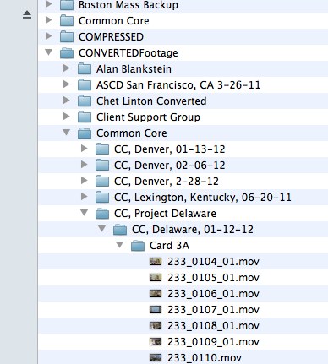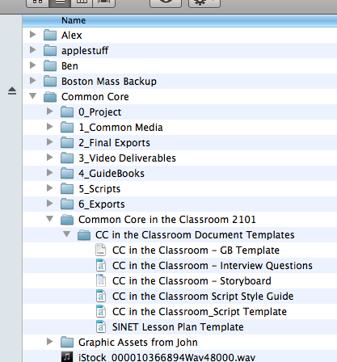

*Fig. 2 CC in the Classroom script template on*

*Fig. 1 video footage on the RAID*

The names of guidebooks and scripts should be created using the following format.

A lowercase “s” for a script or a lowercase “gb” for guidebook, underscore, stock number, hyphen, product (PD, CC, EQ, TS), hyphen, keywords from title (no spaces in between)

*Script example: s_2042-PD-autismclassroom*

*Guidebook example: gb_2053-EQ-dallasinnovates*

If the script is one segment in a program series, you may add a number designating the segment after the product indicator. In the following example, this script is segment 5 in a series of seven scripts.

*Script example: s_2041-CC-5-techologymapping*

The writer will make initial adaptations to the template:

Stock number

Segment number (PD 360, EQIN)

Title of video (PD 360, EQIN)

Name of the lesson (CC Classroom video) *See fig. 3*

Teacher’s name (CC Classroom video) *See fig. 3*

The Common Core standard(s) being featured (CC Classroom video) *See fig. 3*

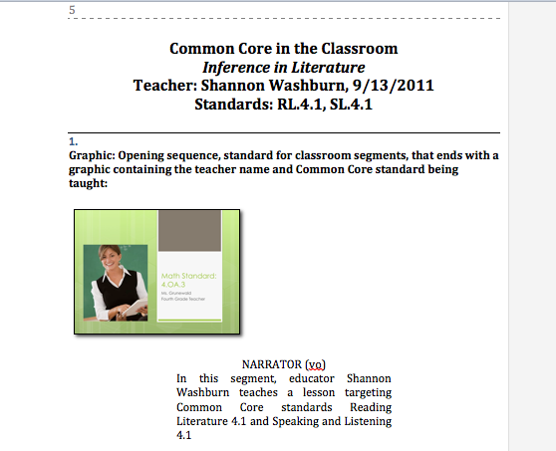

*Fig. 3 First page of a CC Classroom video script*

Once the writer has made the initial adaptations, the writer names the document and saves it to his/her own computer.

5.1.3 CC 360 Classroom Video Scripts

The CC 360 Classroom videos each feature one or more of the Common Core Standards being taught in the classroom. The school, grade level, subject, and teacher will vary, but the format of each video is the same.

Every CC 360 Classroom Video script will contain the following:

a stated objective for the viewer (what the viewer will gain from watching the video)

the Common Core standard(s) being addressed in the lesson

the unique aspects that distinguish the standard being featured in the video

the essential conditions that must be present to replicate the lesson and the high-level results that the featured teacher achieves (standards mastery)

a lesson “blueprint” graphic which will be filled in with information from the Teacher Lesson Plan

Some of the audio at the beginning of the script is prescribed. If the writer cannot find a piece of video with audio that matches the prescribed audio in the template, the writer can fill in with narration to compensate. The template should serve the needs of the writer, not vice versa.

When writing a CC 360 Classroom Video script, the writer should do the following:

**Read and understand thoroughly the Common Core Standard(s)** featured in the video. (<http://www.corestandards.org/the-standards>) Through Narration and teacher voice-over, the writer will make connections between the CC standard, the lesson design, learning activities, and other standards to clearly show the viewer strategic Common Core teaching in action.

**Focus on the lesson plan in chronological order** and include specific mention of assessments (formative and summative) at each stage of the lesson they are present.

**Tie multiple CC standards together** to show how Common Core teaching is a blending of standards in each lesson. (Even if the teacher doesn’t specifically mention them, we can make the connections ourselves).

**Tie each math lesson to the Standards for Mathematical Practice.** (<http://www.corestandards.org/the-standards/mathematics/introduction/standards-for-mathematical-practice/>) This is evident in each math lesson we teach but rarely mentioned by the teacher. Bring out the Standard(s)for Mathematical Practice using narration or teacher voice-over and a graphic of the Practice Standard heading.

**Make note of effective instructional teaching strategies** happening in the classroom action. To prevent interruption of a scene, note the teaching strategy in a graphic in the lower third of the screen. If the strategy truly shows good Common Core teaching, bring it out with narration, teacher voice-over, and graphics.

To learn more about **teaching strategies:**

Watch PD 360 videos related to the teaching strategy

Search academic databases (ERIC and EBSOE)

Consult this website <http://www.merlot.org/merlot/materials.htm?category=2299&&>

Consult an in-house specialist (Lisa Leith, Kevin Klein)

**Focus on intervention strategies** and name them in the script. Intervention strategies are methods and tactics the teacher uses to ensure *each* student meets the objective. An intervention strategy should not be confused with differentiated instruction. Intervention strategies consist of the teacher’s additional support of a student or group of students who are not grasping the skills being taught.

5.1.4 How to Write a Guidebook

This section is being rewritten.

~~Writing a guidebook is an on-going process. Preferably, the scriptwriter for a specific program will also write the guidebooks. As the scriptwriter is writing the scripts, s/he should take notes and brainstorm activities, which will be included in the guidebooks. Because the guidebooks give detailed outlines of the segments, they aren’t completed until after the video segments are finished.~~

~~Writer receives guidebook assignment and due date from the producer.~~

~~If the writer assigned to the guidebook is not the writer who wrote the video segment, the guidebook writer should obtain the Producer’s Notes and the Teacher Lesson Plan document from the producer.~~

~~Writer obtains completed video segments from the RAID, dragging copies to his/her computer.~~

~~Writer opens the script template and prepares it to receive the content of the program.~~

~~Writer watches video, making notes for the Video Outline section found on page 2 of the guidebook.~~

~~Writer composes content for remaining sections of the guidebook.~~

~~Writer attaches Teacher Lesson Plan.~~

~~When the guidebook is finished, the writer emails it to the content specialist for editing (style, voice, and content).~~

~~The content specialist returns guidebook to the writer and the writer makes suggested changes, ensuring that format and language remain consistent.~~

~~Writer uploads guidebook to Sharepoint for the first proofread and sends proofreader #1 an email alerting her that the guidebook has been loaded to Sharepoint. (If proofer is unable to access Sharepoint, writer should email the guidebook document to the proofer).~~

~~Proofreader #1 downloads the guidebook, turns on Track Changes, and proofs document using Guidebook Style Guide and The Chicago Manual of Style.~~

~~Proofreader #1 saves the document, uploads it to Sharepoint, and alerts the writer.~~

~~Writer downloads the newly-reviewed document from Sharepoint and makes the recommended changes, consulting with proofer as needed.~~

~~Writer loads the new document onto Sharepoint and alerts the proofreader #2.~~

~~Proofreader #2 downloads the guidebook, turns on Track Changes, and proofreads the document. If changes are simple, reviewer makes the changes. If proofreader has questions, s/he puts them in comments tagged to the appropriate cell/area of the page.~~

~~Proofreader #2 saves document, loads it onto Sharepoint, and alerts writer.~~

~~Writer makes changes, uploads to Sharepoint and alerts proofreader #2 for one final proof.~~

~~Proofreader #2 ensures all necessary changes have been made, checks final details, makes any minor changes necessary, uploads document to Sharepoint again, and alerts writer.~~

~~After all proofs have been finalized, the writer downloads the guidebook from Sharepoint, makes a copy of the whole guidebook, and then splits the copy up by segments; thus a separate guidebook is created for each segment. Each segment guidebook should have a cover page as well as a bib page. In the segment guidebooks, the cover page is moved to the second-to-last page position.~~

~~Writer exports all resulting documents (whole GB and segmented GBs) to PDF for upload to CC 360.~~

~~Writer sends resultant PDF documents to the Operations Manager who delivers documents to the Delivery Manager.~~

~~The Delivery Manager uploads the final PDF documents to appropriate program: CC 360, PD 360, EQIN, Teaching Strategies blog.~~

5.1.5 How to Access and Upload a Document on SharePoint

Go to <http://intraweb.schoolimprovement.com/SitePages/default.aspx>.

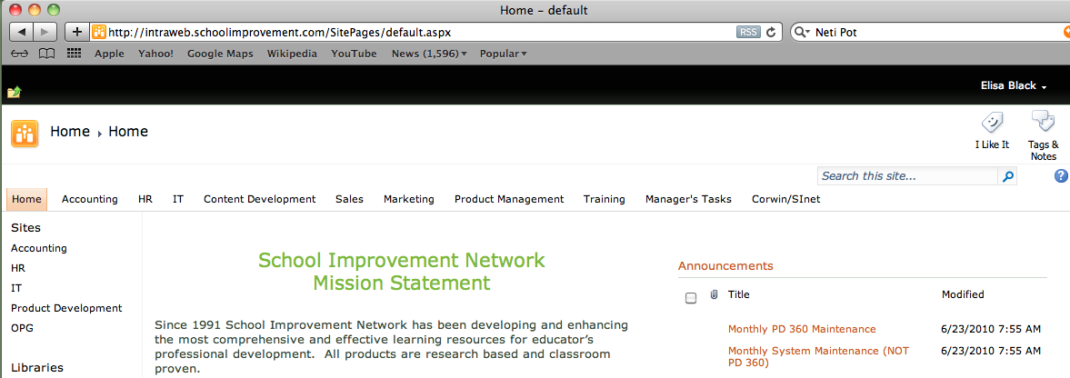Select “Content Development” from the top menu bar running across the screen. *See fig. 4 below*

*Fig. 4 SharePoint homepage, top menu bar*

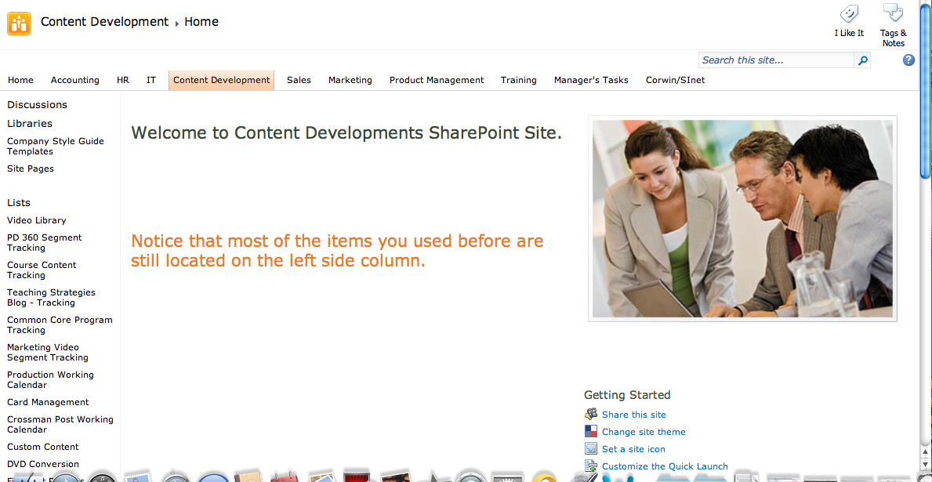Choose from the selections along the left-hand side of the page. *See fig. 5 below*

*Fig. 5 Content Development page, left-hand side menu*

A series of folders or documents should appear. If the document you wish to open is visible, double click on it to open the document. If a folder appears, single click to open the folder, and then double click on the document you wish to open. *See fig. 6 below*

*Fig. 6 SharePoint/Content Development/Company Style Guide Templates*

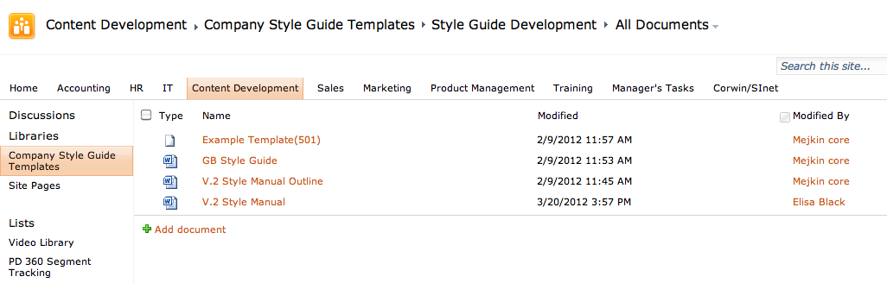

When the document opens, save a copy to your own computer and make changes to that copy.

**Note**: you may see a drop down menu to the side of your document which offers you options to edit, check out the document, view properties, etc. Clicking on the options to check out the document or edit do not guarantee that you can do so. There are some incompatibilities between mac computers and SharePoint because SharePoint was designed for PCs. But this doesn’t mean that you can’t edit the documents. Simple double click and save a copy of the opened document to your own computer, as stated above.

Once you have made your changes to the document, you will need to upload your new document to SharePoint. If you keep the title of your new document the same as the document you checked out, when you upload your new document, it will take the place of the former one.

To upload your new document, go into SharePoint, to the same location where you obtained the original document. Click on the “Add Document” button. *See fig. 7 below*

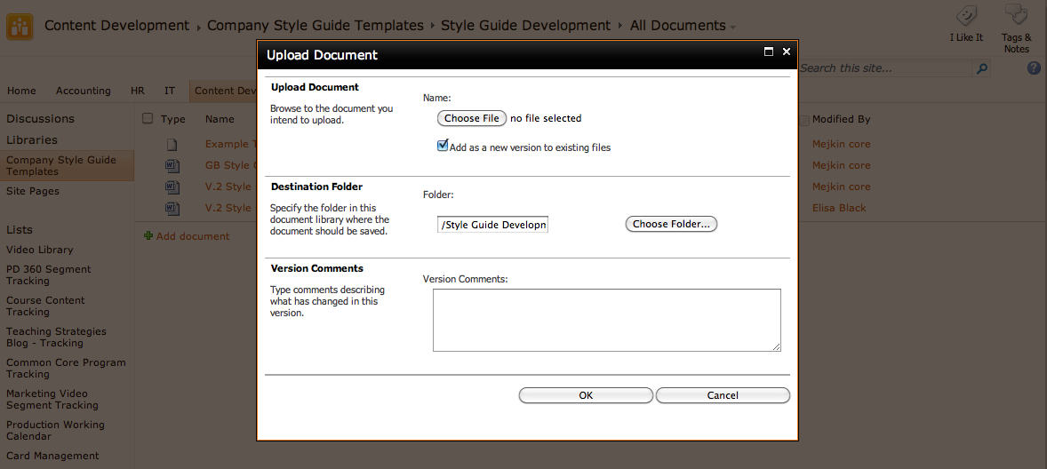A window will open which will allow you to choose the document you wish to upload from your computer and add any comments or instructions you would like to the next viewer of the document. Finally, click OK to finish the procedure. *See fig. 9*

*Fig. 9 Adding a document (saving your changes) to SharePoint*

This will load your document to SharePoint and—provided you’ve kept the title the same—replace the former copy of the document with your new edited one.

5.1.6 Educational Writing Tips

The following chart contains suggested verbiage and words to avoid when writing SINET scripts.

|  |  |  |
| --- | --- | --- |
| **Instead of** | **Please Use** | **Avoid** |
| We *have* to… | What if every educator . . .  Would you consider . . .  Educators are charged with the responsibility to . . .  The expectation is . . . |  |
| “always” or “never” | “often” or “rarely” |  |
| I think… | Research tells us . . .  One perspective might be . . . |  |
| Cause or causes | Is correlated with . . .  Influences the likelihood of . . .  Is connected to . . .  Often aligns with . . . |  |
| results | Data or student outcomes | Significant |
| What kind of tests will you use | How will you assess . . . | Always |
| tests | Assessments | Never |
| explain | Describe or explore | Very |
| Talk about | Explore together, dialogue, discuss | What kind of |
| Teaching techniques | Teaching strategies | What do you think |
| Yes or no questions | Instead, ask “how,” “what,” “why” | In your opinion |
| Which is better | How do you use ___ and ___ | How do you feel |
| Thought-out (as an adjective) | Thoughtful, relevant |  |
| Necessary changes | Changes to improve or to increase effectiveness |  |
| The same | Cohesive, coherent, similar | Much (as in “much more” or “much longer”) |
| Does it match? | Is it aligned with? | What does this mean to you |
| Determine | Define | Exactly |
| Determine whether or not teachers are integrating… | Gather evidence of teacher integration | As in “during learning walks, leaders determine whether or not teachers are integrating standards |
| Curriculum (when you mean classroom practice) | Practice or teaching and learning | Determined or proven—to absolute unless accomplished through empirical research |
| Help or helps (your classroom practice | Impacts or influences or guides (your classroom practice) |  |
| Their students | Students |  |
| tests | Assessments |  |
| Pre-test | Baseline assessment |  |
| relatable | relevant |  |
| Action plan (to reteach) | Intervention plan |  |
| better | More effective |  |
| Are they different from… | How do these differ from . . . |  |
| Look at | Examine, explore, evaluate |  |
| Brainstorm changes you would like to see | Brainstorm ideas for strengthening |  |
| Teacher (unless you are talking about a specific teacher) | Educator |  |
| Your classroom | Your school or district |  |
| This sample | This protocol or model |  |
| What kind of resources | What resources |  |
| Matching | Corresponding |  |
| Help students (or teachers) | Support or guide (students or teachers) |  |
| Assess proficiency to standards | Assess or measure progress towards mastery of standards |  |
| Possible | Potential |  |
| Teachers discuss what they will use to help students who fall well below acceptable proficiency levels | Teachers discuss interventions for students who do not yet demonstrate proficiency | Be careful with quantitative words of unclear meaning, for example “well below” |
| Teachers “come up with” (solutions) | Teachers define, brainstorm, generate or strategize |  |
| Utilize | Use |  |
| Students work individually | Students work independently |  |
| Teaching standards or teaching to the standards | Teaching standards-based lessons or addressing standards |  |
| With | “that includes” (as in “a cycle that includes observation and feedback”) |  |
| Measure students against the | Measure progress towards |  |
| Standards | Standards mastery |  |
| Classroom evaluation | Observation or walkthrough | Avoid “evaluation” to describe a classroom walkthrough or observation unless it truly is an explicitly formal evaluation |
| Common core provides targets | Common Core defines targets |  |
| How will you determine evidences of proficiency? | How will you measure proficiency? |  |
| Teacher teaches a lesson | Teacher delivers or facilitates lesson (not “top down,” but an interactive process) |  |
| In guidebooks: never recommend that students do worksheets or busy work | Recommend engaging, relevant, project-based, collaborative activities |  |
| Talk about | Discuss |  |
| Meet standards | Meet (or exceed) standards-based learning targets |  |

What do teachers do with the standards?

We can make factual statements that describe components of lessons: they include things, involve students, follow steps, and encourage participation.

In terms of their **effects,** we can only say what they intend, aim, or are designed to do:

|  |  |
| --- | --- |
| **LESS ACCURATE** | **ACCURATE** |
| This activity encourages participation | This activity is designed to encourage participation |
| This lesson helps students achieve standard RI.4.2 | The lesson is aligned to standard RI.4.2 |

6. Production Cycle Processes: Editors

6.1 The Communication Process of Post-production

We all share the same end goal: to create the very best product possible. Communication is the bedrock of making this happen. Everyone should learn all they can about as much as they can. That being said, this section outlines how the communication process works most effectively.

Direct communication is always best during the process. If the writer has editing questions during the script writing – ask the editor. If the editor has questions during the editing process about the script – ask the writer. If a writer or editor has a content question, ask the Content Specialist. The producer communicates directly with all team members as needed.

There are two major times of communication:, one is when the piece is in process, and two is when it’s time to review the final piece. The vast majority of communication should have taken place directly between people during the process. When reviewing, the communication should follow the process outlined in the next section.

Hopefully the process outlined here will improve and clarify the Post-production Process and help us continue to achieve our goals of high-quality, high-impact video segments for our clients.

6.2 Post-production Roles

This section outlines the roles in the post-production process and the review process for all video content created by School Improvement Network.

While there may be, from time to time, special circumstances that create deviations from this process, I expect us to follow this procedure 100% of the time. First, let’s review the players in the process.

**General Roles in the Post-production Process**

Each of us own the final quality of the pieces we do. While we share that common goal of making the pieces the best that they can be, there is the potential of confusion and even irritation when one part of the process crosses over into a perceived or actual responsibility of another process.

This is the outline for the roles of each team member as they relate to the post-production process, it is not a complete job description:

**Director of Content Development**

The DCD keeps the schedule and the work flowing for the entire department along with other responsibilities. Daily Scrum meetings are held with post-production teams to track work and keep snags to a minimum.

**Producers**

Producers own the final product deliverable; it is their responsibility to make sure the post process is taking place as it needs to. Working with the DCD, they assign the writer and editor new projects and deadlines. The producer creates, directs and manages the vision of the production process. It is the producer's responsibility to make sure the project stays on track and that it is delivered in a timely manner. Choosing and scheduling narration, and knowing where footage is in the transcribing/logging/processing cue are all under the producer’s watch.

It is the producer’s responsibility, along with the post-production coordinator, to know where the project is in the process and help keep it on track through effective communication.

**Post-production Coordinator**

The post-production coordinator makes sure that a projects paper work keeps up to date and supports the producers through the post cycle of each project. This would include creating tickets and tracking progress with Clairzen project management software, participating in the daily scrum, keeping producers on the road up to date with their projects and handling communication need while the producer is outside the office.

**Vice President of Education Research, Policy and Accountability/Content Specialist (VPERPA)**

Reviews the final product for teaching and learning quality.

**Writers and/or Writers as Content Specialists**

Writers create the script. Writers review the transcripts, the footage and should know what the end goal of the piece is, i.e. this segment is the introduction to the theory, or this is a common core classroom showing an8th grade math standard. In most cases, the general template or style of the piece has been defined for a particular time, so unless the footage or subject calls for a different style, there is an existing roadmap for the script to follow. It is critical that writers not rely only on transcripts for reviewing content. The writing process involves carefully watching the footage and becoming familiar with it.

**Editors**

Editors edit the pieces and create the graphics as needed for the piece. All of this is done along the established guidelines for the type of piece being done. Editors also select the music and create the pacing and flow of the piece based on the writer’s script. The editor’s job is to make the final product look professional, polished, engaging, and clear in the information that is being delivered.

**Audio Post**

Audio post follows the general mix of the editor as given to them in the OMF and other files. Audio is encouraged to do everything possible to improve the final sound track and make sure the audio is correctly edited, i.e. upcuts, downcuts, proper channels, etc.

**Proofers**

Proofers are the final gate in making sure we have reached our potential in technical excellence for each piece. Spelling, grammar, audio and visual drops, and discrepancies with the script are the main area where this group catches the mistakes of the editors. Jeannie and Lorrie, in particular, have the entire history of the company in their background and have seen everything that we have done. This gives them a special insight as well that adds tremendous value to the product. They also proof after encoding to make sure we are getting error free programs up on our site.

**Vice President Media Development**

The VPMD has been charged with reviewing all final versions of every video that we produce. Based on long experience, this covers every element of the final piece from color correction to audio quality, to actual content delivery, and every element that impacts the final piece.

6.3 Edit and Review Procedures

With these roles defined, the next step is to clarify the chain of events and where and how input should work. While the following sections are followed by all, how an editor cuts is up to them. Some may do a layout and then a rough; some may edit a final version from the start adding music and graphics as they come upon them in the script.

**Assembly and Rough Edit of the Piece**

*Editor, producer, and writer [content specialist].*

Editor assembles the piece as scripted, make adjustments, talks with the writer and producer as needed. The operations director, writer, or producer can check in for progress or to ask/answer questions as needed.

**Final Cut**

*Editor [producer and writer as needed].*

Editor edits for pacing with music and graphics, refining the piece to its final polish. The writer and producer can also be involved as needed.

**Final Cut Review**

*Editor, QA Team [Jeannie and Devon], Writer, Director of Content, and producer*

The piece in its final form is reviewed by the writer and director of content. Since there should be communication throughout the process to this point, this review should really be just a **final check** to make sure the **practice is sound**, the **script is****correct** and the **graphics** are as specified in the script. If the editor thought there were more graphics needed, these would be reviewed then. This is a limited time review period, generally 24 hours from being posted by the editor. Reviews maybe done together in a group or by individuals, group review is not mandatory. Content changes from this review are then given to the VPMD.

**Edit Approval**

Vice President of Media Development, Editor

The final, pre-sweetened project is reviewed by John for pace, technical, artistic, logical, and overall quality standards. Changes requested by other reviewers will also be reviewed and amended as needed. Common reviews are generally color correction, sometimes music use, sometimes pacing, and sometimes, but rarely, structural issues. Graphics are reviewed based on current graphic styles and standards in use. As has been the case from time to time, there maybe content issues flagged as well. At that point, the lead writer and/or Director of Content would be brought into this review. Changes are given to the editor, and will be checked before final approval.

**Audio is Sent to Audio Post**

Editor and Audio Post Supervisor

Editor outputs an OMF audio file and a h264 video file to send to audio post. Final mix is done by audio post; correcting levels and EQ to broadcast standards whenever possible. Care is taken, and should be highlighted by the editor as to where nat sound up should occur and the correct balance of music. While the broad parameters of the mix should be in the file sent to audio post, it is here where the quality of the audio should be reviewed as well. If there are questions, audio post should ask the editor about the issue. VPMD will review final mix prior to return to editor whenever possible, making sure any audio notes where passed though the process.

**Final Export**

Editor

The final mix is added to the video and the editor exports the final files for encoding to delivery. Editor should listen to the mix and make sure it represents what they had intended in the edit. Editor also outputs all of the needed delivery files as outlined in the editing workflow manual.

**Transcription Creation/Changes Check**

Jeannie prepares a final transcription of the video that is posted with the video. Since there are usually changes between the script and the final program, she goes through the program one last time to align the transcript with the actual video. At this time she will also check to make sure all changes have been applied.

**Platform Proofing**

Tracie and Lorrie

The final encoded file is placed on the site where Tracie and Lorrie and others do a final proof to make sure that the video works and all elements are there and available to the client.

6.4. Editing Work Flow Process

6.4.1 Pre-edit Setup

Before you get started have an editor help you set up a folded titled with your name in the 0_Editors folder on the RAID. This is where you can send exports, store video elements, and share files with others. Once you have an employee folder, you are ready to begin.

Step 1: Find your project’s converted footage on the Editor’s RAID (arc storage: sinet-video) in the “Footage” folder.

Step 2: Obtain a stock number from Michelle F. for your project.

Step 3: Get a hard drive and label it as your project backup. This backup will update with your projects.

Step 4: Put your footage on your backup drive in case your project needs to go mobile.

Next, make a folder for your project *on your computer* and include the stock number on the front of the folder name. For example: 2079_*EQIN_Kihei.* Create folders in your project folder for:

Documents

Exports

Media

AE Renders

Audio

Stills

Project Files

After Effects

Final Cut

Documents

Export

TIP: If your project needs to leave your desk, make sure you have a current backup.

Now it’s time to create a Final Cut Pro Project! Include the stock number in the name of your FCP project. For example: *EQIN_Kihei_2079.fcp*. Next, import all your footage into your project and edit prep it while the script is being written or formatted by Jeannie (create multi-clips; clip descriptions; look for music; find bloopers, etc.)

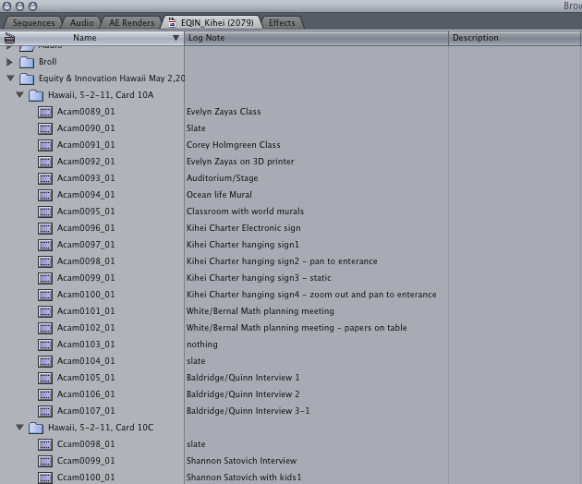

* + 1. TIP: Put your *Log Note* column and *Description* column next to the main *Name* column. This makes it easier to see log notes for your clips and descriptions of your segments.

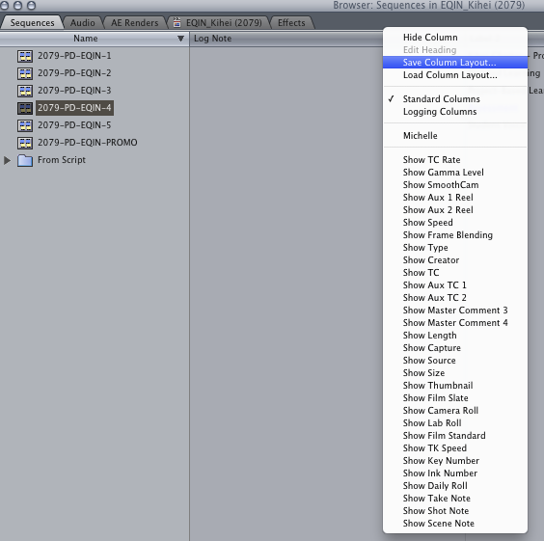

* + 1. NOTE: You can save your column layout by right clicking on one of the columns and selecting “Save Column Layout…”. A window will appear where you can name your layout. Hit “save” and your Custom Layout is saved (see images below)!

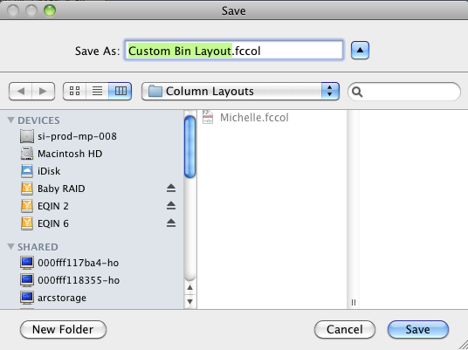

Name your segments with the stock number *before* you start editing. For example: *2105_PD_EQIN_1.* Once you get the script, place segment titles in the description box so you know the correct title of each segment. Talk to your producer to make sure these titles are correct.

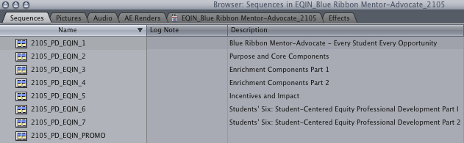

* + 1. TIP: Organize your project with folders. Final Cut calls folders Bins. Use bins to organize sequences, audio, and After Effects renders. Double click on the bin to open as a tab in a new window. Drag that tab to the top of the browser window so you have open tabs for your major bins (see image above).

Before your start editing, make sure your sequence settings are set up like this:

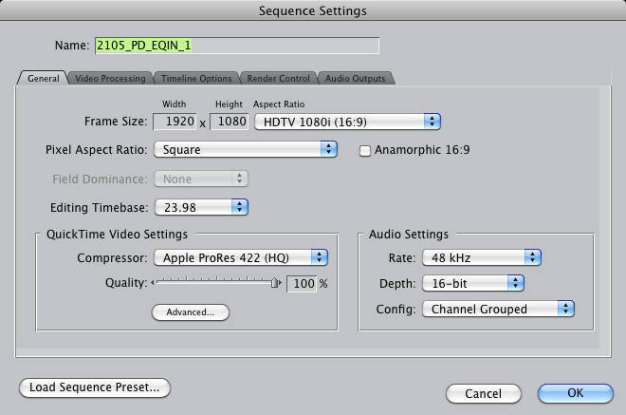

When you drop footage into your timeline and it asks, “Change sequence settings to match the clip settings?” click “no”. If you find that the majority of your timeline needs to be rendered to be viewed, talk to John Crossman to re-configure your settings.

6.4.2 Editing and Graphics

Once you get your project’s script, lay out each segment and work your editing magic!

* + 1. TIP: Organize your timeline so that interviews are on tracks V1, A1, A2; b-roll is on tracks V2, A3, A4; narration on tracks A5, A6; music alternating on tracks A7, A8, A9, A10; lower thirds above the last track of video, isolated; SINET BUG above lower thirds track. B-roll can sometimes take a few tracks, so adjustments can be made to this layout when needed. This general layout makes Barry’s life easier.

Make sure you don’t mix tracks. Keep interviews on the interview track, b-roll on the b-roll track, sound effects on the sound effects track, etc. If you have questions talk to John Crossman.

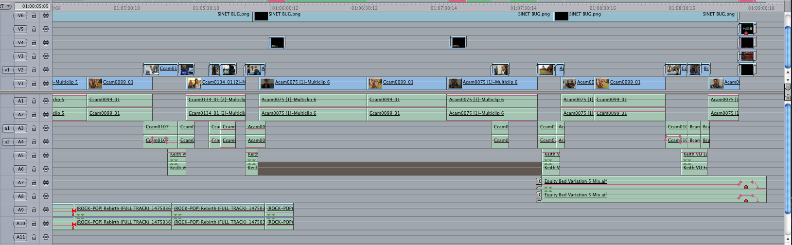

If the segment requires a graphic with text, create it as you edit and have Jeannie proof the spelling and grammar before it is exported.

* + 1. NOTE: If you ever need additional b-roll that isn’t included in your project footage, go to Jeannie. She knows everything that is in the video library and she can quickly and efficiently get what you need.

As you finish editing each segment, create the opening graphics and lower thirds (an iPod is handy at this point).

Before you export opening graphics and lower thirds, have Jeannie proof them (a substantial piece of her job is done at this point). Next, export your graphics and put them in place.

* + 1. TIP: After a day of editing, it is a good idea to save a dated copy of your FCP project in a backup folder just in case something happens to the working project. (Auto Save can get a little messy). It might look something like this: *EQIN_Kihei_2079 12/13/11.fcp.*

To change export settings in After Effects, click the yellow text next to “Output Module” in the Render Queue.

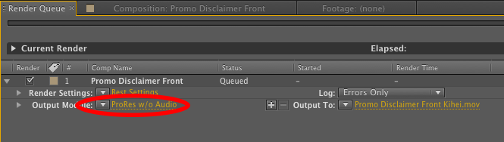

The settings of all your AE Renders, with the exception of lower thirds or graphics that need to be keyed, should be:

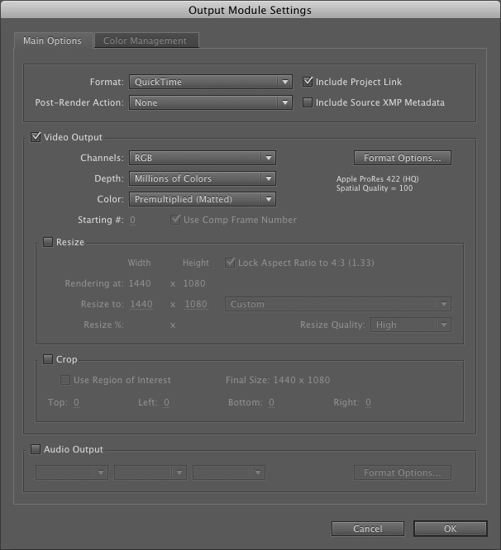

Preset settings can be found by clicking on the drop-down arrow to the right of “Output Module”.

* + 1. TIP: Set these settings as a preset since you will be using them frequently.

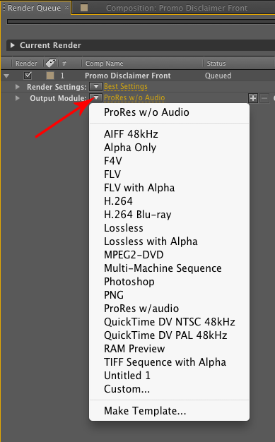

Lower third titles and graphics that need to be keyed, use different export settings because they need an alpha channel. Use the “Lossless with Alpha” preset setting for all your lower thirds.

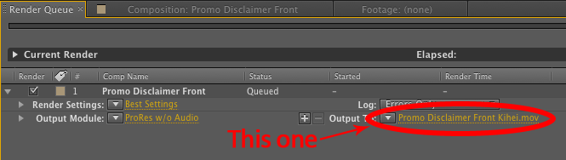

* + 1. NOTE: To change the name of *only* the final render of your After Effects file, click on the yellow highlighted title next to “Output To.” A window will pop up where you can rename the export and select a folder where you want the export to go.

Make sure the copyright (alt +g makes this: ©) appears with your opener or closer like this (No space between the symbol and the year):

©2013 School Improvement Network

The symbol can be inserted using the text tool in Final Cut. Its usual position is the bottom center of the frame.



Make sure your video doesn’t start until about 20 frames in on the timeline and have a few seconds of black after the last cut of video so the fades won’t get cut off on PD 360.

A bug should be put on every final segment. A copy of the SINET bug (SINET BUG.png) can be found in the “SINET Elements” folder on the Editor’s RAID under “Stills” > “SINET Logos.” Place it on the top most track of the sequence. You will have to repeat this graphic a few times to cover the entire length of the video. Fade the bug in as the opener fades out and fade it out as the closer fades in.

6.4.3 Promos

Every program needs a Marketing Promo video unless otherwise specified. Promos are custom to each program. For special direction and questions, see John Crossman.

6.4.4 QA and Beyond

A segment is ready for review when it has all the graphics in place, music, SINET Bug, and balanced audio. Export a QA file for review—H.264 720 x 486 16:9 with the prefix *qa_* for example: *qa_2105_PD_EQIN_1.* This is so files don’t get mixed up, lost, or accidentally deleted (refer to naming guide in the *RAID Procedures and Naming* Section).

Put QA files on the **OLD RAID** in QA folder (12_QA). Make a folder that is titled the same as the program and put your files in there. Send an email to those who will be reviewing your files (John Crossman, Producer, Writer, and QA Team) letting them know they are ready and where they are. Twenty-four hours has been allotted for this review so we can make deadlines. In your email message remind the group of the twenty-four hour review deadline. If there are problems, redirect to John Crossman. *See 6.3 Edit and Review procedures for detailed information.*

All the changes should be sent to John Crossman so he can compile one list of changes for the editor. After the changes are made, make an appointment with Jeannie and have her check that all the changes have been implemented.

Now it is time to export OMFs and MOVs for Barry. Create a new folder with the rest of your assets titled *For Barry.* Unfortunately, FCP doesn’t batch export OMFs so you have to export those one at a time. Boo. Here are the settings for exporting OMFs:

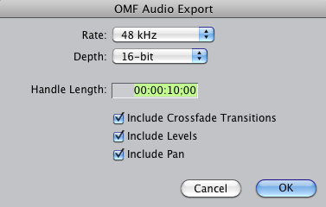

Keep the titles of your OMFs and MOVs the same as the sequence stock name using the prefix *mix_* for example: *mix_2105_PD_EQIN_1*.

Now we batch export MOVs (skip ahead to the “Final Exports” section if you don’t know how to set up a batch export). Here are the settings:

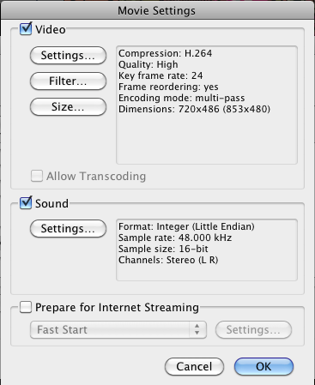

Once your elements have exported, make sure your MOVs have the *.mov* extension on them. You can type them right into the file name, or select the file and click the “more info…” button in the preview window in the Finder to bring up the info box (cmd + i does this too). Make sure the “Hide extension” box is NOT checked. Sometimes you have to do both (type the extension in and uncheck the “Hide extension box”). Sometimes when the extension is missing, the video can’t be played until the user adds the extension (see image below).

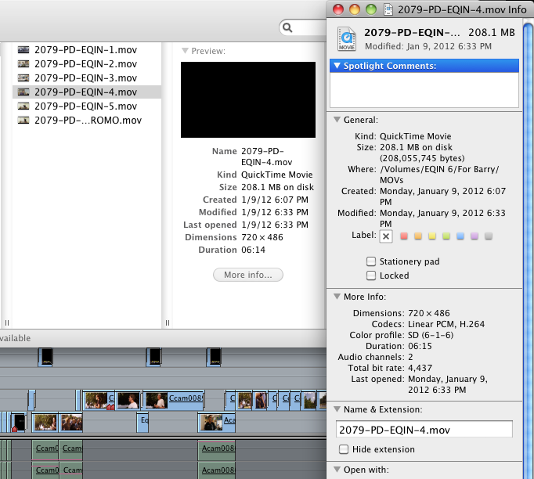

Now you send them! Make sure you include Michelle Fisher on the email since she keeps track of Barry’s schedule. If there are too many elements to be sent in one YouSendIt batch, send one batch with just OMFs and another with just MOVs.

Obtain the Login information for YouSendIt from one of the editors. Log in, click the *Send* tab, type in Barry’s email (and Michelle F.), and attach files.If there are any special instructions for Barry, type it in the message. Don’t forget to put your name in the message so he knows who to send the mixes back to.

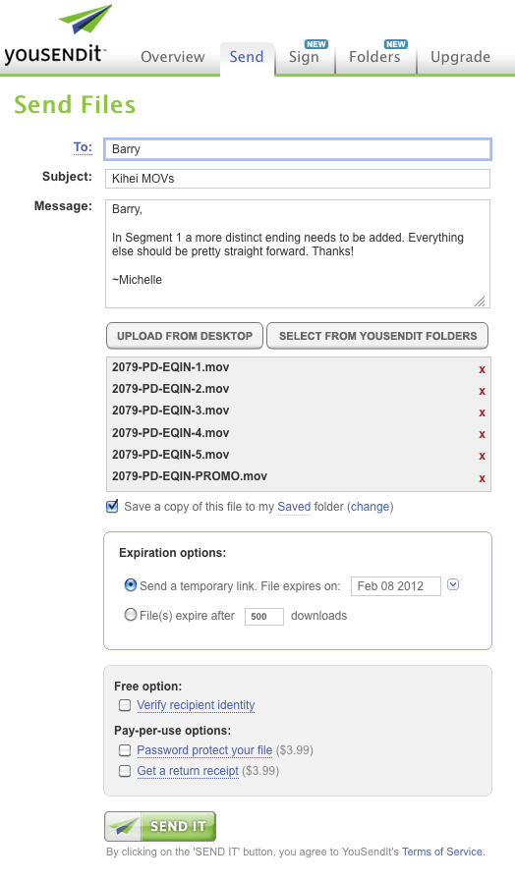

Now SEND IT!Send a second YouSendIt file if needed.

Once you get the mixes back from Barry, put them in a new folder titled *Mixes* within your *Audio Folder*. Put your mixes into your timeline and mute all the other tracks. The mix starts at TC 00:00:00, right at the beginning of your timeline.

* + 1. NOTE: Sometimes the MOVs need to be sent to the Guidebook writer as well, so double check with your producer.

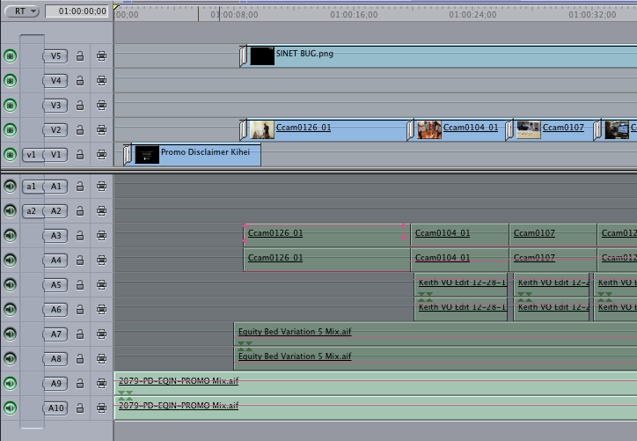

Listen to all the segments to make sure the audio is in sync. Spot-check if you don’t have time to listen to all the segments.

6.4.5 Final Export

Now it’s time to set up final exports for encoding. Highlight all sequences you want to export and right click to bring up an options menu:

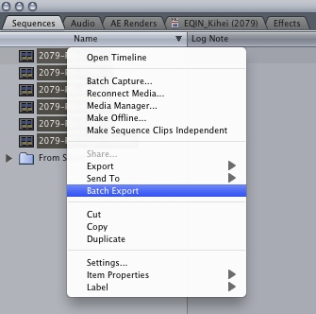

Click “Batch Export” to set up your batch.

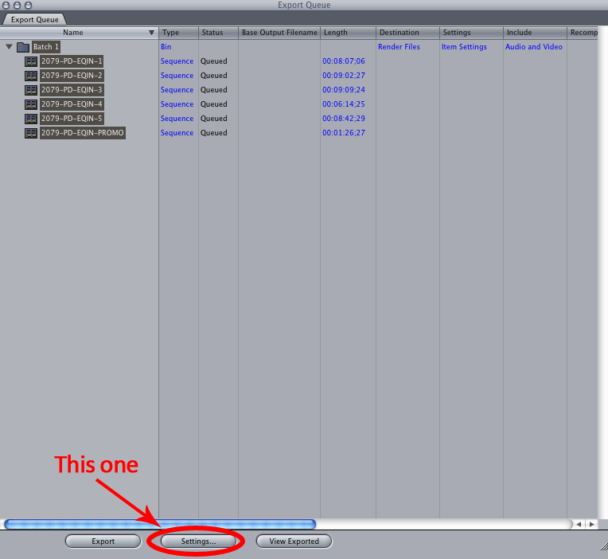

Click “Settings” button (refer to last image) in your Export Queue to get here:

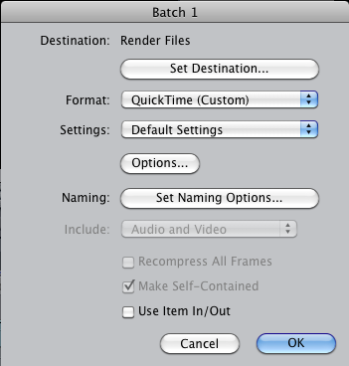

Set your desired destination. Set “Format” to “QuickTime (custom).” Leave “Settings” at “Default Settings” and click on the “Options…” button and use these settings for your final exports:

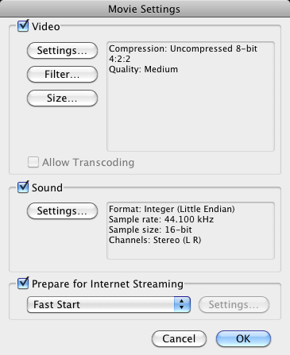

Click “Size…” in the Movie Settings window and change the size of the video to “Current”.

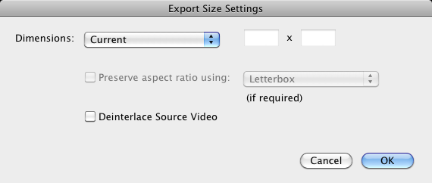

Back in the main Batch Settings Menu (see third image under *Encoding* Exports heading) click the “Set Naming Options” button and make sure the “Add File Type Extension” box is checked.

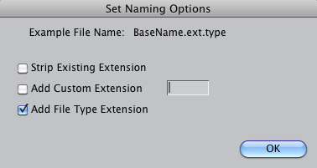

After your final exports are finished, make sure each segment has the *.mov* extension so the encoder will recognize them. If the extension is missing, or the file is named wrong, Tracie will send them back to you to fix.

6.4.6 Delivery Assets

Next to export are Delivery Assets for PD 360 (you don’t need Delivery Assets for your Promo):

Previews – what plays in the Card Deck on PD 360

Set an IN and OUT point in each segment about 15-20 seconds in duration (give or take). Make sure it’s a complete idea that describes the segment.

Set up your batch export with these settings:

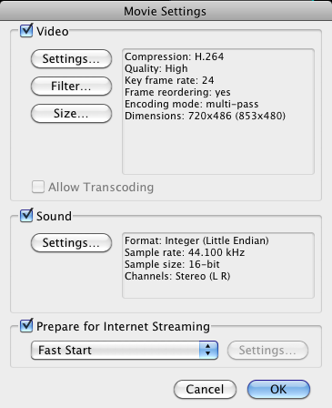

Remember to check the “Use Item In/Out” box before you confirm your batch settings.

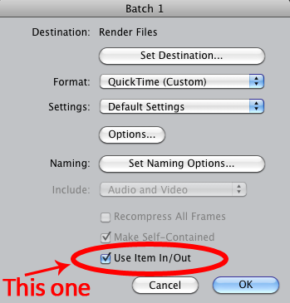

Don’t forget to name the files the EXACT name of the segment it corresponds with, adding the prefix **pre_**. For example: *pre_2079-PD-EQIN-4.mov*. This can be typed directly in your Export Queue.

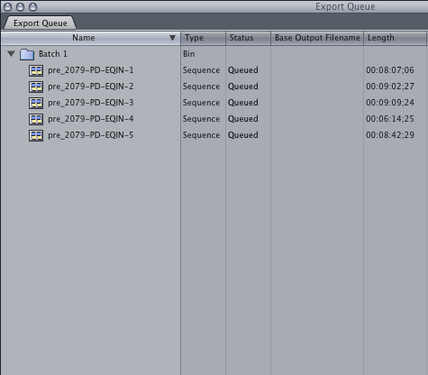

Thumbs – the “freeze frame” in the Card Deck

Set a 1 frame IN and OUT in each segment using the first frame of your Preview.

Set up your batch export with these settings:

Format = Still Image

Settings = Default Settings

Settings Options = JPEG

Check the “Use Item In/Out box.”

Don’t forget to name the files the EXACT name of the segment it corresponds with, adding the prefix **thumb_**. For example: *thumb_2079-PD-EQIN-4.jpg.*

If you forget to add prefixes, or you have the wrong file type, Tracie will send them back to you to fix. Also make sure all your file type extensions are visible.

6.4.7 Archiving and Backups

After all your final exports are complete, ask Tracie for the latest Final Cut Library drive. Copy your project folder from your computer to the Final Cut Library drive. Make sure your stock number is at the beginning of your folder name. Example: *2057_Student-Centered Learning*.

NOTE: Clean up your project so that only final versions get archived. Delete unused sequences in Final Cut and old AE Renders.

Place all your project assets in the Library folder the way they appear in your working project folder. Video footage does not go on this drive unless it’s outside b-roll. While you’re transferring assets, document on SharePoint which Final Cut Library drive your final FCP project is located.

Open Remote Desktop Connection (If you cannot open the RDC just open your Internet browser and go to <http://intraweb.schoolimprovement.com> and continue with step 3)

It might say, “The server name on the certificate is incorrect. Do you want to connect to this computer anyway?” Click connect.

Open Internet Explorer and go to: <http://intraweb.schoolimprovement.com>

Click on the Content Development tab (Step 3)

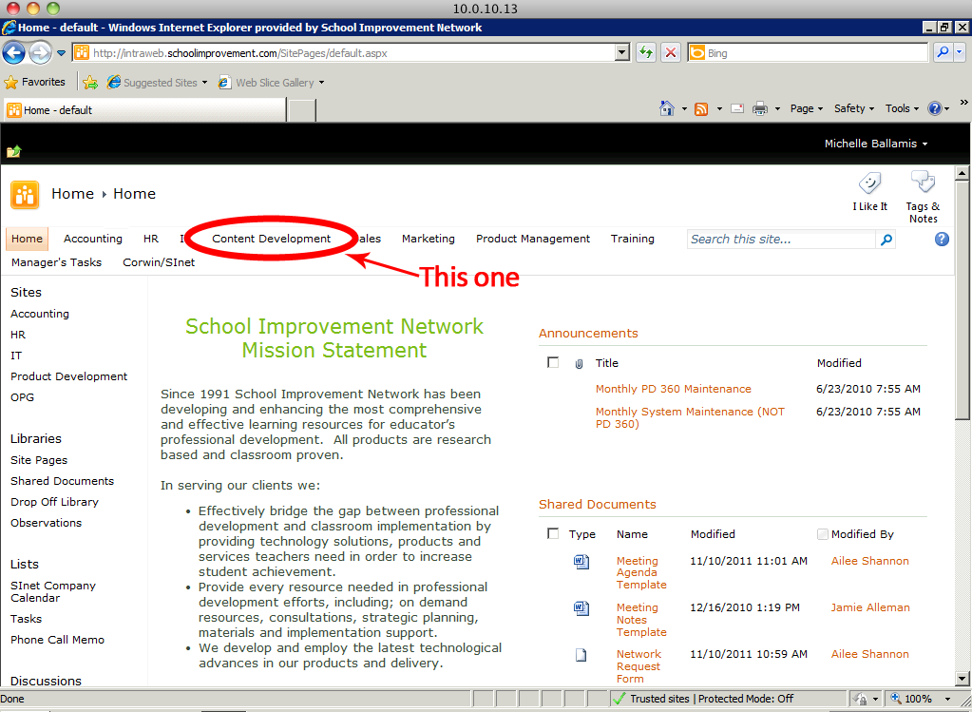

Click on Final Cut Projects Tracking (you’ll have to scroll a bit)

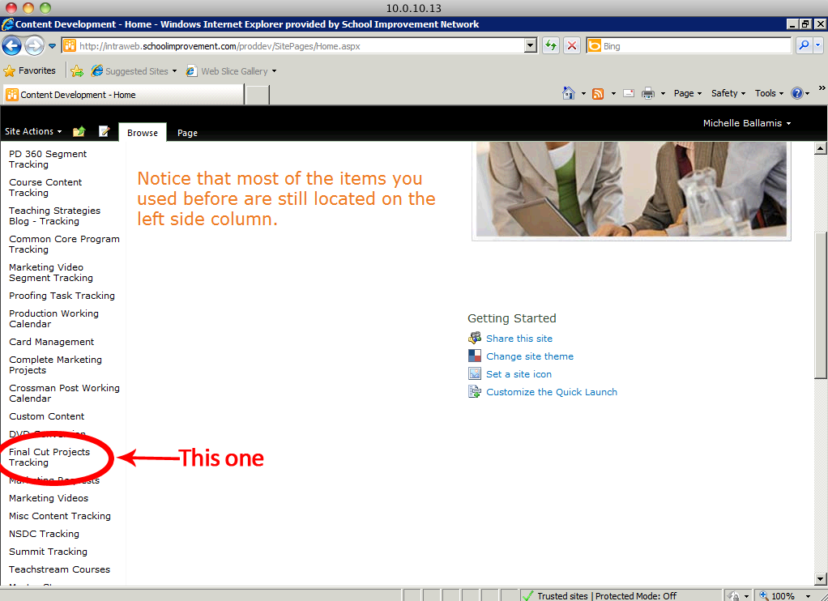

Enter the project information into the spreadsheet

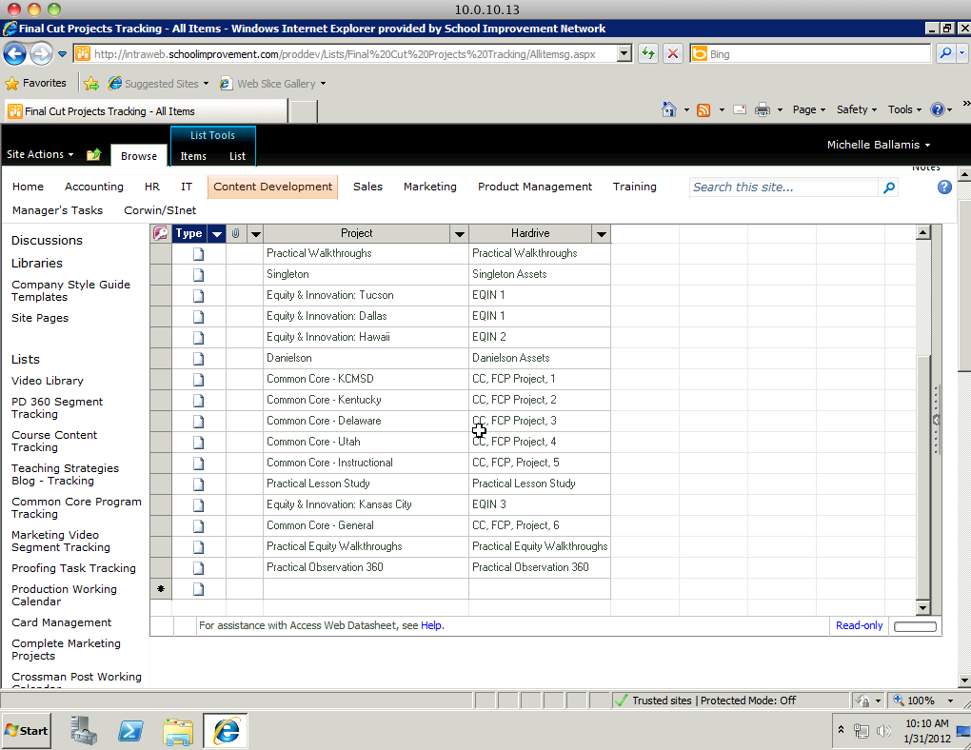

Sign out

When your asset transfer is complete, give Tracie back the Final Cut Library drive so she can back it up. Tracie will let you know when the back up is complete; then you can clear *your* backup drive and use it for your next project. Keep your project folder on your computer for a few months just in case changes need to be made. You are FINISHED! You made it through another project. Time to start again!

6.4.8 RAID Procedures and Naming

The RAID is where all the working footage is saved. By this time you should have your own folder under the 0_Editors folder. If not, have an editor set you up with one now. Ready? Moving on.

The last Monday of every month is RAID Clean Up day. This is the time to delete footage from **completed** projects that are *at least* a month old and **backed-up.** This is also the time to clean out your employee folder and delete all unnecessary files. Communication is key. Talk to the people around you and make sure they aren’t using any of the files you’re deleting. We do this so the RAID won’t fill up and crash (this has happened too many times).

When it comes to naming files and projects there are processes that need to be followed. This naming formula has been developed so any person at any time can see the file and know where it belongs and where it came from. Here is the base naming format for the different projects:

**PD 360/Equity and Innovation/100%**

Stock number_platform_program_segment number

PD 360 EXAMPLE: 2102_PD_PPBL_2

EQUITY AND INOVATION EXAMPLE: 2105_PD_EQIN_1

**Common Core in the Classroom**

Stock number_Common Core_State_GradeSubject_First Initial Last Name of Teacher_CCC

EXAMPLE: 2158_CC_TN_7MATH_MHurt_CCC

**Common Core Extended Classroom**

Stock number_Common Core_State_GradeSubject_First Initial Last Name of Teacher_EC

EXAMPLE: 2158_CC_TN_7MATH_MHurt_EC

**Common Core Coaching Session**

Stock number_Common Core_State_GradeSubject_First Initial Last Name of Teacher_CS

EXAMPLE: 2158_CC_TN_7MATH_MHurt_CS

The following is a guide to naming *everything* (some files will not apply to editors):

|  |  |  |  |
| --- | --- | --- | --- |
| **Prefix** | **File Type** | **Example** | **Use** |
| qa_ | .mov | qa_2102_PD_PPBL_2.mov | Review file |
| mix_ | .omf | mix_2102_PD_PPBL_2.omf | Audio for Barry |
| mix_ | .mov | mix_2102_PD_PPBL_2.mov | Video For Barry |
| pre_ | .mov | pre_2102_PD_PPBL_2.mov | Preview file for PD 360 Card Deck |
| thumb_ | .jpg | thumb_2102_PD_PPBL_2.jpg | Thumbnail for PD 360 Card Deck |
| *No Prefix* | .doc/.docx | 2102_PD_PPBL_2.docx | Script |
| tr_ | .pdf | tr_2102_PD_PPBL_2.pdf | Transcript |
| gb_ | .pdf | gb_2102_PD_PPBL_2.pdf | Guidebook |
| *No Prefix* | .mov | 2102_PD_PPBL_2.mov | Final Exports for Tracie |

The example on this table is using the stock number/names from a PD 360 program: Practical Project Based Learning

Make sure when these files leave your computer the name is correct and the extension is correct and visible. **Tracie will send them back if any part of the file name is wrong.**

7. Production Cycle Processes: Support

We shoot in the field on SXS or “express cards”. These cards, while meeting the express card standard, are designed and produced especially for our SONY cameras and are very expensive. They are designed, like videotape, to be used over and over again and our standard SXS cards are rated for 100,000 read/write cycles, while the SXS-Pro series are rated for 10,000 read and write cycles. Because this media is reused, backing up and/or transferring the media off these cards is critical to our process.

The files the camera creates are mp4 files in a .mxf wrapper. MXF files are an industry standard. These files are not able to play directly back in this wrapper in Final Cut Pro, as FCP is a QuickTime based editing system. So these files must be converted to a .mov file [wrapper], to playback in final cut. Adobe Premiere can play back these native files, and therefore footage used on that editor doesn’t need to be converted to .mov.

There are 4 storage locations used in the department, a Library Drive, a Archive drive, and the Arc Storage High Speed RAID. Library Drives are for the storage of raw media. The archive drive is a backup of the Library drive. The Arc Storage high Speed RAID is where footage is stored during the editing process. This is where converted .mov files are kept. Another normal speed RAID is also available name SI-IT-NSA-003, this can be used as a place to put files temporarily.

7.1.1 Card Transfer

Card transfer is done using the card reader and XD Cam Clip Browser to library drive

(Note, the **library drives** are only to be used for **storage of raw media**)

1- Create new folder on library drive

Enter new data in folder in this order:

Project name, location (city/state), date,

Sub Folder – Project name, location (city/state), and card number

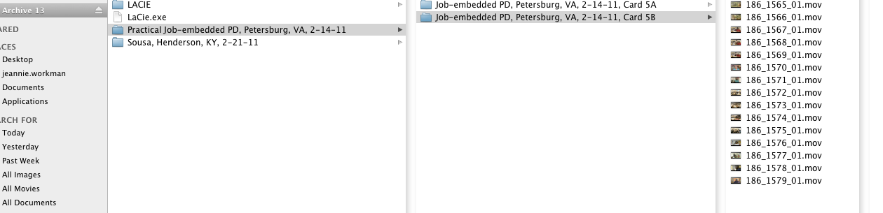

2- Open Preferences under XDCAM EX Clip Browser

Click “Edit Tab”

Check “Perform CRC Check” or make sure it is already checked.

Change Root Folder and Flash Band to: “*Hardrive Name* -(Card Folder Name, the folder you named in previous step)

3- Select all Clips (Command/A)

4- Select Copy All (They should copy to the folder you selected on your Hardrive)

***Be aware that Clip Browser creates a sub-folder that is just numbers, you can move after transfer is done or leave extra sub folder.

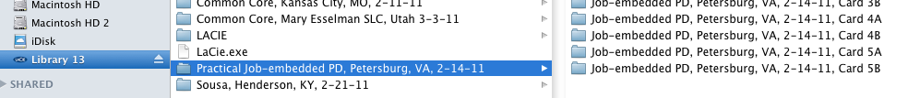

5-Double check file size of clips on transferred drive against clip size on card

6-Once the media is transferred to library drive, it needs to be backed up on the corresponding **archive drive**.

7.1.2 Card Conversion

Use XDCAM Transfer to convert footage to .mov files, latest version of software below:

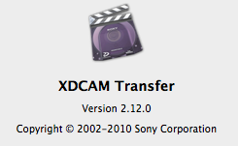

1. Open program and add Card Folder that contains BPAV folder (this folder will be located on a Library drive)



2. Make new folder for Converted Footage under “CONVERTED Footage” on the Raid, this should be the name of your project.

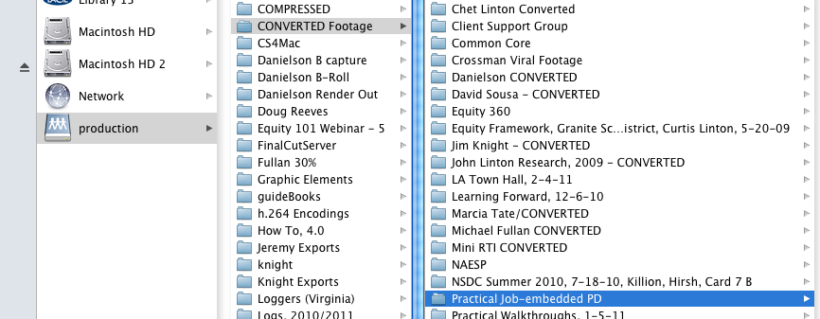

3. Choose import settings under XDCAM preferences

A - This browse folder will be the folder where your converted files will go, which will be under “CONVERTED Footage” on the RAID [SI-IT-NSA-003].

**B** - Match the Preference settings below:

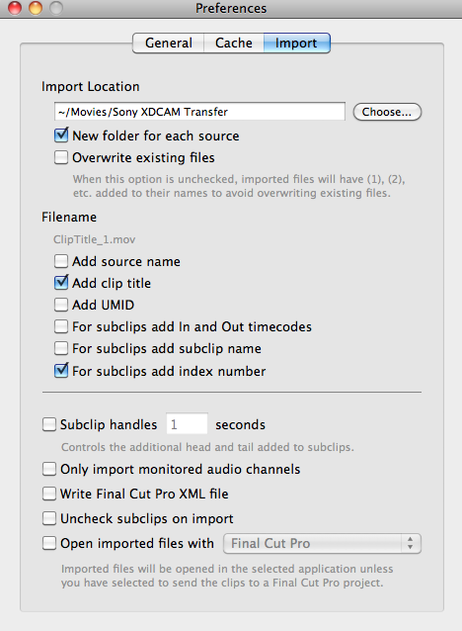

C. Once settings are set, select all clips to be converted then click import.

Open Compressor.

Locate the CONVERTED footage folder on the RAID and drag the footage from one card to be compressed into the batch window of Compressor.

Select all the clips in the batch (CMD+A) and drag the LOG preset in the custom folder of the settings window onto the clips.

If there is not a LOG preset, you get to create one! Begin by adding the Quicktime H.264 setting to one clip and modifying it (modifications are made in the Inspector window) to match the following settings:

Name: LOG

Description: H.264 video with stereo AAC audio. Settings based off the source resolution and frame-rate.

File Extension: mov

Estimated size: unknown

Audio Encoder

AAC, Stereo (L R), 48.000 kHz

Video Encoder

Format: QT

Width: 320

Height: 180

Pixel aspect ratio: Square

Crop: None

Padding: None

Frame rate: (100% of Source)

Frame Controls Automatically selected:

Retiming: (Fast) Nearest Frame

Resize Filter: Linear Filter

Deinterlace Filter: Better (Motion Adaptive)

Adaptive Details: Off

Antialias: 0

Detail Level: 0

Field Output: Progressive

Codec Type: H.264

Multi-pass: On, frame reorder: On

Pixel depth: 24

Spatial quality: 50

Min. Spatial quality: 25

Temporal quality: 50

Min. temporal quality: 25

Timecode Generator

Position: Lower Center--Title Safe

Alpha: 1.000

Label:

Start Timecode at 00:00:00:00 false

Text Color: r:0.0000, g:0.0000, b:0.0000

Font: Helvetica, 24

The width and height of the settings are modified in the Geometry menu of the Inspector. Next to frame size, select “Custom (16:9)” in the drop-down and then change the width to 320. The height should automatically adjust to 180.

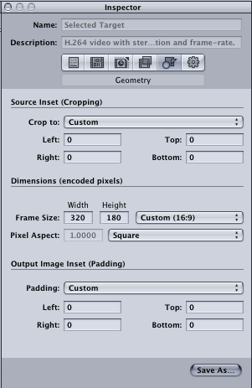

The Timecode Generator can be added in the Filters menu in the Inspector window. Click the box next to Timecode Generator to apply it to the preset. Make sure that the settings are as shown above for the position and font of the time code.

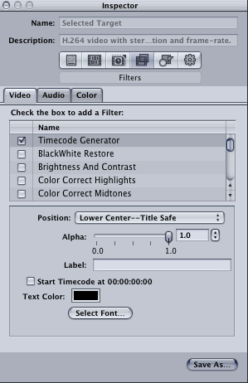

To save the preset, click “Save As…” in the bottom right of the Inspector window. Name the preset “LOG.” This will add the word “LOG” onto the end of the file name for each clip you compress, making it easy to tell that they’ve been compressed.

Use your brand new preset to apply uniform settings to all the clips in the batch.

Select all the clips in the batch again. Apply the destination for all of the compressed clips by clicking Target (on the menu bar at the top of the screen)>Destination>Other. Now select the COMPRESSED folder on the RAID, then the project folder of the footage you’re compressing (ex. Common Core), then the specific project folder (ex. CC, Project Delaware), then create a new folder for your compressed footage (ex. CC, Delaware, 12-1-11) and within that folder create a new folder for the specific card (ex. Card 1A). Select that final card folder as your destination.

Back in Compressor, click the “Submit…” button in the bottom right hand corner of the batch window. It will ask you to name the batch—it is a good idea to name the batch after the state and card # of the footage you’re compressing so you know which is which if you have a long queue of compressing to do.

Create a new batch in Compressor (CMD+N) and repeat steps 2-5 for each card of footage you have to compress, a new batch for each card.

Find something else to do until it is done compressing!

7.1.4 Logging Ticket Preparation

A ticket needs to be created to send out with the compressed footage for transcription. To create this ticket, do the following:

Open a blank copy of the Logging Submit Form excel document. [Available on the SI-IT-NSA-003 RAID in the **Logs** folder] Save it as a new document with a filename that contains the project title, state, and date shot (ex. CC Kentucky 1-17-12, Logging Submit Form).

Open up Final Cut Pro and drag all of the compressed footage into a new project. This is so you can easily see the footage, clip names, and durations. Keep the file structure intact so you know which clips belong to which cards.

For each clip, find and enter the appropriate information for each column on the logging submit form.

Clip Number, Card Number, and Time of Clip (duration) can be found just by glancing at the clips in the Browser in FCP.

Scroll through each clip to find the slates (usually the slates are on an iPad that they hold next to whoever they’re interviewing). Sometimes clips are not slated. This happens most commonly with classrooms they are filming. This is where you have to do a bit of sleuthing and figure which teacher they are filming—look for their interview slate. Using the slate, fill in the Project Title, Location (the school), City/State, Date, and Slate Information (who is in the clip) on the logging submit form.

As you scroll through the clips, determine if they are from Camera A or Camera B and enter in the letter A or B in the Camera column on the logging submit form. Camera A typically films the teachers, while Camera B films the students and other angles or close-ups of meetings. Normally the Card # tells you which camera it is (Card 1A = Camera A), but it doesn’t hurt to look at the footage to make sure.

Once the logging ticket has been prepared, update information on SharePoint. SharePoint is set up the same as the logging ticket, so information can just be copied and pasted from your Excel document into the SharePoint database.

8. Production Cycle Processes: Delivery/Encoding

8.1 Encoding

1-Ticket from Producers is submitted, ticket can be found on SharePoint under Content Development welcome page. [*PD Content Submit.xls*]

2-Files matching ticket are found on Arcstorage Raid under Exports folder

Squeeze is our encoding software used to compress files. We use Squeeze because of the user capability and easy function to create jobs. Plus at one point in time it was one of the only encoders at the time that gave us the correct codec we needed. With Squeeze we have the capability to upload directly to our server when encoding is done. Plus we can create “Jobs” or “Batches” to customize our encoding. As of current we have three different video presets we use on each video file added to the job, they are itemized below. These settings came from multiple tests of bitrates and resolutions. A team between content development and software development was formed to choose these settings. The lower bitrate is to accommodate schools and districts with a small bandwidth. The higher bitrate is to give those schools and district with more bandwidth better quality in the video experience. We still house the flv because the apple devices could not play the mp4 codecs. That has been corrected and will phase out of the player in the months to come.

3-Import into Squeeze to encode/settings are under web on Mac Encoder and Favorites on PC Encoder

**Job 1 - Low Res (SD) Encode**

-Import videos into squeeze

-Apply Low Res setting (640x480, 640 kbps) to job

-Set output to job by right clicking on output and modify to SD folder on internal hard drive

**Job 2 - High Res (HD) Encode**

-Import videos into squeeze

-Apply High Res setting (640x480 1600 kbps) for 4:3 or 16:9 Standard Def Masters to job

**Or**

-Apply High Res setting (1280x720 1600 kbps) for 16:9 HD Masters to Job

-Set output to job by right clicking on output and modify to HD folder on internal hard drive

**Job 3 - FLV Encode**

-Import videos into squeeze

-Apply FLV setting (640x480, 640 kbps) to job

-Set output to job by right clicking on output and modify to FLV folder on internal hard drive

**Job 4 – Preview Files Low Res (SD) Encode**

-Import videos into squeeze, found on Arcstorage RAID in Assets folder within project folder

-Apply Low Res setting (640x480, 640 kbps) to job

-Set output to job by right clicking on output and modify to Preview folder on SI-IT-NSA-003 under Delivery Assets

**Job 5 – Audio (MP3)**

-Import videos into squeeze, found on Arcstorage in Assets folder or Export folder

-Apply MP3 setting 128Kbps

-Set output to job by right clicking on output and modify to PD 360 Audio folder on SI-IT-NSA-003 under Delivery Assets

4-Hit “Squeeze It”

Encodes need to be stored on SI-IT-NSA-003 under “Delivery Assets” HD, SD, FLV folders

8.2 Uploading Process

1-Open Firefox, go to Tools, Web developer, then FireFTP

2-Connect to Akamai (Accounts assigned by Tyler Hansen on Software Dev Team)

Akamai is the service provider/server of streaming our videos. We use Akamai because of many features but the one that applies to content development is the adaptive streaming capability. We can have multiple bitrate streaming for a better user experience. This is the future of our encoding.

3-Find files on local hard drive or on SI-IT-NSA-003 to upload

Choose corresponding folder to upload to:

-gb (Guidebooks)

-lesson plans

-mp3 (Audio)

-thumbs

-transcripts

-video – HD/SD/Preview

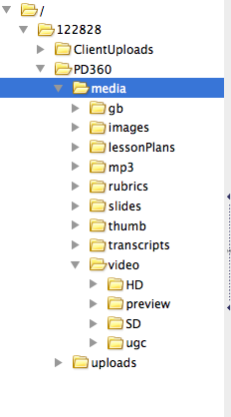

8.3 Flush/Purge Files

Flush/Purge is automatic and takes place every 18 hours. Any overwrites to the server allow a 24-hour flush to occur, usually plan overnight for effects to occur.

8.4 Back up

Transfer files from RAID to Sinterra Master as well as Sinterra Backup

Note: on SharePoint what Sinterra Master the video segment masters are stored

8.5 Proofing Video

Once the video has been encoded and uploaded to the server, we perform yet another quality check to make sure that it is performing on the platform as intended. We have the ability to place them on the platform for testing without them “going live” to the customer. This final check is very detailed, as you will see, and one of the reasons we need to delivery on our schedules, since this is such an intensive final step, it should not be rushed.

Watch video and check for accuracy of:

Title

Time

Lower third

Slides

Clarity - i.e. visually, glitches, opening/closing, sound, etc.

2nd/3rd proofing for corrections

Proofing PD 360/Common Core

Proofing PD 360 programs and courses for accuracy of:

Titles - segment titles, numbers, etc.

Links to tasks - guidebooks, MP3, transcripts, share-a-link, reflection and follow-up questions

Written material - pop-up and info boxes, thumbnails, segment lengths, syllabus’, activities and instructions

Help feature 2nd/3rd proofing for corrections

Other Materials That Fall Under Proofing

**Webinars**

**Encodes/Akamai Player**

**Focus feature**

**Strategy of the Week**

**Marketing materials**

**User guides**

**Emails**

**Admin. requests** - i.e. checking ID’s, time codes, change what’s necessary, turn-on programs, input reflection and follow-up questions

**Letters**

**Keep a company word list and style guide updated**

**8.6** Creating Descriptions for PD 360, Common Core Info Boxes

I first create the descriptions in an Excel document. I have found this to be an invaluable asset in doing quick searches of content. It is a working document and enables me to make changes easily.

I create the descriptions on the Excel document as follows:

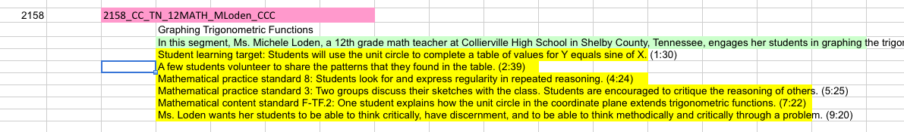

1st line – file name of segment

2nd line – segment title

3rd line – main description of segment (which is also used for press release)

4th, 5th, ,6th,, etc., lines – key points of segments with time codes

* I work with the original transcript as I watch the video.
* The description of the segment typically comes from the opening paragraph of the script, which is usually the narration.
* I typically identify the key points of the segment by the narration inserts in the script or by graphics that identify key points. I also identify key details by the teacher interviews in the segment, always trying to use the original text in the script.

**Entering the Data Into PD 360 or Common Core Using the Admin Tool**

Go to the Admin tool

Go to Add/Edit Content

Go to main program folder

Go to segment folder

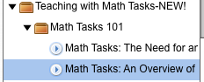

Entering the Description Data – this is the same with PD 360 or Common Core

* Enter the italics command, which is <i>, then type in Segment 2 of 4 of this program. Enter ending italics command, which is </i>
* Copy the main description from the Excel document. Enter the line break command, which is <br/>
* With the current program we have, you cannot use bullet points, so the – symbol is used at the beginning of each key point. Follow each key point with appropriate time code in parentheses, then add the line break symbol, which is <br/>

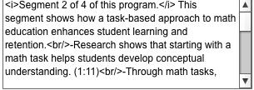

Entering the Search Data – this is the same with PD 360 or Common Core

* Enter the main program title, the segment title, and any key words that could be used in a search

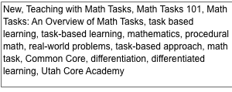

**Tagging Segments – PD 360**

* Go to the Tags bar

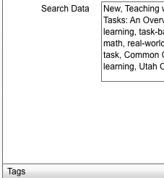

* Go to Topics bar
* Click on the desired topic (these topics were programmed in the Admin tool from a list compiled by John Linton several years ago. They cannot be added to or deleted unless someone from software dev does it.)

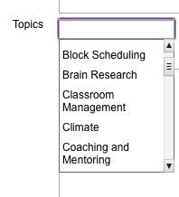

* It is possible to tag a topic that is not listed in the Topics folder by clicking on the Tags box and manually typing in the name of the tag you want

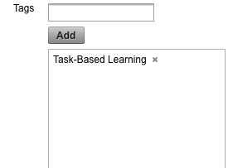

**Tagging Segments – Common Core**

* The tagging system for Common Core is different than that for PD 360. Note that the search functionality for Common Core and PD 360 is such that you can not search items in one or the other for both; you can only search for Common Core in Common Core and PD 360 in PD 360.
* The first three boxes for tagging were created by Sara and I question their use now.
* The fourth box is where the custom tags are entered. These tags can only be entered by going to the bar in Common Core Tools that says Common Core Tree.

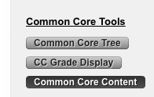

* Find the Common Core standard in the Common Core Tree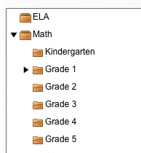
* Open the appropriate grade and find the appropriate standard

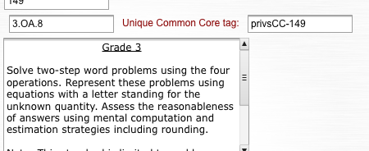

* Copy the data in the “Unique Common Core tag box and paste this data in the Admin box that says “CCTags”

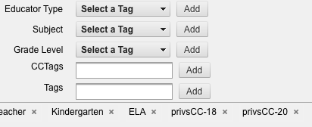

* Be sure to hit save at the bottom
* All of the description data is now entered for segment
* Go to the Common Core videos and double-check for errors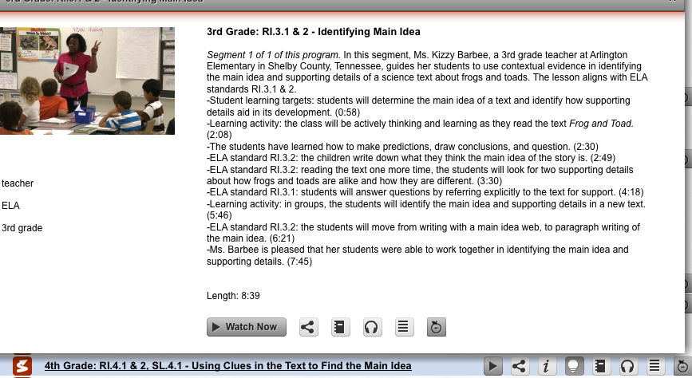

**Formatting Final Transcripts**

The purpose of the final format is to create a document that matches, word for word, the final video.

* I take the original script from the writer and watch the final, edited segment
* I remove all editing cues and delete unused portions of original script
* I add additional words that were added in editing, but were not on original script
* A benefit of this process is it is a good final proof of the video segment. I have occasionally found errors that were missed in the other levels of proofing.
* When the script matches the video, I format it to create a final transcript for storage as a PDF attached to the PD 360 or Common Core Platform

The final transcript is formatted as follows:

* The transcript is saved in the font Calibri, size 12
* The transcript cover page is a template that is adjusted for each segment and contains the following elements:
* Header, which is segment number and title of segment
* Footer, which is copyright
* School Improvement Network Logo
* Program name
* Segment number
* Segment name
* Transcript

The final transcript is saved as a PDF

The PDF is loaded onto the platform using AKAMAI

9. Your Personal Training Schedule and Check Off

The first day at School Improvement Network will be orientation with the HR department. Once that process is over, you are expected to complete the following training section in the first week on the job. Simply studying this guide and answering the questions at the end of this training section can accomplish most of that. Persons involved in various areas of our department will present some training, and some will involve using and viewing our products. You will also be introduced to your mentor who you are urged to bother as much as needed to answer your questions.

Please download the Personal Training Checklist at SI-IT-NSA-003/20_Content Development Training/Documents. A copy is included later in this section for reference.

9.1 Company History, as told by John Crossman

9.1.1 John and Blanch Linton and Linton Productions

The genesis of School Improvement Network starts with John and Blanch Linton.

John graduated in Journalism from BYU and worked for KBYU-TV and then the Motion Picture Studio at BYU for 8 years. While there he won many awards for his documentary work and was in demand for his services. Following an administration shake up of all of the audio and video/film services at BYU, John was laid off, being told he was more likely to survive outside of BYU than some others they were keeping.

John started Linton Productions and indeed survived and flourished for a number of years doing film work for a broad range of clients including many former clients he had worked for at the BYU Motion Picture Studio.

John and his partners decided that they wanted to grow and do full-length motion pictures helping to create a genre that would later be named “Mormon Cinema.” Long story short, over three full-length motion pictures, and various business decisions it became unsustainable and Linton Productions was forced to close down.

At this time, John joined Blanch as a teacher for the then Jordan School District. Blanch had been teaching elementary school, and John taught9th grade science. Not having been in a classroom before, John yearned for a way to develop his teaching skills, and at this time teachers were literally walled off from each other inside their own classrooms. This is when he first had the idea of filming teachers using best practices so others could see how good teachers taught.

View: **20 Year SD** on SI-IT-NSA-003/Content Development Training/Videos/History

*Please realize this video was shot on flip cams, by marketing for in-house use. Audio and video quality is the result.*

9.1.2 Chet and Joan Linton and The Video Journal of Education

Chet and Joan joined John and Blanch and the Video Journal of Education was created. The concept was easily accepted, but you should understand at this point, 1991-1992, professional development for teachers almost didn’t exist, at least not on the nationwide scale it does now. While large urban areas were experiencing challenges with meeting students needs, and with growing diversity and poverty in their populations, those challenges were generally limited to those areas. Money for teacher training was generally very small, and development at the time consisted of very few leaders, or teacher leaders attending a convention with little or no coordination in sharing and implementing that professional development.

The Video Journal of Education was originally based on the nine-month school year, producing two videos per month, or approximately 50 minutes of content. So, a years worth of content would equal about 450 minutes of content. From 1991, until 2006 we followed that general plan although over the years we ramped up to average about 90 minutes of content per month. Some years we did as many as 30 programs, and we started breaking issues into elementary, middle, and high school programs, or elementary and secondary programs. John Crossman had edited for John Linton from the first videos he did for the Jordan School District, and was the only editor at that time that had a fully integrated graphics suite in his editing suite allowing great flexibility in creating 2 and 3D graphics to help explain the content of the programs.

The programs were sold generally as volumes, or as a complete set for the year, but there became pressure as the library grew to sell specific programs, or a custom set of programs and we eventually did that. Sales were always an issue, as in how to reach more teachers, and although the company continued to grow, we still felt we weren’t reaching enough teachers.

View: **Chet Story** on SI-IT-NSA-003/Content Development Training/Videos/History

9.1.3 Cory, Curtis, and Hollee Linton [Mackay] and School Improvement Network

The entire Linton family was involved in the company full time if for no other reason than

John and Blanch were living it 24/7/365. Chet of course was married to Joan, but Hollee was at the end of her high school career and about to enter university, Cory a year or two behind her. Curtis was in middle school and Trent was in elementary.

Hollee quickly became the resident QA person as she had a talent for proofing and was busy quality checking printed collateral as well as videos and graphics.

I know the other’s bedrooms became the warehouse for albums and cassettes as the enterprise spread throughout their house on Weeping Willow drive in Sandy. All pitched in to make sure shipments were made ready for the daily UPS pick up.

The winter of 1991 John and Blanch and the family moved to Pepperwood in Sandy, and that allowed them to really create the first office in the basement with places for Hollee, and Jeannie Workman - John’s sister, who had started earlier logging the many tapes that were being shot each production trip. At this time John shot all of the footage, wrote the scripts and Blanch researched topics, coordinated schedules and travel, ran the day to day needs of the business, interviewed all of the people they filmed, helped create marketing and packaging materials, and worked with John refining the final programs.

Chet was dealing with sales and marketing, and Joan was keeping the books day to day, and Steve Olsen was writing the guidebooks.

In 1996 or 97 the office outgrew the house and the Linton’s neighbor was building an office building at 8686 south 1300 east, which they moved the company into, eventually spreading into every nook and cranny until it was bursting at the seams.

Chet’s desire to reach more teachers lead them to create a product in 2005 called Teachstream, in which an on-line series of prompts and guides would be shown to a teacher who logged in, while the video content was delivered via compressed files on CD’s. [DVD’s were just about to come out, but remained expensive, and most schools did not have a DVD player at that time.] A real issue was bandwidth at this point as it was still the early days of the commercial use of the Internet. It was also around this time that the company changed their name from The Video Journal of Education, to School Improvement Network.

In 2007, the company was at a real crossroads. The web technologies and the general bandwidth around the country had grown to the point that a truly on-line video based professional development solution could be developed and as the sales of the video tape series where waning, PD360 was launched. It was the most expensive time to be developing this technology and the decision literally had to be made to put all of their resources, including the equity in their homes, into hoping PD360 would work, or selling off the content for the highest price they could get and shutting down the company.

They decided to take the risk, and as the next year began to roll out, their risk turned out to be the groundbreaking, game-changing concept of on-demand, on line professional development PD 360, with the content and backend that to this day is still unmatched in the industry. The company has been on a geometric growth pattern ever since.

There were 16 original volumes of the Video Journal of Education comprising about 320 videos and over 12,000 minutes of content. Production slowed down in the first years of PD 360 as it was a major effort to convert that 12,000 minutes on content to on line content [no it wasn’t actually all done, and probably never will ALL be on line]. Learning Frameworks 360 was created largely by Steve Olsen and Blanch Linton after vol 16 was completed. Production started to ramp back up 2009-2010 as premium courses for a number of Corwin Publishing authors was launched, and then really took off with the start up of the Common Core series which is still in active production today.

Other videos to watch: PD 360 Marketing videos, several versions, Common Core 360

9.1.4 Where You Can Find Further Bits of History in This Guide

In terms and Lingo section 1.8.6, the Style guide section 3

9.2 Company Leadership

9.2.1 CEO/President

Chet Linton, President/CEO leads the School Improvement Network currently. As a founder of the company, he has seen it from inception to over 47 million dollars in sales, and from four people into well over 200 employees.

9.2.2 Executive VP Product Development

Curtis Linton

9.2.3 Executive VP Operations

Cory Linton

9.2.4 Executive VP Sales and Customer Success

Jeff Moore

9.3 Department Structure and Leadership

9.3.1 Who Do I Report to for Resources, Personnel, and Administrative Issues?

In most instances, Michelle Fisher will be your contact for these issues. Michelle can answer most questions about company policy and the nitty-gritty of the day to day like reporting hours, schedules, PTO, Flex time, and general benefits. More detail can be provided by HR.

9.3.2 Who Do I Report to for Technical, Style, Creative, and Production Processes?

John Crossman is charged with this area of responsibility and questions should be directed to him. He has the background and history to explain any reasoning behind the processes of what we do and why we do them the way we do.

9.3.3 Annual Review

Annual reviews are done by John. Annual reviews are mandatory and the results can impact raises and promotions.

While the exact details of annual reviews will vary by position, some or all of the following areas will be included;

WorkSkills review

[Excel worksheet]

* 1. Technical Scoring:
     1. Software used [beginner, intermediate, expert, certified]
     2. Software learned
     3. Software wanted to learn
     4. Ability to consistently hit review targets of completion, i.e., all video and audio setting correct. Export to post audio to spec.
     5. Ability to consistently keep projects organized and archived
  2. Creative Scoring:
     1. Areas I feel very good about
     2. Areas I need more work on
     3. New areas for learning
  3. Productivity:
     1. Weekly hours worked average [time log w/specific activity]
     2. Most effective activity
     3. Least effective activity

From the excel worksheet the general answers for these questions are created. There would also be a form with room for more in-depth answers:

* What are your responsibilities within your current role?
* What are your strengths?
* What are the areas where you feel you could improve?
* What is your plan to ensure continual growth in your current

position?

Personal-development review:

* What are your personal goals for the next year?
* What are your professional development goals (education and

production) for the next year?

* What are your long-term professional goals? [Five years]
* How can SINET support your goals?

.

The feedback we get throughout the year from your co-workers will be included, and most importantly how you feel you are doing.

9.4 Your Responsibilities Training

In this section is the outline for our training… using the document saved in SI-IT-NSA-003/20_content development training/Documents/Personal training Checklist, you can complete each of these training objectives.

9.4.1 My Job Description

9.4.2 People on My Team

9.4.3 Roles on My Team

9.5 Department Training/Cross Training

9.5.0 Training on PD 360 and/or the Educator Effectiveness System

9.5.1 Training in the Content Selection Process

9.5.2 Training in the Production Cycle

9.5.3 Training in the Pre-production Process

9.5.4 Training in the Production Process

9.5.5 Training in the Post-production Process

9.5.6 Training in the Delivery and Proofing Process

9.5.7 Video Segments Review

9.6 Personal Training Completion Check List

School Improvement Network Training Checklist

Please copy and use document located in SI-IT-NSA-003/20_content development training/Documents/Personal training Checklist

**Content Development Personal Training Plan Report**

My name: __________________________________________________

My Job: _____________________________________________________

My Mentor: __________________________________________________

## 9.1 Company History

[ ] I have read the company history section of the department manual.

[ ] I have watched the following videos and a completed these reflection

questions:

**20 Year SD:** *(SI_IT_NSA_003/20_Content Development Training/videos/history)*

* + 1. *Please realize this video was shot on flip cams, by marketing for in-house use. Audio and video quality is the result.*

1. What degree did John Linton graduate college with? ______________________________________________________________________________________________________________________________________________________________________
2. Where did he work for the first 10 years of his career? ______________________________________________________________________________________________________________________________________________________________________
3. What group did John and Blanch meet with and who helped them launch the Video Journal of Education? ___________________________________________________________________________________
4. What did Chet do first to help his parents get started? ___________________________________________________________________________________
5. What was an early concern potential customers related to Chet? ______________________________________________________________________________________________________________________________________________________________________

**Chet Story:** *(SI_IT_NSA_003/20_Content Development Training/videos/history)*

1. What is a benefit of on-demand professional development? ________________________________________________________________________________________________________________________________________________________________________
2. What does 100% mean to us? ____________________________________________________________________________________________________________________________________________________________________________________________________________________________________________________________
3. What three things do we need to do to help teachers become effective? ____________________________________________________________________________________________________________________________________________________________________________________________________________________________________________________________

**9.2 Company Leadership**

[ ] I have read and know about the top leaders in the company as outlined in section 9.2.1 – 9.2.4 of the Content Development Team Member Manual. Additional questions should be emailed or directed to Vice President of Media Development, John Crossman or Director Content Development, Michelle Fisher.

**9.3 Department Structure and Leadership**

[ ] I have read and understand section 9.3 of the Content Development Team Member Manual. Additional questions should be emailed or directed to Vice President of Media Development, John Crossman or Director Content Development, Michelle Fisher.

**9.4.1 My Job Description**

[ ] I know and understand my job description

**9.4.2 People on My Team**

[ ] I have met all of the people on my team: [the group I report with in the scrum] ______________________________________________________________________________________ ______________________________________________________________________________________ ______________________________________________________________________________________

**9.4.3 I Know and Understand the Roles on My Team**

[ ] Yes [ ] No

Questions? Ask Director of Content Development, Michelle Fisher or Vice President Media Development, John Crossman

### 9.5 Department Training/Cross training

**9.5.0 Training on EES/PD 360**

[ ] Send an email to [support@schoolimprovement.com](mailto:support@schoolimprovement.com) saying you are a new employee and need a full license to EES.

[ ] Log on and create your profile as directed

Once you are on PD 360, twirl down the PD 360 Core License and you will see a lot of folders that hold the content. Open the “How to Use PD 360” Folder and watch these videos. It is recommended that you watch all of the videos in the master file to really see all that the platform can do. Keep in mind that features may and do change. As of this writing, Q1, 2013 this PD 360 platform will stopped being developed by midyear. We will unveil and entirely new platform in the summer of 2014.

[ ] I have watched the series “How to Use PD 360”.

**9.5.1 Training in the Content Selection Process**

[ ] I have read and understand the content selection process as described in section 2.1 of the Content Development Team Member Manual. Additional questions should be emailed to Lisa Leith, Vice President of Education Research, Policy, and Accountability, or a content specialist.

**9.5.2 Training on the Production Cycle**

[ ] I have read and understand the production cycle as outlined in section 2.2 of the Content Development Team Member Manual. Any additional questions should be emailed to Vice President of Media Development, John Crossman.

**9.5.3 Training on the Pre-production Process**

[ ] I have read and understand the pre-production process of a producer located in section 4.1 of the Content Development Team Member Manual. Additional questions should be emailed or directed to Vice President of Media Development, John Crossman or Director Content Development, Michelle Fisher.

**9.5.4 Training in the Production Process**

[ ] I have read and understand the production process as outlined in section 4.2 of the Content Development Team Member Manual. Additional questions should be emailed or directed to Vice President of Media Development, John Crossman or Director Content Development, Michelle Fisher.

**9.5.5 Training in the Post-production Process**

[ ] I have read and understand the post-production process located in sections 4.3, sections 6 and 7 of the Content Development Team Member Manual. Additional questions should be emailed or directed to Vice President of Media Development, John Crossman or Director Content Development, Michelle Fisher.

**9.5.6 Training in the Delivery and Proofing Process**

[ ] I have read and understand the delivery and proofing process located in section 8 of the Content Development Team Member Manual. Additional questions should be emailed or directed to Delivery manager Tracie Neeley or Director Content Development, Michelle Fisher.

**9.5.7 Concur Expense and Travel Software Training and Account Set Up**

Jesse Mace is the contact in accounting to get this set up and trained on.

**9.5.8 Video Segment Review**

So now that you’ve seen what we do, why we do it and how we do it, let’s view some different kinds of videos we have done.

The next video will explain our vision of the common core state standards initiative. There is a lot of misinformation out in the public dialog about this movement and as we started to understand what educators were struggling with, we produced this video to help them see what it was about. This video continues to be used today to explain to parents, teachers, government leaders, and others what our vision of the common core is.

**Common Core Vision** *SI_IT_NSA_003/20_Content Development Training/videos/training*

*Producer: Steve Burton, Writer: Curtis Linton, Editor: John Crossman*

1. Who created the Common Core State Standards Initiative? __________________________________________________________________________________________________________________________________________________________________________________________________________________________________________________________
2. Who does the common core make the expert in the classroom? ___________________________________________________________________________________ ___________________________________________________________________________________
3. What is one of the greatest challenges facing U.S. public Education? ___________________________________________________________________________________ ___________________________________________________________________________________

These next two videos are part of a premium course we did for Micheal Fullan’s book *Motion Leadership, The Skinny on Becoming Change Savvy*. As part of the course, Michael wanted to use a Chicago-based education comedy troupe to introduce the important concepts of his book.

**Change Wavelength:** *(SI_IT_NSA_003/20_Content Development Training/videos/training)*

*Producer: Curtis Linton, Editor: John Crossman*

1. What is the main point about change in this video? _______________________________________________________________________________________

______________________________________________________________________________________

**Fullan Promo** *(SI_IT_NSA_003/20_Content Development Training/videos/training)*

*Producer: Steve Burton Editor: John Crossman*

1. What is a difference between the program promoted in this piece vs. most other pieces that we do? ___________________________________________________________________________________ ____________________________________________________________________________________

1. What is Micheal Fullan trying to capture in this course? ________________________________________________________________________________________________________________________________________________________________________
2. What is the goal of this course? ____________________________________________________________________________________________________________________________________________________________________________________________________________________________________________________________

The next video is a promotional piece for a summit, or conference, School Improvement Network has hosted for the last two years.

**SIIS Promo 1280** *(SI_IT_NSA_003/20_Content Development Training/videos/training)*

*Producer: Steve Burton, Editor: John Crossman*

1. What is this promo promoting? ________________________________________________________________________________
2. What will attendees see and learn? ________________________________________________________________________________ ________________________________________________________________________________

Next, watch these following examples of types programs we produce.

[ ] Common Core in the Classroom

2158_CC_TN_KMATH_CCC.mov

*(SI_IT_NSA_003/20_Content Development Training/videos/training)*

*Producer: Alex Anderson, Writer Deanna Roark, Editor: Seth Warburton*

[ ] Practical PD

2046_PD_PLS-1.mp4 Practical Lesson Study

*(SI_IT_NSA_003/20_Content Development Training/videos/training)*

*Producer: Ben Johnson, Writer; Kaarina Roberto, Editor: Michelle Ballamis*

[ ] Viral Video/Success Story

2033_PD_EQIN-1.mp4 - Apollo Middle School

*(SI_IT_NSA_003/20_Content Development Training/videos/training)*

*Producer: Ben Johnson, Writer Kaarina Roberto, Editor: Michelle Ballamis*

Who Says 3

*(SI_IT_NSA_003/20_Content Development Training/videos/training)*

*Producer: Curtis Linton, Editor: John Crossman*

Baltimore – Paul Lawrence Dunbar

*(SI_IT_NSA_003/20_Content Development Training/videos/training)*

*Producer: Curtis Linton, Editor: John Crossman*

[ ] Promos

PD 360 4 hd.mp4 PD 360 v4

*(SI_IT_NSA_003/20_Content Development Training/videos/training)*

*Producer: Steve Burton, Writer: Steve Burton , Editor: John Crossman*

[ ] Custom/Special Projects

Detroit Michigan-EAA Final h264

*(SI_IT_NSA_003/20_Content Development Training/videos/training)*

*Producer: Curtis Linton, Editor: John Crossman*

New Orleans – Berhman ES.mov [Done for the Courageous Conversations Summit 2010]

*(SI_IT_NSA_003/20_Content Development Training/videos/training)*

*Producer: Curtis Linton, Editor: John Crossman*

You will find a few other videos in the folder not mentioned here, if you still want to see more.

Michelle Fisher and John Crossman and your assigned mentor stand by to help you get a successful start to your career here at School Improvement Network, please do not hesitate to ask!

I have completed my personal training and submit it as complete.

Date:

Signed: